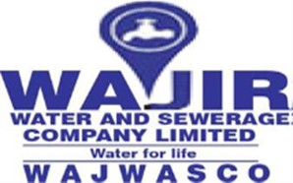

CONSULTANCY SERVCES FOR THE DESIGN REVIEW, PREPARATION OF FINAL DETAILED DESIGN, BIDDING DOCUMENTS, ENVIRONMENTAL AND SOCIAL IMPACT ASSESSMENTS (ESIAs), RESETTLEMENT ACTION PLANS (RAPs), SUPERVISION OF WATER AND SANITATION WORKS IN WAJIR TOWN AND THE PROVISION OF TECHNICAL ASSISTANCE
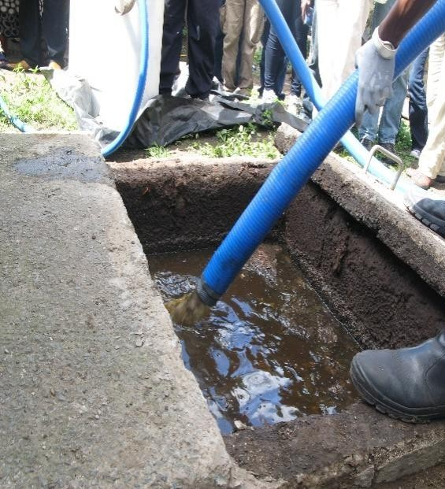
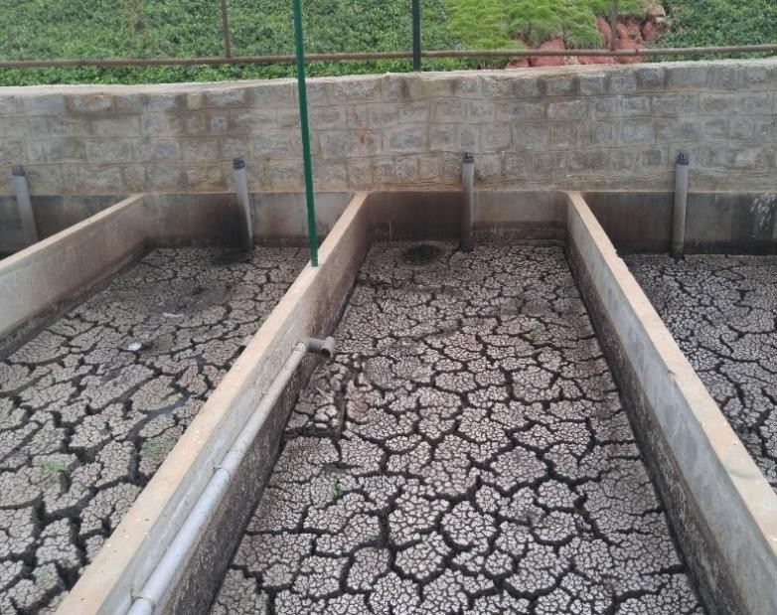

ENVIRONMENTAL AND SOCIAL IMPACT ASSESSMENT REPORT FOR THE PROPOSED WAJIR FAECAL SLUDGE AND SEPTAGE TREATMENT PLANT,
WAJIR MUNICIPALITY, WAJIR COUNTY OCTOBER 2024

 | East African Engineering Consultants Ltd | In Joint Venture With | 

CITATION

This report should be cited as:
WAJIR FAECAL SLUDGE TREATMENT PLANT PROJECT (2024) Environmental and Social Imapct Assessment (ESIA) Report, for Wajir Water and Services Company (WAJWASCO), Wajir County, Charles Lwanga Muyembe,Nairobi, Kenya.

DECLARATIONS
I, submit this Environmental and Social Impact Assessment Report for the proposed Wajir Faecal Sludge and Septage Treatment Plant Project.
Signed at ……………………. on this…...day of 2024
Signature ……………………………………………………….……... Designation: ………………………………………………………….
I, Charles Lwanga Muyembe, submit this Environmental and Social Impact Assessment Report for the Proposed Wajir Faecal Sludge and Septage Treatment Plant Project in accordance with the Environmental Management and Coordination Act, Cap 387 and the Environmental (Impact Assessment and Audit) Regulations, 2003.
Signed at Nairobi...on this … Day of …2024 Signature ………………………………………………… Designation: EIA/AUDIT LEAD EXPERT REG. NO.1283

TABLE OF CONTENTS
CITATION ii
DECLARATIONS iii
TABLE OF CONTENTS iv
LIST OF APPENDICIES ix
LIST OF FIGURES ix
LIST OF TABLES x
LIST OF ACRONYMS xii
EXECUTIVE SUMMARY xiv
ES 1: Back Ground Information xiv
ES 2: Project Location xiv
ES 3: Proposed Scope of Works xiv
ES 6: Project Alternatives xv
ES 7: Socio-Economic and Environmental Baseline Information xvi
ES 8: Policies, Legal and Institutional Frameworks xvii
ES 9: Public Participation and Stakeholder Engagement xxi
ES 10: Identification of Environmental & Social Impacts and Mitigation Measures. xxii ES 11: ESMMP xxvii
ES 12: Conclusion and Recommendations xxix
- INTRODUCTION 1
  - Back Ground Information 1
  - Project objectives 1
  - Objectives of the Environmental and Social Impact Assessment Project Report 1
  - Scope of the Study 2
  - Terms of Reference (ToR) 2
  - Justification of the ESIA 3
  - Environmental and Social Impact and Assessment Team 3
- ESIA APPROACH METHODOLOGY 4
  - Environmental and Social Screening 4
  - Environmental and Social Scoping 4
  - Desktop Study 4
  - Site Assessment 5
  - Public Participation 5
    - Stakeholder engagement interviews 5
    - Socio-economic surveys 6
  - Data Analysis, Reporting and Documentation 6
- PROJECT DESCRIPTION 7
  - Project Location 7
    - Proposed Scope of Works 7
    - Project Activities and Processes 9
  - Safety and public health requirements 10
  - Environmental Protection 10
  - Estimated Project Budget 10
- PROJECT ALTERNATIVES 12
  - The “no project” alternative 12
  - The ‘yes’ project alternative 12
  - Alternative FSTP Location 13
  - Alternative Sources for Construction Materials 13
  - Technology Alternatives 13
- SOCIO-ECONOMIC AND ENVIRONMENTAL BASELINE INFORMATION 14
  - Biophysical Environmental Baseline 14
    - Topography 14
    - Climate 14
    - Geology and Soils 14
    - Flora 14
    - Fauna 15
    - Ecological Conditions 16
  - Socio-Economic Baseline 16
    - Administrative and Political Units 16
    - Demographics 18
    - Literacy Levels 19
    - Access to Health services 20
    - Transport 21
    - Sanitation 21
    - Water resources 24
    - Land Use and Land Tenure 25
    - Housing 25
    - Youth 26
  - Cultural and archeological baseline 26
    - Cultural baseline 26
    - Archaeological Baseline 26
- POLICIES, LEGAL AND INSTITUTIONAL FRAMEWORKS 29
  - National Laws and Regulations 29
  - County Laws and Regulation 31
  - National Policy Framework 31
  - County Policy Framework 34
  - Sustainable Development Goals 34
  - Multilateral Environmental Agreements 35
  - World Bank Operational Safeguards 37
- PUBLIC PARTICIPATION AND STAKEHOLDER ENGAGEMENT 39
  - Objectives of The Consultation and Public Participation (CPP) 39
  - Methods used for consultation and public participation 39
  - Stakeholder Consultations 39
  - Schedule of stakeholder engagement 40
  - Stakeholder Engagement Outcomes in the EIA report and Final Design of the Project 43
  - Public Disclosure of ESIA and Annual Monitoring Reports 44
7.7. Continuous Public Participation and Engagement Outlook 47
- IDENTIFICATION OF ENVIRONMENTAL & SOCIAL IMPACTS AND MITIGATION MEASURES 48
  - Environmental and Social Impact Identification and Analysis/Rating 48
  - Anticipated project positive impacts During Pre-Construction Phase 49
  - Anticipated Positive Impacts During Construction Phase 49
  - Anticipated positive impacts during Operation Phase 51
  - Anticipated Positive Impacts During Decommissioning Phase 51
  - Anticipated Negative impacts during pre-construction phase 51
  - Anticipated Negative Impacts during Construction 53
  - Anticipated Negative Impacts during Operation stage 61
  - Anticipated Negative Impacts During Decommisioning Phase 67
- ENVIRONMENTAL & SOCIAL MONITORING & MANAGEMENT PLAN(ESMMP) 69
  - Objectives of the ESMMP 69
  - Impacts Classification Criteria 69
  - Implementation Arrangements for the Environmental and Social Management Plan 70
  - ESMMP 72
    - ESMMP for Preconstruction Stage 72
    - ESMMP for Construction Phase 73
    - ESMMP for Operation Phase 83
    - ESMMP for Decommissioning Phase 90
- GRIEVANCE REDRESS MECHANISM 91
  - Objectives of the GRM 91
  - Proposed Grievance Redress Procedure 91
  - The Four Tiers of Grievance Redress Mechanism 94
  - Worker Grievance Procedure 94
  - World Bank Group Grievance Redress Service 95
- CONCLUSION AND RECOMMENDATIONS 97
  - CONCLUSION 97
  - RECOMMENDATION 97
REFERENCES 98
ANNEXES 99

LIST OF APPENDICIES
Appendix 1: Lead Expert License 100
Appendix 2: List of participants in the Stakeholder Engagement Meeting 103
Appendix 3: Minutes of the Stakeholders Meeting 108
Appendix 4: Sample of filled stakeholder questionnaire 111
Appendix 5: Public participation Attendance List 128
Appendix 6: Minutes of the Public Participation Meeting 131
Appendix 7: Land Ownership Documents 134
Appendix 8: Proposed FSTP Schematics 137
Appendix 9: Chance Find Procedure 138

LIST OF FIGURES
Figure 1: Location of Wajir town 7

Figure 3: Plant cover in the proposed project site 15

Figure 4: Marabou stork in the existing dumping site 15

Figure 5: Cow at the proposed site 16
Figure 6: Layout of Wajir Town Showing the different Zones 17
Figure 7: Highiest level of education 20
Figure 8: Children going to school 20
Figure 9: TB Manyatta hospital 21
Figure 10: Bucket toilet 22
Figure 11: Open transport truck 23
Figure 12: Existing dumpsite in Alimaow 23
Figure 13: Solid waste management 23

Figure 14: Water sources 24
Figure 15: Manyatta house at homestead 25
Figure 16: Old buildings in the Wajir prisons compound 27
Figure 17: Common wealth war graves 27
Figure 18: Wajir museum 28
Figure 19: Stakeholder engagement meeting 45
Figure 20: Public participation meeting 45
Figure 21:Photo with the area chiefs of Alimaow and Furaha 46
Figure 22: Interview with the NEMA County Director 46
Figure 23: Interview with the NDMA Director 46
Figure 24: Interview with the Director of lands and Physical Planning Department 47

LIST OF TABLES

Table 1: Summary of EIA Team and Responsibilities 3

Table 2: Design flows 2025-2045 8

Table 3: Weighted average faecal sludge characteristics of proposed FSTP 8

Table 4: Components of the Wajir FSTP 9
Table 5: Estimated Project Costs 10
Table 6: County Government Administrative wards 16
Table 7: Population Distribution and density by Sub-County 18
Table 8: Key Population Data Wajir Town 19
Table 9: Key Sanitation Systems in Wajir Town 22
Table 10: Applicable National Laws and Regulations 29
Table 11: County Laws and Regulations 31

Table 12: Applicable Policies 31
Table 13: County Policy Framework 34
Table 14: SDGs 34
Table 15: Schedule of Public Consultation Meetings 40
Table 16: Summary of Stakeholder Consultation Issues 40
Table 17: Summary of Public Participation Issues 42
Table 18: Impacts Consequences 48
Table 19: Impacts Likelihood 48
Table 20: Significance Rating Matrix 49
Table 21: Negative Impacts ratings and associated color codes 49
Table 22: The potential impacts classification formula 69
Table 23: GRC Guiding Principles 91
Table 24: Grievance Redress Mechanism 93

LIST OF ACRONYMS

ABT | Appropriate Building Technology
AIDS | Acquired Immuno-deficiency Syndrome
ARAP | Abbreviated Resettlement Action Plan
CESMP | Contractor’s Environmental and Social Management Plan
CFC | Chlorofloro carbons
CIDP | County Integrated Development Plan
CPP | Consultation and Public Participation
EHS | Environment Health and Safety
EA | Environmental Assessment
ECDE | Early Childhood Development Education
EIA | Environmental Impact Assessment
EHSG | Environment, Health, and Safety Guidelines
ESAAP | Environment and Social Audit Action Plan
ESIA | Environmental and Social Impact Assessment
EMCA | Environmental Management and Coordination Act
ESMF | Environmental Social and Management Framework
ESMMP | Environment and Social Management & Monitoring Plan
FSTP | Faecal Sludge Treatment Plant
GoK | Government of Kenya
HIV | Human Immuno-deficiency Virus
KNBS | Kenya National Bureau Of Standards
NEAP | National Environmental Action Plan
NEP | National Environment Policy
NEMA | National Environment Management Authority
NGO | Non-Governmental Organization
PAPs | Project Affected Persons
PLUPA | Physical and Land Use Planning Act,
RAP | Resettlement Action Plan
OP | Operation Policy
OSHA | Occupational Health and Safety Act
SDG | Sustainable Development Goals
SPA | Service Provision Agreement

STD | Sexually Transmitted Diseases
ToR | Terms of Reference
UNCBD | United Nations Convention on Biological Diversity
UNFCC | United Nations Framework for Convention on Climate Change
VMGP | Vulnerable Marginalized Groups Plan
WAJWASCO | Wajir Water Supply and Sanitation Company
WASREB | Water and Service Regulatory Board
WB | World Bank
WFSTP | Wajir Faecal Sludge Treatment Plant
WSDP | Water and Sanitation Development Project
WSP | Water Service Provider

EXECUTIVE SUMMARY

ES 1: Back Ground Information

Wajir Water and Sewerage Company Limited (WAJWASCO) is the implementing agencies of the WSDP in Wajir County. Wajir Water & Sewerage Co. Ltd, (WAJWASCO) was incorporated in 2013 under the companies Act 2002 (cap.486). The company is currently regulated by WASREB, through a Service Provision Agreement (SPA) in 30/09/2014 to provide water supply and sewerage services within Wajir Town and its environs. The County Government of Wajir has appointed WAJWASCO as a Water Services Provider (WSP) for the whole of Wajir County.
The project Components were repackaged in four categories;
- Review and Supervision of implementation of Environmental and Social Safeguards.
- Sanitation Improvement project.
- Faecal sludge Management Works and operational auxiliary facilities
- Construction of Sanitary Lanes.
This ESIA Report is for the Faecal Sludge Treatment Plant for Wajir Town..
Justification of the ESIA
The implementation of the proposed project shall have both socio-economic and environmental impacts on the project area. In order to alleviate any detrimental effects of the project, there is need to assess possible impacts of the development on the environment and the socio-economic attributes of the project area.

ES 2: Project Location

Wajir County is located in the formerly North Eastern Province of Kenya, and borders Somalia to the East and Ethiopia to the North. Within Kenya, it borders the counties of Mandera, Isiolo, Marsabit and Garissa.
The County has six sub-counties, namely: Wajir East, Wajir South, Wajir North, Wajir West, Eldas and Tarbaj.
Wajir town, which is the project area, is in the jurisdiction of Wajir East sub-county. Based on the 2019 Kenya Census, it has a total population of 101,247. Wajir town is divided into ten zones, each with an elected zone chief.

ES 3: Proposed Scope of Works

The proposed site for the faecal sludge treatment facility is located 6 Km SE of Wajir CBD and about 5 km from the Airport at 188150 Northing and 615300 Eastings. The infrastructure to be developed on site will comprise of the following
  - Tanker discharge bay and inlet chute
  - Screening unit
  - Holding Basins
  - Sludge pumping stations
  - Sludge drying beds
  - Two primary anaerobic ponds
  - Two secondary anaerobic ponds
  - Two facultative ponds

  - Two maturation ponds
  - Constructed wetlands
  - Biosolids drying slabs
  - Generator house
  - Operations Building
  - Elevated water storage tank
  - Guard house
  - Incinerator
  - Waste to Value facility

The project activities shall include among others clearance of vegetation, earthworks and excavation of ponds, transportation of materials, construction of treatment works, construction of the ponds, operation of site management camp and associated facilities, storage of materials, accommodation for project crew, operation of the project and decommissioning of the facilities.

Estimated Project Budget
The total estimated project according to the engineer’s bills of quantities is 547,066,420, inclusive of 16%VAT.

ES 6: Project Alternatives

The “no project” alternative
Under the No-Nothing Alternative, no FSTP will be built and operated, and the insanitary conditions associated with the dispersal of raw untreated faecal sludge on lands surround the town will continue. The do-nothing alternative would mean that land and water and ultimately Wajir will continue to be polluted and loaded with untreated faecal matter and potential disease vectors.
The ‘yes’ project alternative
This was considered a viable option. This option was considered viable as opposed to the ‘no option’ because the yes project alternative implies that the project be implemented and once implemented there will be a number of gains that will be realized.
Space has been reserved in the current layout to allow for future incorporation of a waste to value preposition and in particular the reuse of sludge for agricultural composting, which is also the lowest value product in the waste regimes of an FSTP.

ES 7: Socio-Economic and Environmental Baseline Information

Biophysical Environmental Baseline
Wajir County has an average annual rainfall of 240mm, with April being the wettest month and July the driest. Temperatures average 27.9°C, peaking at 36°C in February and March, with June to August being the coolest. Vegetation includes acacia and Commiphora species, while livestock farming, especially of cattle, camels, goats, and sheep, is common. The area also hosts marabou storks and various livestock breeds.
Socio-Economic Baseline
Wajir County has six constituencies and 30 wards, with 14 administrative sub-counties. The proposed faecal sludge treatment plant is about 1.5 km from a nearby dispensary, and the site is accessed via dusty murram roads from Wajir town along the Isiolo-Mandera Road. Housing in the area includes a mix of Manyattas (made from sticks, mud, and fabric), semi-permanent, and permanent homes made of stone and corrugated iron sheets. The area reflects a blend of traditional and modern living structures.

ES 8: Policies, Legal and Institutional Frameworks

National Laws and Regulations | County Laws and Regulation | National Policy Framework | County Policy Framework | Sustainable Development Goals | Multilateral Environmental  Agreements
- The  Environm ental Manage ment and Co- ordinatio n Act, (EMCA)  1999 and amended in 2015 and subsequ ent Regulatio ns.  - Occupati onal Health and Safety Act 2007  CAP 514.  - The  Public Health Act 1986  revised | - County Govern ment Act No.17  of 2012  - Wajir  County Climate Change Fund Act, 2016 | - Kenya  Vision 2030  - The  National Environm ental Action Plan (NEAP) 1994  - Policy  Paper on Environm ent and Develop ment 2014  - The  National Water Resource s Manage ment Policy (1999)  - HIV and AIDS | - Wajir  County integrat ed develop ment goals 2023-  2027 | - SDG  Goal 1; No poverty  - SDG  Goal 2; Zero Hunger  - SDG  Goal 3; Good health & well Being  - SDG  Goal 4; Quality educatio n  - SDG  Goal 5; Gender equality  - SDG  Goal 6; Clean Water  and Sanitati | - United  Nation s Frame work for Conve ntion on Climat e Chang e (UNFC CC)  - Vienna Conve ntion for the Protect ion of Ozone Layer  - Conve  ntion on Biologi  cal Diversi

National Laws and Regulations | County Laws and Regulation | National Policy Framework | County Policy Framework | Sustainable Development Goals | Multilateral  Environmental Agreements
2012  (Cap 242).  - The  Physical and Land Use Planning Act, (PLUPA) 2019  - National Construct ion Authority Act No.  41 of  2011  - Sustaina ble Waste Manage ment Act 2022  - Children Act (2001)  and revised 2016  - County Governm |  | Policy 2009;  Setting Minimum Internal Require ments (MIR) for managin g HIV  and AIDS.  - Gender Policy 2011;  Mainstre am gender concerns  .  - Sessiona l Paper No. 7 of  2005 on National Employm ent Policy and Strategie s for  Kenya |  | on  - SDG  Goal 7; Affordab le and clean energy  - SDG  Goal 8; Decent work and economi c growth  - SDG  Goal 9; Industry  ,  Innovati on and infrastru cture  - SDG  Goal 10; Reduce d inequalit ies  - SDG  Goal 11;  Sustain able | ty (1992)  - African Union- Agend a 2063  - African Charte r on  the Rights and Welfar e of  the Child.  - Montre al Protoc ol on Substa nces that Deplet e the Ozone Layer (1987)

National Laws and Regulations | County Laws and Regulation | National Policy Framework | County Policy Framework | Sustainable Development Goals | Multilateral  Environmental Agreements
ent Act (2012  - Work  Injury Benefits Act, 2007  - Water  Act (2016)  - Sexual Offences Act (2006)  - Climate Act (2016)  Revised 2023.  - Urban  Areas and Cities Act (2011)  - EMCA  regulatio ns on (Noise, Waste manage ment, Air  Pollution, Excessiv |  | - Sustaina ble Waste Manage ment Policy 2021  - Kenya  Youth Develop ment Policy 2019  - The  National Museum s and Heritage Act;  - HIV and AIDS  Preventio n and Control Act |  | cities and commu nities  - SDG  Goal 12; Respon sible consum ption and producti on  - SDG  Goal 13; Climate action  - SDG  Goal 15; Life on land  - SDG  Goal 16; Peace justice and strong institutio ns  - SDG  Goal 17; Partners

National Laws and Regulations | County Laws and Regulation | National Policy Framework | County Policy Framework | Sustainable Development Goals | Multilateral  Environmental Agreements
e Vibration s and Noise, Water Quality Regulatio ns, Extended Producer Responsi bility Regulatio  ns |  |  |  | hips for the goals

ES 9: Public Participation and Stakeholder Engagement

The assessment involved consultations with relevant stakeholders in target Project area as per social assessment requirements of cultural appropriateness and FPIC.

Date | Meeting Venue | Stakeholder Consulted | Number of Meeting  Attendance | Gender
31st July 2024 | Midpoint Coffee House | Wajir Water and Sewerage Company (WAJWASCO).  Director, National Drought Management Authority  CEC Education CEC Public Health  CEC Lands and physical planning CEC Water and sanitation Religious leaders  Local Government and administration  Wajir Municipality director County Commissioner  Wajir County NEMA director Engineers??  KWS KFS | 31 | Male: 21  Female: 10
1st Augus t 2024 | Midpoint Coffee House | Chief and locals of Alimaow and Furaha villages  CEC Education WAJWASCO | 30-Alimaow 30-Furaha | Male 50  Female 10

Summary of Stakeholder Consultation Issues

S  No. | Concern/Comment/Question | Response/Recommendation
1 | Why shouldn’t the client do the sewer system that had been proposed initially? | The sewer system is not feasible given the area does not have sufficient water supply. Sewer systems can only operate in areas where there is a lot of water sufficient to push the wastes in the trunks.  The area is also a flat plain, making it difficult for sewer system to operate as it is also dependent on  gravity to enable the flow of the wastes down slope to the FSTP.
2 | Are there design methods that have been considered to mitigate the possible negative impacts of the plant, given it is a high risk,  where there will be production of greenhouse gases in the ponds? | Yes, there are engineers who are still designing the plant with operation and maintenance considered, and a final design report shall be shared and discussed.
3 | With the existing court case on the management of the existing dumpsite, how is the client going to ensure it is handled to prevent conflicts with the locals | The client expressed his concern and said that he shall ensure every issue is addressed to enable the project progresses without fail for the better of the community and Wajir as a whole.

S  No. | Concern/Comment/Question | Response/Recommendation
In order to ensure fair hearing, this question shall be anchored in the project SEP as an ongoing concern.

The Court has issued Stay Orders on the case and allowed parties to remedy the situation at the Dumpsite. The Environmental & Management Coordination Act that regulates the proceedings of Tribunal and Environmental Law Court provides an automatic stay under section 130 which states the following; No decision or order of the Tribunal shall be enforced until the time for lodging an appeal has expired or, where the appeal has been commenced, until the appeal has been determined.

The Appeal has been allowed by the Environment and Court and a mention done. As of now one of the Petitioners out of the two who had filed the case has since withdrawn from the Petition and sent withdrawal to the Court email.

This Project is one of the definite actions that the County is taking in order to improve the site and ensure the site in question is managed well including access control, solid waste management and air-
fouling.
4 | A member proposed Public Private Partnerships during the proposed project  operation phase to enable proper management of the plant. | This was noted
5 | The attendees wanted to understand the importance of the byproducts of the proposed plant. | There will be production of wastewater, that after undergoing treatment can be used for irrigation in farms.  The dried sludge could be used as manure or processed into briquettes.
6 | This is a high-risk project, it should be taken with a lot of seriousness, and ensure all the possible negative impacts are addressed  well. | There shall be an ESMMP available that shall be addressing all the anticipated negative impacts and the costs indicated.

ES 10: Identification of Environmental & Social Impacts and Mitigation Measures

Anticipated project positive impacts

Pre-construction  phase | Construction Phase | Operation Phase | Decommissioning Phase
Inclusivity in decision-making | - Creation of employment  - Increased business opportunities  - Increased Property | - Improved sanitation.  - Reduction in waterborne diseases  - Increased property value | - Adaptation to Changing Needs  - Improved Public Safety  - Environmental Restoration  - Cost Savings

 | Values  - Community Engagement  - Environmental Protection  - Skills Development | - Improvement of quality of life  - Reduction in water inaccessibility  - Improved Quality of Life

Anticipated Negative impacts during pre-construction phase

Impact | Mitigation measures
Divided opinion on project implementations | - To address these impacts, it's essential for project implementers to adopt inclusive and participatory approaches that facilitate constructive dialogue, consensus- building, and conflict resolution.  - Engaging stakeholders early and regularly throughout the project lifecycle.  - Conduct extensive public participation and consultation with key stakeholders
High Expectations of the Local Communities in relation to Jobs | - The hiring requirements must be clear, properly publicized before the start of the recruitment process and respected by the design team. For a better impact on the communities this process shall be conducted with the involvement of local leaders;  - In the event there are local expectations for employment that cannot be met by the project, the limited availability of places shall be made known to the interested parties through local authorities; and  - The principles and procedures for hiring shall, as far as possible, give priority to the hiring of skilled local workers.

Anticipated Negative Impacts during Construction

Impact | Mitigation measures
Noise and Excessive Vibrations | - Contractor will comply with provisions of EMCA 1999 and amendments 2015 (Noise and Excessive Vibrations Regulations of 2009)  - The Contractor shall keep noise level within acceptable limits (55 Decibels during the day and 35 Decibels during the night) and construction activities shall, where possible, be confined to normal working hours in the residential areas.  - Hospitals and other noise sensitive areas such as schools shall be notified by the Contractor at least 5 days before construction is due to commence in their vicinity.  - Undertake Noise and Excessive Vibration Assessments.  - Effective use of appropriate PPE by exposed workers and Proper maintenance of machines.  - Any complaints received by the Contractor regarding noise will be recorded and communicated to the Supervising Engineer for appropriate action.
Soil Pollution | - Any polluted soil should be handled with care for proper disposal.  - Concrete mixing shall be done on concrete slabs or a large metal sheet or mortar boards.  - Maintenance of vehicles to be done strictly at a designated place/Drip tray to be used to avoid oil spills.  - Excavation materials to be stock piled at the demarcated location.
Air Pollution | - Vegetation and Greenery; Incorporate green infrastructure elements such as vegetative barriers and green roofs into construction projects to help absorb pollutants and improve air quality in the surrounding area.  - Regulatory Compliance; Ensure compliance with relevant environmental regulations and permits governing air quality standards and emissions limits for construction activities.  - Water sprinkling to reduce the dust at the construction sites.  - Use of dust masks to operators and those working in the dusty areas.  - Use of goggles for all operators.  - Construction machines/equipment will be well maintained to ensure total fuel

Impact | Mitigation measures
combustion. All vehicles involved in construction works will be frequently checked and well serviced during the whole construction period so that the level of exhaust emissions is reduced.
- Speed of vehicles hauling construction materials shall be reduced and the construction materials will be covered with tarpaulins.
Increased Crime and Insecurity | - Contractor and Supervision Team to liaise regularly with the Local Administration and Police Service to address any security and crime arising during project implementation.  - Contractor to provide 24 hours’ security to Workforce Camps, Yards, Stores and to the Supervising Team’s Offices.
Occupational Health and Safety Risks | - Contractor to provide a Health and Safety Plan prior to the commencement of works to be approved by the Supervising Engineer.  - Construction Workers and the Supervising Team to be provided with Personal Protective Equipment including gloves, gum boots, overalls and helmets. Use of PPE to be enforced by the Supervising Engineer.  - Fully stocked First Aid Kits to be provided within the Sites, Camps and in all Project Vehicles  - Isolate the site from access by the local communities during the construction for their safety and health  - Contractor to provide clean water for drinking and healthy food to all the workers  - Contractor to adhere to maximum eight hour working rule  - Contractor to ensure only qualified personnel operate machinery.
Sexual Exploitation and Abuse | - Establish strict codes of conduct for all project staff and contractors, with clear penalties for SEA violations.  - Conduct community awareness campaigns to educate local populations about their rights and reporting mechanisms.  - Set up confidential and accessible reporting systems where victims can safely report SEA incidents without fear of retaliation.  - Provide mandatory training for all project staff on SEA prevention, gender sensitivity, and appropriate workplace behaviour.  - Regularly monitor project sites and enforce policies through independent oversight and periodic audits.  - Ensure that victims of SEA have access to medical, legal, and psychological support.
Inadequate stakeholder Engagement and Exclusion of disadvantaged and vulnerable groups | - Share project information widely and in a timely manner through diverse, feasible and accessible channels of communication e.g., public forums.  - Introduce measures for affirmative action that would ensure especially persons with disability, the elderly and women have access to job opportunities.  - Undertake recruitment transparently, while ensuring the inclusion of disadvantaged groups.  - Develop and implementation of a stakeholder engagement plan.  - Engage stakeholders throughout the project phase as guided by the approved stakeholder engagement plan.  - Culturally appropriate consultations and early involvement of VMGs in the project.  - Use of tailored communication channels to ensure VMGs can access project information.  - Training and empowerment programs to enhance VMG participation.  - Ensure VMGs have equal access to project benefits and opportunities.  - Culturally sensitive systems for VMGs to safely report issues.  - Adherence to policies that protect VMG rights.  - Ongoing assessment involving VMGs to track the project’s impact on them.
Child labour and Abuse Risk | - Ensure each employee signs a code of conduct that covers child protection ensuring no children are employed on site in accordance with national labour laws.  - Ensure that any child sexual relations offenses among contractors' workers are promptly reported to the police.  - Employ workers who are 18 years and above, and with a valid national ID at the time of

Impact | Mitigation measures
hire.
- Implement and monitor the employment register regularly.
- Comply with the national labour laws and labour management practices.
- Put visible signage on site “No Jobs for children.”
Gender-Based Violence and Sexual Exploitation and Abuse (SEA) and Sexual Harassment (SH) | - Establish clear policies and codes of conduct against GBV, SEA, and SH.  - Provide mandatory training for staff and community awareness campaigns.  - Implement confidential reporting channels and support services for victims.  - Involve local leaders and empower vulnerable groups to foster a supportive environment.  - Ensure safe work environments and secure transportation for workers.  - Partner with NGOs for enhanced support systems and referral services.  - Tailor interventions to be culturally appropriate for the local context.  - Develop and implement a plan to manage the risk of SEA/SH.  - Map the GBV referral pathways and create awareness among women and men on the risk of SEA/SH.
Leakage of fuel and lubricants | - Dripping pans to be used to contain all hydrocarbon leakages on construction equipment.  - Re-fuelling on designated areas.  - In case of hydrocarbon spills, the contaminated soils will be collected and treated to remove the hydrocarbon and prevent the hydrocarbons from being washed away in storm water to the nearby water bodies
Community Health and Safety Risks | - Construction site shall be provided with barricades to protect neighbours and those passing-by.  - Therefore, the public particularly the children shall not be allowed to come closer to the swing area of excavators or other equipment at site.  - In places where there are vehicles transporting construction materials and also at turning places towards the construction site, appropriate warning signage shall be posted.  - Sensitization and training of the surrounding communities regarding the risks associated with construction activities.  - Constant surveillance from security to make sure that there are no “uninvited guests” in the project site.  - Sppread of HIV/Aids due to labour influx and behavioural change
Anticipated Negative Impacts during Operation stage

Impacts | Mitigation Measures
Gender-Based | - Develop and implement a plan to manage the risk of SEA/SH.  - Map the GBV referral pathways and create awareness among women and men on the risk of SEA/SH
Violence and
Sexual
Exploitation
and Abuse
(SEA) and
Sexual
Harassment
(SH)
Inadequate | - Share project information widely and in a timely manner through diverse, feasible and accessible channels of communication e.g., public forums.  - Introduce measures for affirmative action that would ensure especially persons with disability, the elderly and women have access to job opportunities.  - Undertake recruitment transparently, while ensuring the inclusion of disadvantaged groups.  - Develop and implementation of a stakeholder engagement plan.  - Engage stakeholders throughout the project phase as guided by the approved stakeholder engagement plan.
stakeholder
Engagement
and Exclusion
of
disadvantaged
and vulnerable
groups

Impacts | Mitigation Measures
- Culturally appropriate consultations and early involvement of VMGs in the project.
- Use of tailored communication channels to ensure VMGs can access project information.
- Training and empowerment programs to enhance VMG participation.
- Ensure VMGs have equal access to project benefits and opportunities.
- Culturally sensitive systems for VMGs to safely report issues.
- Adherence to policies that protect VMG rights.
- Ongoing assessment involving VMGs to track the project’s impact on them.
Water Pollution/Conta mination | - To mitigate the impacts of water pollution and contamination, the project should prioritize integrated water management approaches that address both the root causes and symptoms of pollution. This includes investing in infrastructure for safe drinking water supply, wastewater treatment, and solid waste management, promoting sustainable agricultural practices to reduce runoff and pollution, strengthening regulatory frameworks and enforcement mechanisms to prevent industrial pollution, and raising awareness about the importance of water conservation and pollution prevention among community  members.
Foul smell | - Install biofilters, which use natural biological processes to filter and neutralize odorous compounds from the air.  - Transport sludge and other materials in enclosed conveyors or pipelines to prevent the escape of odors.  - Minimize the time sludge spends in open-air conditions by quickly processing and covering it to reduce odor generation.  - Dewater and stabilize sludge as quickly as possible to reduce the biological activity that causes odors.  - Create buffer zones with green belts or vegetation around the plant to absorb and disperse odors.  - Place the most odor-intensive operations away from residential areas and near the center of the facility to minimize exposure to the community.  - Implement regular cleaning schedules for all equipment and facilities to prevent the buildup of odorous materials.  - Quickly repair any leaks, overflows, or broken equipment that could lead to increased odor emissions.  - Regularly monitor odor levels in and around the plant and share the results with the community.  - Establish a system for the community to report odors and ensure a rapid response to any issues raised.  - Use trees and plants known for their odor-absorbing properties around the facility.  - Avoid overloading treatment systems, as this can lead to incomplete processing and higher odor emissions.  - Adjust operations during hot seasons when odour emissions might be higher due to increased microbial activity
Mosquito nuisance | - Establish a maintenance schedule to remove debris and organic matter from ponds, along with a monitoring program for mosquito populations.  - Incorporate aeration systems in water retention ponds and introduce natural predators (e.g., fish) to control mosquito larvae. Use constructed wetlands for biological control.  - Manage swampy areas with vegetation that repels mosquitoes and ensure drying beds are designed to prevent standing water.  - Educate local communities on mosquito control and involve stakeholders in monitoring efforts.  - Develop an Integrated Pest Management plan, considering biological, physical, and environmentally safe chemical controls, including the use of larvicides if necessary.  - Use mosquito-repelling plants in landscaping and ensure proper drainage to prevent stagnant water accumulation.
Anticipated Negative Impacts During Decommissioning Phase

Impacts | Mitigation Measures
Disruption of Services | - Implement phased decommissioning to minimize disruption to services.  - Provide alternative sanitation options for affected people.  - Schedule decommissioning activities during off-peak hours to reduce impact on service provision.
Environmental Disturbance | - Conduct thorough environmental impact assessments prior to decommissioning.  - Implement erosion and sediment control measures to prevent soil erosion and water pollution.  - Replant native vegetation and restore habitats affected by decommissioning activities.
Health and Safety Concerns | - Enforce strict safety regulations and provide adequate training for workers.  - Implement dust and noise control measures to minimize pollution and disturbance to nearby residents.  - Communicate potential risks to the public and provide guidance on safety precautions.

ES 11: ESMMP

Implementation Arrangements for the Environmental and Social Management Plan (ESMP)
Implementing an Environmental and Social Management Plan (ESMP) for the Wajir Faecal Sludge Treatment Plant (FSTP) involves coordinated efforts from various stakeholders, including the project proponent, consultants, and contractors. Here’s a comprehensive overview of the implementation arrangements and capacity requirements for each party, as well as measures to ensure effective ESMP implementation;

Roles and Responsibilities
Project Proponent
- The proponent is responsible for ensuring compliance with the ESMP throughout the project lifecycle.
- Allocate necessary resources (financial, human, and technical) for the effective implementation of the ESMP.
- Facilitate communication between all stakeholders, including regulatory bodies, local communities, and contractors.

Consultant

Contractor

- Provide expert guidance in the design and implementation of the ESMP, ensuring that environmental and social considerations are integrated.
- Develop monitoring frameworks and tools to assess the effectiveness of the ESMP and prepare periodic reports for the proponent and regulatory authorities.
- Conduct training sessions for project staff and contractors on ESMP requirements and best practices.

- Responsible for implementing specific mitigation measures outlined in the ESMP during construction and operational phases.
- Maintain documentation of compliance with the ESMP and report any non-compliance incidents to the proponent and consultant.
- Engage with local communities to address concerns related to construction activities and ensure adherence to social safeguards.

ESMMP for Preconstruction Stage
The environmental and social impact mitigation plan outlines key actions to address potential project issues. For environmental impacts, delays in approvals from NEMA and other agencies will be managed by ensuring all necessary permits are obtained before starting the project, with a budget of KES 300,000. For social impacts, public participation will be conducted to address divided opinions, and local hiring will prioritize community members, with transparent communication on employment opportunities. Community engagement and employment processes will be monitored throughout the project cycle to ensure compliance.

ESMMP for Construction Phase Environmental Risks
  - Noise Pollution: Implement EMCA regulations, maintain acceptable noise levels, and use
PPE. Budget: Ksh 500,000.
  - Air Pollution: Use vegetation barriers, ensure regulatory compliance, and maintain equipment. Budget: Ksh 400,000.
  - Soil Pollution: Control erosion and monitor soil quality. Budget: Ksh 400,000.

  - Waste Generation: Improve waste management practices and site cleanliness. Budget: Ksh 500,000.
  - Fuel Leakage: Use containment measures for spills and treat contaminated soil. Budget: Ksh 150,000.

Social Risks
  - Sexual Exploitation and Abuse: Establish conduct codes, awareness campaigns, and support services. Budget: Ksh 300,000.
  - Occupational Safety: Enforce safety protocols and provide protective gear. Budget: Ksh 300,000.
  - Child Exploitation: Ensure age restrictions and monitor employment. Budget: Ksh 200,000.
  - Crime and Insecurity: Collaborate with local authorities for security. Budget: Ksh 900,000.
  - Stakeholder Engagement: Share project information widely and involve disadvantaged groups. Budget: Ksh 250,000.
  - Gender-Based Violence: Implement management plans and establish reporting channels. Budget: Ksh 150,000.
  - HIV/AIDS Awareness: Conduct campaigns and provide health services. Budget: No additional cost.
  - Community Safety: Install barricades and educate on construction risks. Budget: Ksh 200,000.

ESMMP for Operation Phase
The Environmental and Social Risk Management Plan addresses key impacts related to the project, focusing on Gender-Based Violence (GBV) and Sexual Exploitation and Abuse (SEA), which are prioritized with awareness programs and a grievance mechanism at no additional cost. Water pollution is a critical concern, with strategies for impermeable liners and treatment systems, also without added expenses. The plan emphasizes inclusive stakeholder engagement, allocating Ksh 200,000 for transparent communication and recruitment of disadvantaged groups. Mitigation measures for foul odors and mosquito nuisances involve biofilters and facility maintenance, with budgets of Ksh 100,000 and Ksh 200,000, respectively. Septage spill prevention during transportation is set at Ksh 250,000, while worker health measures include PPE and hygiene training, costing Ksh 100,000. Additionally, Ksh 200,000 is earmarked for controlling scavenger fauna, and Ksh 250,000 is allocated for managing greenhouse gas emissions through methane capture and process optimization. Overall, the plan reflects a strong commitment to environmental protection and community safety.

ESMMP for Decommissioning Phase
The Decommissioning Environmental and Social Risk Management Plan addresses potential impacts during the decommissioning phase, focusing on three main areas:
- Disruption of Services (Low-Medium Impact): The plan includes phased decommissioning to minimize service interruptions, provision of alternative transportation routes, and scheduling activities during off-peak hours. Monitoring will assess service disruptions, with responsibilities shared between local administration and WAJWASCO, at no additional cost.
- Environmental Disturbance (Low-Medium Impact): Emphasizing thorough environmental impact assessments and erosion control measures, the plan aims to restore habitats by replanting native vegetation. Compliance and survival rates of replanted vegetation will be monitored, with oversight from the Environmental Management Team, WAJWASCO, and consultants.
- Health and Safety Concerns (Medium Impact): The plan focuses on enforcing safety regulations, training workers, and implementing dust and noise control measures. Public risk communication and safety guidance will be prioritized, with monitoring of safety adherence and public feedback. Local administration and WAJWASCO will manage this area, with a budget of Ksh 200,000.

ES 12: Conclusion and Recommendations

Conclusion
The project will offer employment to the locals both direct and indirect. The project will cause no displacement of households. With implementation of the project following the EMMP provided, negative impacts shall be reduced to the minimum maximizing on positive impacts;
The entire project cost is KES 547,066,420 (Five Hundred and Forty-Seven Million, Sixty-Six Thousand, and Four Hundred and Twenty)
From the above bills, the law requires that the Client pays 0.1% of the project cost or a minimum of Kshs 10,000 as NEMA licensing fee. Based on the total cost of the project of Kshs 547,066,420. The Client will pay Kshs 547,066.42 to NEMA for the processing of the NEMA license for the entire project.

Recommendation
The Lead expert recommends the following;
- There should be continuous public participation, household questionnaires, focused group discussions and stakeholder engagement administered within the project location to ensure total project acceptance.
- ESMP measures should be effectively implemented during project implementation, and operation phase of the project under the strict supervision of the proponent and consultant to achieve maximum project acceptability;
- Where complains arise, the contractor, WAJWASCO and Wajir County should solve the problem according to the requirements of ESMP.
- The management should look for other relevant approvals where possible including National Construction Authority before commencement of the project activities.
- Since all the insignificant negative impacts have been addressed, the consultant recommends that NEMA should approve the ESIA report so that it is implementation to benefit the communities in Alimaow and Furaha location and areas of Wajir County.

INTRODUCTION

Back Ground Information

The Government of Kenya is undertaking Water and Sanitation Development Project (WSDP), with financing from the World Bank. Component 2 of the Project entails the Expansion of water supply and sanitation services in marginalized areas in the North-eastern Counties of Kenya that includes Wajir County.
Wajir Water and Sewerage Company Limited (WAJWASCO) is the implementing agencies of the WSDP in Wajir County. Wajir Water & Sewerage Co. Ltd, (WAJWASCO) was incorporated in 2013 under the companies Act 2002 (cap.486). The company is currently regulated by WASREB, through a Service Provision Agreement (SPA) in 30/09/2014 to provide water supply and sewerage services within Wajir Town and its environs. The County Government of Wajir has appointed WAJWASCO as a Water Services Provider (WSP) for the whole of Wajir County.
In April 2021, WAJWASCO awarded the East African Engineering Consultants Ltd in Joint Venture with Systel Engineering Ltd in association with SULIS Ltd the contract to undertake consultancy services for the design review, preparation of final detailed design, bidding documents, environmental and social impact assessments (ESIAs), resettlement action plans (RAPs), supervision of water and sanitation works in Wajir town and the provision of technical assistance to WAJWASCO.
The project Components were repackaged in four categories;
- Review and Supervision of implementation of Environmental and Social Safeguards.
- Sanitation Improvement project.
- Faecal sludge Management Works and operational auxiliary facilities
- Construction of Sanitary Lanes.

This Detailed Design Review Report is for the Faecal Sludge Management Works and the auxiliary facilities for Wajir Town. An Inception Report of May 2021 and a Conceptual Design Review Report of June 2021 preceded it.

Project objectives

The detailed design of the WFS&STP components has been based on the following objectives.
- To improve sanitation and public health in the Wajir town.
- To reduce waterborne diseases through proper faecal sludge and septage treatment.
- To protect groundwater and surface water from contamination.
- To establish a sustainable waste management system.
- To promote the use of treated by-products in agriculture.
- To build capacity among local authorities and stakeholders.
- To engage the community in sanitation practices and plant benefits.
- To create job opportunities and stimulate economic development.
- To ensure compliance with national and international sanitation standards.
- To implement innovative technologies for effective waste treatment and resource recovery.

Objectives of the Environmental and Social Impact Assessment Project Report.

The Environmental & Social Impact Assessment (ESIA) is expected to achieve the following objectives:

- To identify all potential significant environmental and social impacts of the proposed Project and recommend measures for mitigation.
- To assess and predict the potential impacts during site preparation, construction, operational and decommissioning stages of the Project.
- To verify compliance with environmental regulations.

- To generate baseline data for monitoring and evaluation of how well the mitigation measures will be implemented during the Project cycle.
- To allow for public participation.
- To prepare an Environmental and Social Management Plan to mitigate the identified impacts to ensure sustainability of the proposed Projects.
- To recommend cost effective measures to be implemented to mitigate against the negative impacts.

The ESIA report has been prepared in accordance with the Client (WAJWASCO and World Bank) Guidelines, the Environmental (Impact Assessment and Audit) Regulations, 2003 (and the amendment Regulations of 2019) and Environmental Management and Coordination Act (EMCA) 1999 amended in 2015).

Scope of the Study

To identify the potential environmental and social impacts, and to come up with the proper mitigation measures for the proposed projects, the consultant used both conventional and participatory approaches. In conducting this exercise, the consultant.
- Conducted project site visits, consulting with the local communities, and other relevant key stakeholders.
- Carry out comprehensive assessment ensuring all environmental concerns and views of all parties/persons likely to be affected by the project are taken into consideration.
- Reviewed the preliminary designs for the proposed project to get acquainted with environmental issues in the project site vicinity.
- Schedule time for site visiting activities to be undertaken for the ESIA.
- Developed an environmental and social management and monitoring plan with mechanisms for evaluating compliance and environmental performance, which include the cost of mitigation measures and the timeframe of implementing the measures.
- Publicized the project and its anticipated effects by posters in strategic places, publishing a notice in both official and local languages in the Kenyan Gazette and one of the local dailies.
- Liaising with NEMA for compliance with all mandatory and regulatory requirements relating to the ESIA.

Terms of Reference (ToR)

In compliance with legal and professional requirements, it is expected that the outputs from this study reflect a consultative process being generated by WAJWASCO.
The authenticity requires the consultant to conduct the below tasks;
- Assessment and description of location/site, objectives, scope, nature of the proposed project,
- Analysis of the proposed project activities during the proposed project cycle; construction, operation, decommissioning phases,
- Establish the suitability of the proposed project in the proposed location,
- Review and establish all relevant baseline information as will be required by NEMA (Physical, Biological and Social Cultural and economic) and identify any information gaps,
- Description and analysis of policy legal and institutional framework including but not limited to Kenyan policies, laws, regulation and guidelines which have a bearing on the proposed project and will also serve as benchmarks for monitoring and evaluation, and future environmental audits,
- Analysis of the designs, technology, procedures and processes to be used, in the implementation of the works,
- Consultation and Public Participation (CPP): Identify key stakeholders and affected persons; hold a public meeting and provide /collect written evidence i.e. minutes,

- Identify and analyze proposed project alternatives including but not limited to: Scale and extent; project site alternatives, no project alternatives, design alternatives, material alternatives and technologies alternatives,
- Identify, predict and carry out in-depth analysis all actual potential and significant impacts on flora, fauna, soils, air, water, the social, cultural and community settings; the direct, indirect, cumulative, irreversible, short-term and long-term effects anticipated to be generated by the proposed project, both positive and negative throughout the project cycle,
- Recommend sufficient mitigation measures for all the potential negative impacts identified,
- Analyze occupational health and safety issue associated with the proposed project,
- Develop an Environmental and Social Management Plan (ESMMP) proposing the measures for eliminating, minimizing or mitigating adverse impacts on the environment, including the cost, timeframe and responsibility to implement the measures.

Justification of the ESIA

The implementation of the proposed project shall have both socio-economic and environmental impacts on the project area. To alleviate any detrimental effects of the project, there is a need to assess possible impacts of the development on the environment and the socio-economic attributes of the project area. First, the proposed project will be evaluated against the framework provided by the Physical Development plan to ensure proper alignment. Then an Environmental Impact Assessment is conducted in accordance with the Client Guidelines, Environmental Management and Co-ordination Act (EMCA), Act, Cap 387, and the Environmental (Impact Assessment and Audit) Regulations, 2009 (and the amendment Regulations of 2019). Due to the likely socio-economic impacts of the project, our Environmental Specialist and Socio-Economic Specialist have also collected socio-economic data to support the Environmental Impact Assessment and to be used for Economic Evaluation of the Project. They were assisted by Field Assistants and a group of Enumerators especially in the process of acquiring the primary data in the field.
The execution of the assignment was carried out during the preliminary design of the Project to ensure that the designs produced comply with environmental requirements and consider socio-economic status in the areas. The outcome of the Environmental Impact Assessment will be used to moderate the Engineers’ Designs to ensure that they are in harmony with the environmental and socio-economic attributes of the project area. This approach will enhance the protection of the environment and the local community from negative effects of development.

Environmental and Social Impact and Assessment Team

Table 1: Summary of EIA Team and Responsibilities

Design Lead E
ation Name | Respon | sibilities
xpert Charles | MuyembSeuperv  Provide Review | ise ESIA field Surveys and Socio economic field surveys’ general guidance  ESIA Reports and Socio Economic Reports
gist Charity | GathuthiConduc  Conduc | ting Socioeconomic surveys and assessments ting household surveys and assessments
ate Expert Saraph | ina NasimCiayruryin  Drafting Conduc | g out Field Surveys/Assessments of ESIA reports  ting Socioeconomic Field assessments
mentalist Michae  Davis Wa | MomanyPieer re nami Carryin  Drafting  Conduc | view  g out Field Surveys/Assessments of ESIA reports  ting Socioeconomic Field assessments

Sociolo Associ

Environ l

ESIA APPROACH METHODOLOGY
As stated earlier, the ESIA Study was carried out in compliance with the government of Kenya’s Environment Management and Coordination Act of 1999, among other relevant laws, regulations and guideline standards.

The general steps followed during the assessment were as follows:

- Environmental and social screening, in which the project was identified as among those requiring Environmental and Social Impact Assessment under schedule 2 of EMCA, 1999
- Environmental scoping that provided the key environmental issues
- Desktop studies
- Physical inspection of the area and surrounding areas
- ESIA Public participation via the use of general questionnaires, key informants’ interviews, socio-economic surveys and interactive meetings
- Data analysis and
- Report preparation.

Environmental and Social Screening

This step was conducted through legal review and desktop studies to assess whether there will be a need for an environmental and social impact assessment, and what level of assessment is necessary. This was done using a screening checklist in reference to requirements of the EMCA, 1999, and specifically the second schedule. The proposed project is listed as a medium risk project in Legal Notice 31&32 of EMCA with potential limited adverse environmental and social risks and/or impacts that are few, generally site-specific, largely reversible and readily addressed through mitigation measures.

Environmental and Social Scoping

The scoping process, through an ESIA scoping checklist, was conducted to help narrow down onto the most critical issues requiring attention during the assessment. Environmental issues were categorized into physical, natural/ecological and social, economic and cultural aspects. It also included discussions with key stakeholders, managers and design engineers as well as interviews with local communities. Data from secondary sources was used to outline the bio-physical features, socio-economic characteristics of the residents, the existing infrastructure services and the forms of land tenure.

Desktop Study

Desktop study included document review on the nature of the proposed activities, project documents, designs, policy and legislative framework as well as the environmental setting of the area among others. This method was achieved through;

- Data Collection: The desktop study began with gathering relevant data from various sources. This includes geological maps, topographical surveys, historical records, land use patterns, environmental reports, and any existing documentation related to Wajir.
- Review of Regulations: Understanding the legal and regulatory framework is essential. This involved studying laws, environmental regulations, and any other pertinent rules that may influence the project’s design and execution.
- Environmental Analysis: Assessments related to environmental factors such as air quality, water resources, soil composition, and potential hazards (like flood zones or contaminated sites) were conducted based on available data. This helped in identifying potential risks and mitigation measures.

- Infrastructure Evaluation: The existing infrastructure surrounding the site was evaluated, including transportation networks, utilities (water, electricity, sewage), and telecommunications. This information was crucial for determining project feasibility and integration into the existing infrastructure.
- Risk Assessment: Potential risks such as natural disasters (earthquakes, floods), environmental hazards (pollution, waste disposal), and socio-economic factors (population density, economic trends) were analysed to gauge their impact on the project.
- Stakeholder Analysis: Identification of stakeholders, including local communities, government agencies, NGOs, and other relevant parties, was done to understand their interests, concerns, and potential contributions or obstacles to the project.

Site Assessment

Field visits were made for physical inspections of the areas around the project site and the environmental status of the surrounding areas to determine the anticipated impacts. Site assessment was undertaken through the following;

- Physical Inspection: A site visit was conducted to assess the actual conditions on the ground. This included evaluating terrain features, vegetation, existing structures, drainage patterns, and any visible signs of environmental impact or contamination.
- Surveying: Precise measurements and surveys were carried out to map the site accurately. This involved using tools like GPS, total stations, and other surveying equipment to create detailed topographical maps and layouts.
- Ecological Assessment: This included identifying flora and fauna species, assessing habitat quality, and evaluating potential impacts on ecosystems due to the project’s development.
- Utility Mapping: Utility lines (such as water pipes, gas lines, electrical cables) were located and mapped to avoid accidental damage during construction and to plan utility relocations if necessary.
- Safety and Accessibility: Evaluating safety hazards on-site and ensuring accessibility for workers, equipment, and emergency services are integral parts of the site assessment. This included assessing risks related to construction activities and implementing safety protocols.

Public Participation

Public participation meetings were conducted specifically the project area. Key informant interviews, stakeholder engagement meeting and a public engagement meeting were held, which was attended by stakeholders and selected members of the community. To ensure adequate public participation in the ESIA process, questionnaires were administered to the main stakeholders, and the information gathered was subsequently synthesized and incorporated into the ESIA Comprehensive Project Report (CPR). Additionally, the consultant incorporated the concerns and views of all stakeholders and the affected people.

Stakeholder engagement interviews

Following this, background information is gathered from the informant, including details about their expertise or experience. The main body of the interview consists of focused questions designed to elicit detailed insights or perspectives on specific aspects of the topic, with the interviewer probing further and seeking clarification where necessary.
Towards the end of the interview, the interviewer may summarize key points discussed, inviting the informant to reflect on additional insights. The interview concludes with gratitude for participation and a reminder of any follow-up steps. Subsequently, the conversation is transcribed and analysed to extract relevant themes and insights.

Stakeholder engagement interviews served as invaluable tools for obtaining rich qualitative data, offering nuanced perspectives that complement quantitative research methods. Some of the key stakeholders came from people with disabilities’ representative, women, public facility institutions and religious leaders.

Socio-economic surveys

Socioeconomic surveys are comprehensive data collection efforts aimed at understanding the social and economic characteristics of a population or specific groups within it.
These surveys began with the careful selection of a representative sample using various sampling techniques to ensure accuracy and reliability. A structured questionnaire is then developed to gather information on demographics, income, education, employment, housing, health, and access to services. Trained surveyors administered the questionnaire through face-to-face interviews, adhering to standardized protocols to maintain data quality.
The target sample representative population for the data collection was done through the following sampling techniques;
- Simple Random Sampling: Every member of the population had an equal chance of being selected.
- Cluster Sampling: The population was divided into clusters, based on geographic or political boundaries. A sample of clusters was selected; in this case samples from Ali Maow village, Furaha village and Wajir township, and then a random sample of members within selected clusters was studied.
- Convenience Sampling: Samples were chosen based on ease of access and availability. Expert Sampling: Involved the selecting of experts in the field and individuals with specialized knowledge within the project areaOnce data collection was completed, the collected data underwent rigorous analysis, utilizing both descriptive and inferential statistical methods to summarize trends and draw meaningful conclusions.
The findings of the socioeconomic survey were then interpreted and reported, providing valuable insights to inform decisions and program planning.

Data Analysis, Reporting and Documentation

Data was quantitatively and qualitatively analysed in terms of themes. The Environmental Social Impact Assessment Study Report was compiled from the findings in accordance with the guidelines issued by NEMA for such works and prepared and submitted by the proponent for consideration and approval. The Consultant ensured constant briefing of the client during the exercise.

PROJECT DESCRIPTION

Project Location

Wajir County is located in the formerly North-eastern Province of Kenya, and borders Somalia to the East and Ethiopia to the North. Within Kenya, it borders the counties of Mandera, Isiolo, Marsabit and Garissa. The County has six sub-counties, namely: Wajir East, Wajir South, Wajir North, Wajir West, Eldas and Tarbaj.
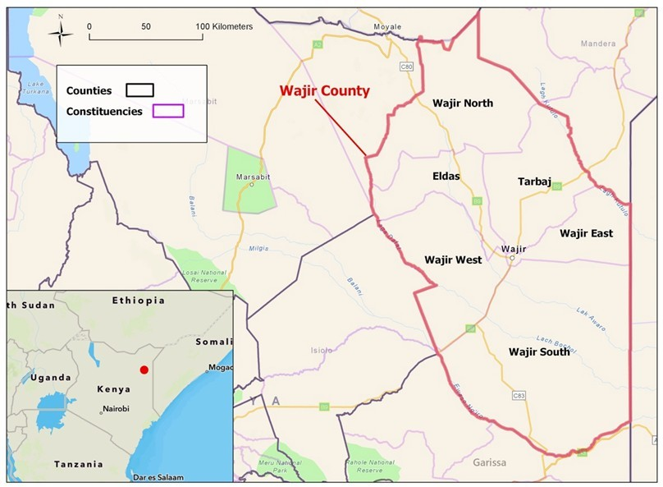
Figure 1: Location of Wajir town

Wajir town, which is the project area, is in the jurisdiction of Wajir East sub-county. Based on the 2019 Kenya Census, it has a total population of 101,247. Wajir town is divided into ten zones, each with an elected zone chief.

Proposed Scope of Works
The treatment plant is anticipated to handle three waste streams; bucket waste, septage and washing station wastewater (construction ongoing). As discussed in the previous chapter, most residents of Wajir use buckets for waste containment, with fewer relying on septic tanks. The proportions of septage and bucket waste are expected to shift over the plant's design life. Additional inflow is expected from the form a bucket washing station at the FSTP. The bucket-washing facility is recommended to clean used buckets before their reuse. Currently, the bucket cleaning station is under construction at the proposed FSTP site. It will feature dedicated areas for cleaning, disinfecting, and drying buckets.
Peak inflows are projected for the medium term (2035), with estimated cumulative flows reaching 49 m³/day.
Table 2below summarizes the expected inflows throughout the plant's design life. The proposed designs are based on these maximum expected inflows for treatment.

Table 2: Design flows 2025-2045

Source | 2025 | 2035 | 2045
Bucket waste | 20 | 24.4 | 9
Septic tanks | 9 | 17.4 | 21
Improved toilets | 1 | 5.2 | 9
Washing station wastewater | 1 | 2 | 1
Total in m3/day | 31 | 49 | 40

The faecal sludge characteristics adopted in the design were determined based on the proportions of inflows from the various sources. Table 3below summarizes the average characteristics of the faecal sludge streams of the proposed FSTP.

Table 3: Weighted average faecal sludge characteristics of proposed FSTP

No. | Parameter | Unit | Design Influent Bucket Sludge | Design Influent Septage | Design Influent Wash  Station Wastewater | Weighted Average Influent Characteristics
1 | Flow | m3/day | 22 | 25 | 2 | 49
2 | Biochemical  Oxygen Demand (BOD5) | mg/l | 189,956 | 305.925 | 200 | 95,000
3 | Chemical Oxygen Demand  (COD) | mg/l | 298,261 | 742 | 300 | 149,000
4 | Total Suspended Solids (TSS) |  | 50,442 | 327.1675 | 100 | 25,000
5 | Electrical  Conductivity (EC) | µS/cm | 2,780 | 4,960 | - | 3,691
6 | pH | - | 7.0 | 8.3 | 6.5-8.5
7 | Total Dissolved Solids (TDS) | mg/l | 46,646 | 1,906 | 200 | 24,000
8 | Total Volatile Solids (TVS) | mg/l | 610.4375 | 29.715 |  | 326
9 | Ammonia  Nitrogen (NH4- N) | mg/l | 2500 | 200 | 200 | 1,000
10 | E. coli | CFU/100ml | - | - |  | 1*10^10
11 | Total Coliforms (TC) | CFU/100ml | - | - |  | 1*10^10

The proposed site for the faecal sludge treatment facility is located 6 Km SE of Wajir CBD and about 5 km from the Airport at 188150 Northing and 615300 Eastings.

The Faecal Sludge Treatment Plant (FSTP) includes the following components:

Table 4: Components of the Wajir FSTP

Component | Number of components
Tanker discharge bay and inlet chute | 2
Screening unit | 2
Holding Basins | 6
Sludge pumping stations | 2
Sludge drying beds | 13
Two primary anaerobic ponds | 2
Two secondary anaerobic ponds | 2
Two facultative ponds | 2
Two maturation ponds | 2
Constructed wetlands | 4
Biosolids drying slabs | 80No. in 2 phases
Generator house | 1
Operations Building | 1
Elevated water storage tank | 1
Guard house | 1
Incinerator | 1
Waste to Value facility | To be developed in future

Project Activities and Processes
The proposed construction of FSTP within the area of interest is anticipated to consist of various activities such as; clearance of vegetation, earthworks and excavation of ponds, transportation of materials, construction of treatment works, construction of the ponds, operation of site management camp and associated facilities, storage of materials, accommodation for project crew, operation of the project and decommissioning of the facilities.

Building Works
These include the following: -
Structural Construction: Erecting buildings and structures required for administrative, operational, and maintenance purposes.
Utilities Installation: Installing water supply, electrical systems, and sewage infrastructure within the treatment plant.
Landscaping and Final Site Preparation: Finalizing landscaping to ensure site integration with the surrounding environment.

Site Works
Clearance of Vegetation: Clearing the site of vegetation to prepare for construction activities.
Earthworks and Excavation of ponds: Excavating ponds and preparing the ground for laying foundations and infrastructure.
Transportation of Materials: Transporting construction materials to the site, including pipes, concrete, and equipment.
Construction of Treatment Works: Building the main treatment structures and facilities for processing faecal sludge and septage.
Construction of Ponds: Constructing settling ponds or treatment lagoons for the treatment process.
Operation of Site Management Camp and Associated Facilities: Setting up temporary camps for project management and providing associated facilities like offices and amenities.
Storage of Materials: Establishing storage areas for materials and equipment needed during construction.
Accommodation for Project Crew: Providing housing and facilities for the project workforce during construction phases.
Operation of the Project: Managing the operational phase of the treatment plant once construction is complete.

Decommissioning of Facilities: Planning for the eventual closure and decommissioning of facilities at the end of their useful life.

Safety and public health requirements

This is an integral part of the project especially during the construction phase. Warning and advisory notices, drugs and condoms would be provided for throughout the project duration. The contractor shall allow for qualified professionals to conduct lectures to the workers regarding the spread of HIV/AIDS.

Environmental Protection

The Contractor is supposed to ensure so far as is reasonably practicable and to the satisfaction of the responsible proponent agent; that the impact of the construction on the environment shall be kept to a minimum and that appropriate measures as brought out in the ESMP are taken to mitigate any adverse effects during the construction. These measures shall include:

    - After extraction of construction materials, all quarries and borrow pits shall be backfilled and landscaped to their original state to the satisfaction of the Engineer. Those near the project road shall be backfilled in such a way that no water collects in them.
    - The spilling of bitumen, fuels, oils, lubricants and other pollutants shall be avoided and if spilt, shall be collected and disposed of in such a way as not to adversely affect the environment.
    - Long traffic diversion roads shall be avoided to minimize the effect of dust on the surrounding environment. In any case all diversions shall be kept damp and dust free.

Estimated Project Budget

The estimated construction cost for the Wajir FSTP has been calculated using recent tender rates from contracts in Kenya, as well as rates provided by manufacturers, equipment suppliers, and local service providers. These costs include all applicable government duties, taxes, and a 16% VAT. A summary of the estimated costs for the various project components is presented below;

Table 5: Estimated Project Costs

BILL NO. | ITEM DESCRIPTION | AMOUNT (KES)
BILL No. 1: | Preliminary And General | 54,898,537
BILL No. 2: | Inlet Works | 6,875,841
BILL No. 3: | Holding Basins - 6no | 68,858,566
BILL No. 4: | Sludge Pump Station - 2no | 31,744,826
BILL No. 5: | Sludge Drying Beds -13no | 131,454,682
BILL No. 6: | Flow Distribution Chambers - 4no | 7,264,366
BILL No. 7: | Primary Anaerobic Ponds- 2no | 9,682,908
BILL No. 8: | Secondary Anaerobic Ponds- 2no | 11,043,681
BILL No. 9: | Facultative Ponds- 2no | 15,186,234
BILL No.10: | Maturation Ponds - 2no | 11,536,126
BILL No. 11: | Constructed Wetlands - 4no | 5,979,747
BILL No. 12: | Biosolids Slabs | 17,795,866
BILL No. 13: | Operations Building | 4,113,389
BILL No. 14: | Guard House | 988,378
BILL No. 15: | Solar Power System | 4,533,762
BILL No. 16: | Generator House And Genset | 5,768,794
BILL No. 17: | Incinerator Shed | 5,179,204

BILL NO. | ITEM DESCRIPTION | AMOUNT (KES)
BILL No. 18: | Fencing And Gates | 3,933,165
BILL No. 19: | External Works | 4,761,272
BILL No. 20: | Civil Works | 22,193,717
BILL No. 21: | Schedule Of Day works (Rates Only) | 4,942,380
 | Sub-Total (A) | 428,735,439
 | Contingencies 10% Of Sub-Total (A) | 42,873,544
 | Sub-Total (B) | 471,608,983
 | Add 16% Vat Sub-Total (C) | 75,457,437
 | Grand Total Sub-Total (B) + Sub-Total (C) | 547,066,420

PROJECT ALTERNATIVES
Analysis of project alternatives for the proposed project considered three possible alternatives / options namely:
- Alternative 1: NO Project” Option
- Alternative 2: the “YES” alternatives
- Alternative 3: The alternative Water sources.
- Alternative 4: Alternative power sources for the intakes

The “no project” alternative

Under the No-Nothing Alternative, no FSTP will be built and operated, and the insanitary conditions associated with the dispersal of raw untreated faecal sludge on lands surround the town will continue. The do-nothing alternative would mean that land and water and ultimately Wajir will continue to be polluted and loaded with untreated faecal matter and potential disease vectors.
This option implies that;

- There will be no improved modern human waste management activities;
- Unavailability of sufficient sanitation services;
- No Improved surrounding of the project area attracting more settlements within the area;
- No Improved infrastructure within the area that will include road upgrading, electricity connection, water connection among others;
- No Increased capacity of the sanitation service chain to accommodate future increased population.
- No employment creation at the local level
- No Boost on investor confidence in the sanitation sector due to un-operational project that has already been invested in.

Therefore, if the no option will be pursued it is likely that we may lose more than what is to be gained if the proposed project is to be implemented.

The ‘yes’ project alternative

This was considered a viable option. This option was considered viable as opposed to the ‘no option’ because the yes project alternative implies that the project be implemented and once implemented there will be a number of gains that will be realized including the following;

- Improved modern sanitation and operation from the proposed project;
- Availability of sufficient sanitation services to the community;
- Improved surrounding of the project area attracting more settlements within the area;
- Improved infrastructure within the area that will include road upgrading, electricity connection, water connection among others;
- Increased capacity of the sanitation service chain to accommodate future increased population.
- Employment creation at the local level
- Boost on investor confidence in the sanitation sector.
- Development and improvement of local infrastructure.

Alternative FSTP Location

Selection of the FSTP location has been done by applying the criteria listed above. There were no options to be considered. The fact that the selected location is located on land that did not require acquisition because it was already Public Land as attached in Appendix 7 and the fact that it is located downwind from the town for most of the year, and still is easily accessible, indicates that few other options would offer a better choice. By the time that the ESIA study started the site had been selected already, and there were no reasons to propose or select another site.

Alternative Sources for Construction Materials

Gravel, hard core stones, aggregates and sand for construction activities will be extracted from existing sites currently used as borrow sites. No other borrow areas will be opened unless the existing ones are depleted and there is an agreement with the regional and the responsible district authorities. Water for the works mainly for preparation of concrete may be drawn from groundwater or nearby streams unless it is determined that this is unsuitable for construction works.

Technology Alternatives

As outlined in Chapter 3 above, the concept design was guided by the requirement to select a low-cost option for faecal sludge treatment.
The Wajir FSTP design phase presents a unique opportunity to incorporate a waste-to-value plant that can address the region's waste management challenges while generating tangible benefits for the local community. By turning waste into valuable resources, the facility can also generate revenue streams that will support its ongoing operations, ensuring that it remains functional and sustainable for years to come. Building on the pre-feasibility study conducted in early 2021, Sanivation is conducting a detailed waste to value feasibility work aimed to validate pre-identified waste-to-value (W2V) options for Wajir. Sanivation is collaborating closely with WAJWASCO to select the most suitable W2V concept for the Wajir FSTP. Sanivation's approach includes the following key activities;

- Market Analysis: Conduct a detailed market analysis to understand the potential demand and value of different reuse options.
- Business Model Development: Build out potential business models for validated W2V options
- Finalization of W2V Concept: Finalize the process flow, technology, and concept for the chosen W2V option, completing the feasibility work for the project.
Space has been reserved in the current layout to allow for future incorporation if the study determines waste to value to be feasible.

The ESIA study team has considered no other technical alternatives.

SOCIO-ECONOMIC AND ENVIRONMENTAL BASELINE INFORMATION

Biophysical Environmental Baseline

Topography
Wajir County is mainly made of plains starting from 150 meters and rising to 460 meters above sea level. There are some hills in the Northern part of the county on the border with Ethiopia, that is, Malaba hills, which is a gazetted forest. Also a non-gazetted forest covers the lower parts of Wajir North towards Korondile.
The county does not have any natural water bodies such as lakes and rivers. However, during rainy seasons, some waterways have water flowing from the Northern Hilly areas towards the southern low lands for a short period. The government and some private initiatives have excavated earth pans to collect rainwater for livestock and domestic use. The area sometimes experiences flooding during the rainy seasons creating seasonal swamps, which together with drainage lines serve as grazing zones during dry season and are used for cultivation during the rainy seasons. These seasonal swamps are in Lagboghol and in the western and southern parts of Habaswein.

Climate
The average precipitation is 240mm Annually. Historical data show that July is the driest month with an average of 1mm of rain; while April is the wettest month with an average of 68mm. The Northern parts of the county, Bute, Gurar and surrounding areas receive higher rainfall of between 500 and 700mm. Average temperature is 27.90°C; The warmest months are February & March with an average of 36°C while the coolest months are June, July & August with an average low of 21 °C.
The County experiences frequent droughts especially from June to September, which impact negatively on livestock, crop farming, education, nutrition, access to water and pasture. On the other hand, rain sometimes cause flash floods which damage infrastructure and may kill goats and sheep. The frequency and intensity of the extreme climatic events has been increasing in the recent past disrupting the livelihood of the communities.

Geology and Soils
Geology: Wajir County is part of the broader geological formation of the Eastern Rift Valley in Kenya. Sedimentary rocks, volcanic formations, and alluvial deposits characterize the region. Specific geological studies and maps for Wajir County may be found in reports and publications from the Geological Society of Kenya or academic institutions conducting research in the area.
Soils: The soils in Wajir County vary but are generally sandy and characterized as arid and semi-arid soils. They often have low organic matter content and fertility. Soil types include sandy loams, sandy clays, and in some areas, calcareous soils. Soil fertility and composition influence agricultural practices and water retention capabilities, which are crucial for sustaining livelihoods in the region.

Flora
Flora in Wajir County, Kenya, primarily consists of vegetation adapted to semi-arid to arid conditions. The plant life in this region plays a crucial role in sustaining local ecosystems and supporting livelihoods. Here. Some key aspects of the flora in Wajir County are; acacia species trees, which are prominent within the area, they are well adapted to arid environments and provide important resources such as fodder for livestock, wood for fuel, and shade, Commiphora Species: Species within the Commiphora genus, such as Commiphora africana (African Myrrh). Local communities know these shrubs for their resin and medicinal uses.

The flora of Wajir County not only supports local biodiversity but also plays a crucial role in providing ecosystem services and sustaining the livelihoods of pastoralist communities. Conservation efforts and sustainable land management practices are essential for preserving this fragile ecosystem. The distribution of flora in Wajir County varies with altitude and soil type. In lower-lying areas, you find more drought-resistant species, while higher elevations may support different types of vegetation adapted to slightly cooler and more humid conditions.
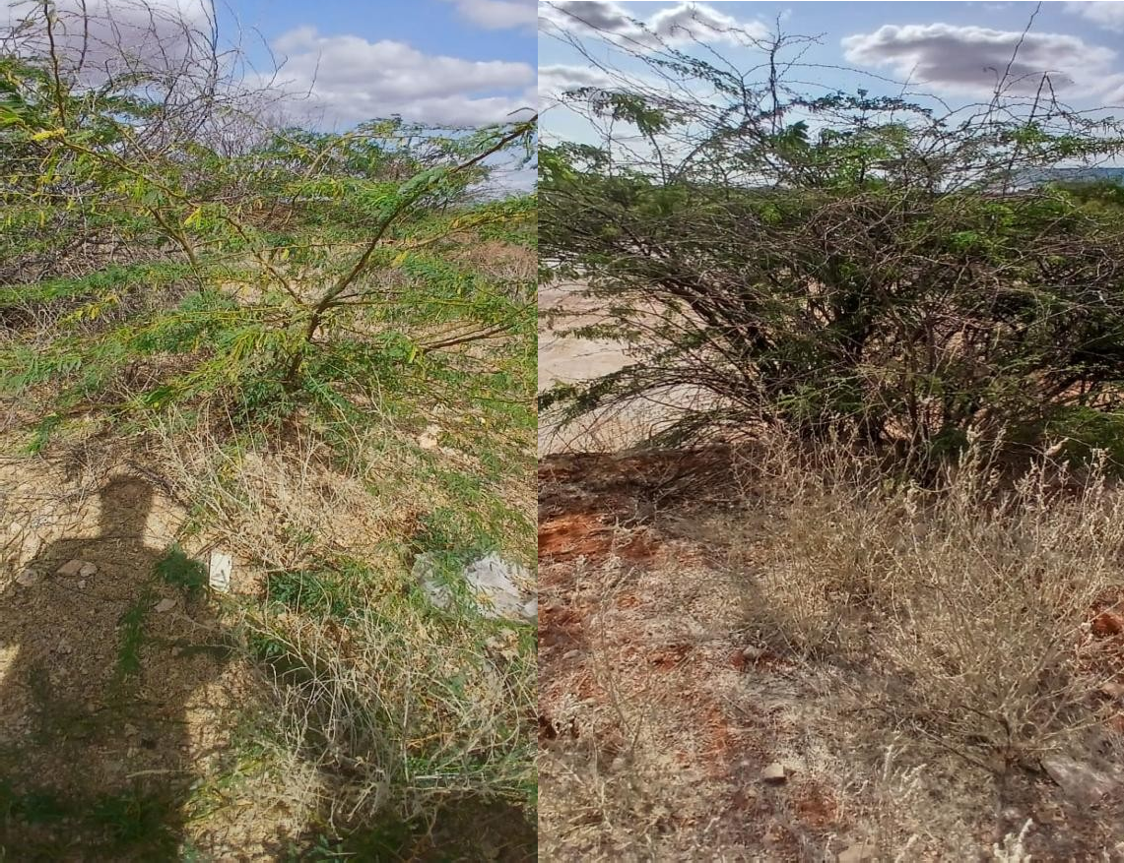
Figure 2: Plant cover in the proposed project site

Fauna
The project area has few animals. Marabou storks, goats, sheep, cows, camels among other animals are animals that are present within Alimaow area, which is the proposed project site.
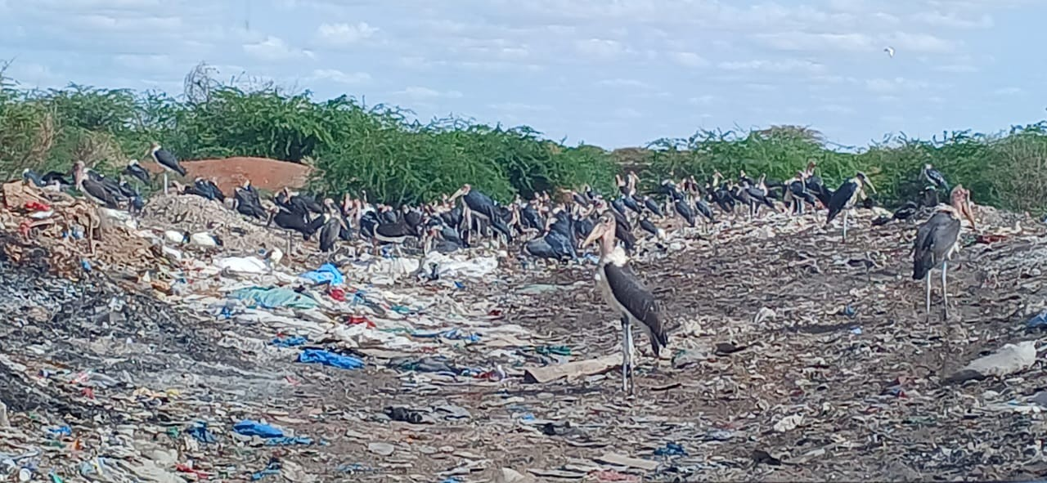

Figure 3: Marabou stork in the existing dumping site

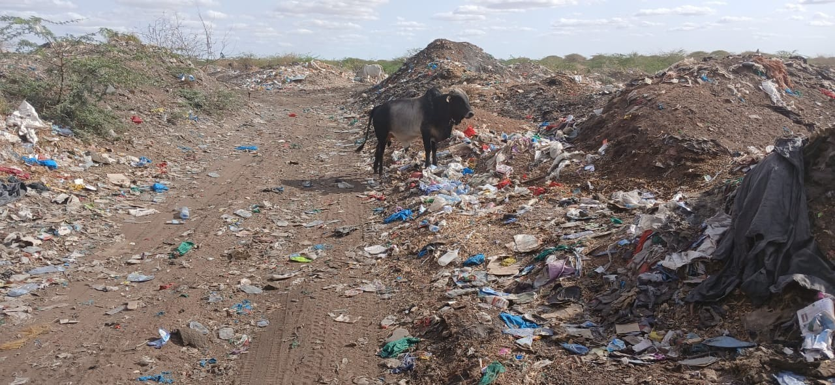

Figure 4: Cow at the proposed site

Ecological Conditions
Wajir has approximately 10,000 km2 of arable land out of which, 8,400 ha are under food crop production in the higher altitude regions (DALF, CGW); Available data shows that the county has a food poverty rate of 72% and majority of its inhabitants depend primarily on relief support including relief food and social protection programs because the acreage under food and cash crops is low and poverty levels are very high. The agricultural sector (mainly livestock keeping) accounts for 85% of Wajir County household income. Nomadic pastoralism is more prominent in the county and defines the lifestyle of most of the county’s inhabitants. The main livestock bred include cattle (Boran), camel (Dromedary Somali type), goats (Galla), sheep (Black head Persian), donkey and poultry (indigenous birds and hybrid layers) which is mostly practiced in Wajir Town.
The historic climate scenario in the last decades showed an increase in drought and a moderate increase in temperature in the first wet season (January – June); the Second wet season (July- December) was characterized by an increase in precipitation and a lower increase in mean temperature. Models of future climate projections show that Wajir County will remain highly susceptible to drought and high temperatures. Over the next decades, we expect high increases in the length of drought spells, moderate increases in mean temperatures and moderate decreases in intense rain in both seasons.

Socio-Economic Baseline

Administrative and Political Units
The County has six constituencies namely: Wajir South, Wajir North, Wajir East, Wajir West, Eldas and Tarbaj; and thirty (30) wards. The County Government uses the six constituencies as administrative areas/units of devolution. Effectively, as at October 2022, the County Government has six sub-counties each headed by an administrator. Critical services such as health, revenue, public works, roads, and water have offices and officers deployed and stationed at the Sub-counties. There are plans to deploy economic planning staff to operationalize the offices to offer coordination of the county government services as well as linkages with the national government and development partners at the sub-county level. However, the village administrative units have not been operationalized.

Table 6: County Government Administrative wards

Sub-County | No. of wards
Wajir East | 4
Eldas | 4
Tarbaj | 4
Wajir North | 7
Wajir South | 7
Wajir West | 4
Total | 40
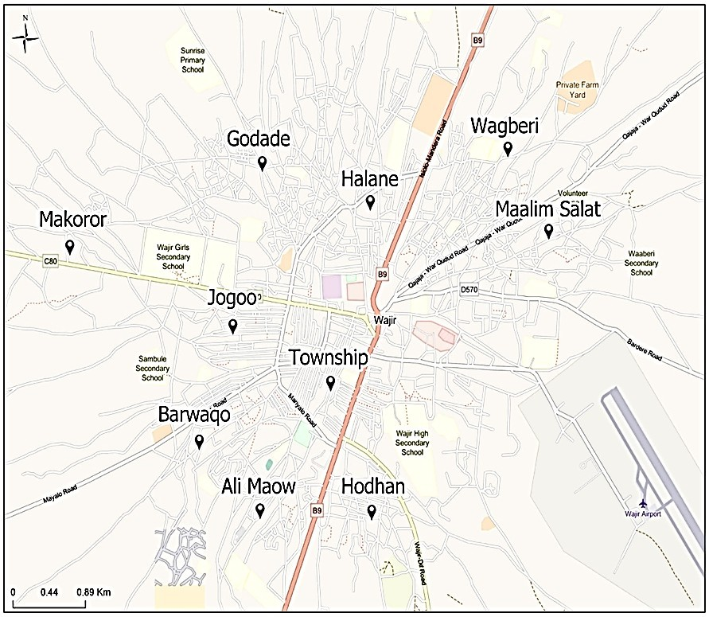

Figure 5: Layout of Wajir Town Showing the different Zones Source; Design report
Regarding national government administration, there are 14 administrative sub-counties namely Wajir East, Wajir South, Habaswein, Tarbaj, Wajir West, Eldas, Wajir North, Buna, Wajir South, Hadado, Diif, Sabuli, Khorof Harar and Korondile.

Demographics
Population Size, Composition and Distribution
The 2019 Kenya Population and Housing Census indicate that the county had a total population of 781 214 which is projected to reach 848,385, 915,082 and 964,154 in 2022, 2025 and 2027 respectively. Males comprise 50.4 percent of the population and female population accounts for the remaining 49.6 percent. According to the KNBS analytical report and projections, the county is projected to record the following statistics between 2020 and 2025: a net migration of -2,039; 134,111 births; 20,815 deaths; crude birth rate of 31.2/1,000; and crude death rate of 4.8/1,000.
Guided by the Urban Areas and Cities Act No. 13 of 2011 as amended in 2019, the county has six urban areas consisting of Wajir Municipality, Habaswein, Bute, Eldas, Griftu and Tarbaj Towns. The urbanized population stand at 23 percent which is projected to slightly grow to 25 percent by 2027. The urban population is projected using the 4 percent national average urbanization growth per annum. Wajir Municipality carries the highest urbanized population at 51 percent, followed by Habaswein at 28 percent while Bute, Eldas, Griftu and Tarbaj stand at 8 percent, 7 percent, 4 percent and 2 percent respectively.

Population Density and Distribution
Wajir has an average density of 15 persons per square kilometer as at 2022, this is projected to grow to 17 persons by 2027. In Table 7. in terms of sub-counties, Tarbaj is the least densely populated at 6 people per square kilometer as at 2022, slightly growing to 7 people by 2027. Wajir East is the most densely populated standing at 30 persons per square kilometer in 2022 and growing to 34 by 2027.

Table 7: Population Distribution and density by Sub-County

Sub- County | 2019  Census | Land Mass | Density | 2022  Projections | Density | 2025  Projections | Density | 2027  Projections | Density
Wajir North | 112,083 | 7,930 | 14 | 121,720 | 15 | 131,289 | 17 | 138,330 | 17
Eldas | 88,502 | 4,492 | 20 | 96,112 | 21 | 103,668 | 23 | 109,227 | 24
Wajir South | 290,929 | 21,646 | 13 | 315,944 | 15 | 340,782 | 16 | 359,057 | 17
Tarbaj | 57,227 | 9,608 | 6 | 62,148 | 6 | 67,033 | 7 | 70,628 | 7
Wajir East | 110,651 | 4,053 | 27 | 120,165 | 30 | 129,612 | 32 | 136,563 | 34
Wajir West | 121,822 | 9,044 | 13 | 132,297 | 15 | 142,697 | 16 | 150,349 | 17
Total | 781,214 | 56,773 | 14 | 848,385 | 15 | 915,082 | 16 | 964,154 | 17
Source: Wajir CIDP 2023-2027

Population Projection by Broad Age Groups
Wajir has a relatively young population, table 8 shows that the youth constitute 34 percent of the county population. Children of school going age constitute over 40 percent of the population in 2022 and is projected to slightly decrease to 37 percent by 2027. Children under five constitute 16 percent of the county population. The challenges facing this group include: malnutrition, low immunization coverage and low enrolment in ECDE.

6.1 percent of the population is in the category of ECDE as at 2022, projected to slightly decrease to 5.6 percent by 2027. The population that is economically active stand at 53.4 percent in 2022, slightly growing to 57.3 percent by 2027. This implies that the dependency ratio is consistently decreasing over the plan period although at a slow pace. The older persons, 65+, constitute a small proportion of the population remaining around 1.6 percent over the plan period. The dominant Somali community’s cultural practices of taking care of the elderly within the family structures is expected to partly take care for this segment of the society. In addition, the national and county governments must continue and upscale social protection for the elderly, OVCs, most vulnerable and severely disabled segments of the county population.

Population of Persons with Disability
The population of persons living with disability in the county by category; there is a population of 6,886 persons that lived with disability at the time of census in 2019.
In terms of category, most of the people with disability have a problem with mobility at 23.7 percent of the population, followed by difficulty with self-care at 20.2 percent and cognition problem at 18.4 percent. The least is difficulty in hearing at 11 percent.
Geographically, Wajir South constituency has the highest population of people with disability at 36 percent, followed by Eldas at 29 percent and Tarbaj has the least at 5 percent.
Table 8: Key Population Data Wajir Town

Sub location | Population
 | 2019 | Current -2025
Township | 3,638 | 3,882
Halane | 9,332 | 9,957
Wagberi | 9,775 | 10,430
Maalini Salat | 10,640 | 11,353
Hodhan | 2,781 | 2,967
Barwaqo | 8,498 | 9,067
Alimaow | 3,819 | 4,075
Jogoo | 11,110 | 11,854
Jogbaru | 22,122 | 23,604
Total Population | 83,734 | 89,209

Literacy Levels
The education sector analysis reveals that the gross enrollment for ECDE stands at less than 37 percent with only around 19,000 children enrolled against an eligible population of over 51,000 children. In primary schools, gross enrollment is reported at around 35 percent with approximately 70,000 children in school against a projected eligible population of over 200,000 in 2022. Secondary education figures depicts an even worse performance with gross enrollment standing at around 22 percent; approximately 20,000 children are in school against a projected eligible population of over 93,000 children.
In our study area which is Alimao village, Furaha village and Wajir township, 10% of the sample population has attained university education, 20% tertiary education, 16% secondary education, 14%

primary education, and 40% no form of education as their highiest level of education. And 68% of the children in the survey attend school where as only 32% do not attend school; as shown in the pie charts below;

Highiest level of education
10%
None
Primary
20% 40% Secondary Tertiary
University

16%
14%

Figure 6: Highiest level of education
children going to school

Not going to school

Going to school

Figure 7: Children going to school

Access to Health services
Half of Women in the County deliver in non-healthy facility (50%) compared to the national average of 14%. Delivery in Non-health facility predisposes women to maternal mortality. The national average for deliveries in Health facility is far much higher than that of Wajir County at 49.2%.
In Wajir County, malnutrition rates are alarmingly high at over 15 percent. Gross enrolment rate for ECDE stands at 37% while immunization coverage stands at 68 percent against a national average of 84%. Children access to basic social services is impeded by poverty in all its forms and dimensions. Child poverty stands at 81% (KNBS 2019) where nutrition poverty stands at 53% and monetary poverty stands at 84%. This has serious implications for child wellbeing, development and survival. Key

Strategies for tackling these problems will be a priority in this medium-term plan to ensure improvement of children situation in the county.
There is a dispensary that is located approximately 2 km away from the proposed site for the faecal sludge treatment plant. 82% of the sampled population did not express satisfaction in the available health facilities and health services being offered. Most of them walk long distances to access medical services, which most of the times they are expensive thus most of the people do not afford.
To the north east of the proposed FSTP project site, exactly 4.26km is the Wajir TB Manyatta hospital.
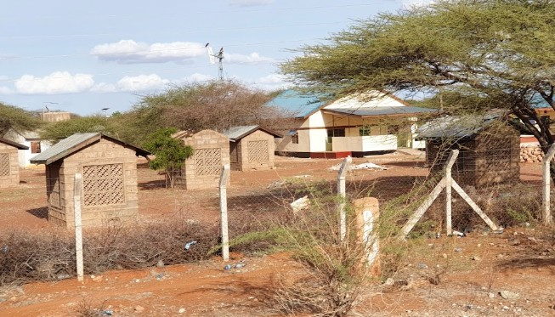

Figure 8: TB Manyatta hospital

Transport
The Roads Sector was able to achieve 28km of Tarmacked roads in Wajir County out of 43km targeted during the plan period of the Wajir County Integrated Development Plan of the year 2023-2027 under review. A total of 70kms were covered under graveled roads from the target of 870km. The number of drifts constructed during this period was 22 as against a planned target of 80. Targeted. expanded and bush cleared roads in the period accounted for 2050km as against a planned target of 5000km. Further, graded roads increased from 1000km to 3420km during the plan period though some remain repeat activities after every rainy season while 20kms of tarmacked roads were maintained against a planned target of 28km.
The Housing Department was able to renovate 30 houses out of a target of 50. With regards to training of artisans under the Appropriate Building Technology (ABT) Programme, 600 artisans were successfully trained. No new ABT centers were constructed during this period, and no ABT blocks were manufactured due to breakdown of the ABT machines.
The roads in the proposed area are murram roads that are overly dusty, and is accessed from the Wajir town by Isiolo-Mandera Road/ B9.

Sanitation
For solid waste management, only Wajir municipality has a collection and disposal system. But even the municipality system is not able to collect 100 percent of the garbage generated daily. According to the 2019 KPHC, the County Government collects solid waste from only 22.3 percent of the households in Wajir East. The figure is even much lower for the county average with only 5.7 percent of households having their waste collected by government.

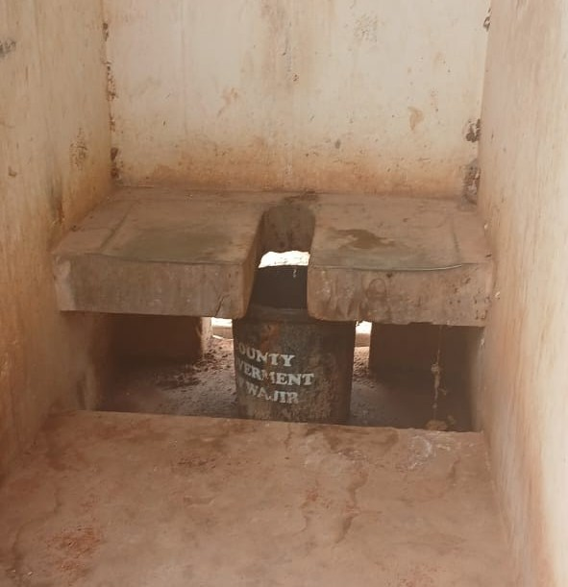
Wajir Municipality faces crippling challenges in sanitation services due to lack of proper waste management system and inadequate water supply coupled with high e-coli levels. The KPHC 2019 shows that 46.3 percent of the Wajir East Households still use buckets as the main mode of human waste disposal. In the medium term, the Government will prioritize investments to improve access to portable water and improved sanitation in Urban Areas.
Further, environmental pollution resulting from lack of a proper solid waste management system and exposed dumpsites is a big challenge in Wajir Municipality and all other urban areas in the county. Plastic waste is a major contributor of the situation of poor sanitation. This situation hampers investments and general business environment in the County. In the medium term, the Government will prioritize investments in both liquid and solid waste management system including operationalization and proper management of the existing dumpsite in Wajir. Overall, only 46% of residents in Wajir County use improved sanitation, while the rest use unimproved sanitation.

Table 9: Key Sanitation Systems in Wajir Town

Sanitation System | Bosch, MIBP, (2017) | Sanitation Assessment Report (2021)
Sewer System | 0% | 0%
Septic tank | 9% | 11%
Bucket toilets | 50% | 76%
Improved Toilet | 3% | 2%
Unlined Pit |  | 6%
Open defecation | 38% | 5%
 | 100% | 100%

Figure 9: Bucket toilet
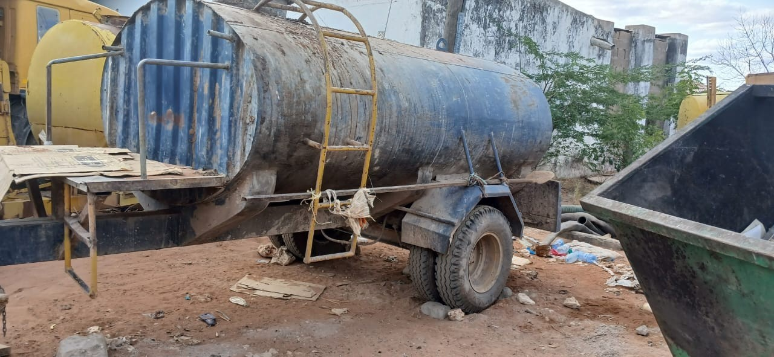

Figure 10: Open transport truck
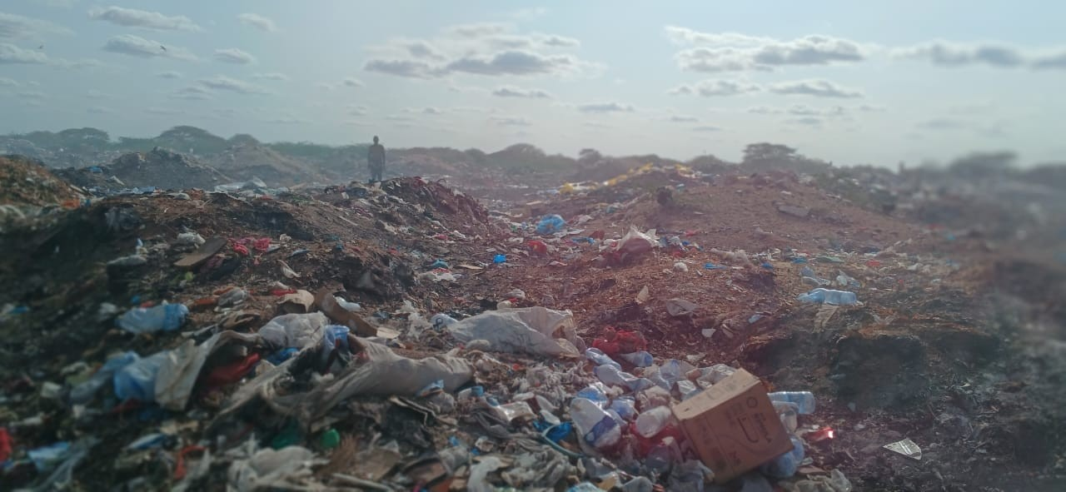

Figure 11: Existing dumpsite in Alimaow

From the survey, most of the solid wastes are burned and disposed irregularly, with the least disposed to landfills.
0% 5% 10% 15% 20% 25% 30% 35%
15%
Municiplaity
10%
Disposed to landfill
20%
Disposed to wild disposal area
25%
Disposed irregularly
30%
Solid waste managemnet
Burning

Figure 12: Solid waste management

Water resources
In Wajir County, 49 % of residents use improved (safe) sources of water, with the rest relying on unimproved water sources. There is a significant variation in safe drinking water where 55.4 percent of rural and 35.7 of urban use unsafe water. Safe/Improved sources of water comprise protected spring, protected well, borehole, piped into dwelling, piped and rainwater collection while unimproved sources include pond, dam, lake, stream/river, unprotected spring, unprotected well, jabia, water vendor and others.
Bute town has a serious problem operating without a water supply system and relying on water pans for most part of the Year. The proposed Bute dam to be implemented by the National Government is expected to solve this problem once it is constructed. Habaswein and Eldas towns have existing water supply systems although they do not cover 100 percent of the townships. Eldas has an ongoing flagship water project, that is, Anole Water Supply that is aimed at extending the current system to the outskirts of the town. The flagship project is implemented by the National Government. On the other hand, Habaswein will have to be prioritized in this current plan to be able to increase the water supply coverage as well as respond to the expected future growth. Griftu Town has an existing supply system, with a relatively high yielding borehole as the main source. However, the peripheral settlements in the town remain underserved with residents walking long distances and spending long hours to collect water for both domestic and livestock use. Tarbaj has a supply system that is sourced from Sarman. The borehole supplying the town has relatively good yield to sustain the town while the water pipeline system has a problem that needs to be repaired well. Frequent breakages are reported on the pipeline making the town go without water for long periods.
Water sources
80%
70%
60%
50%
40%
30%
20%
10%
0%
Buy from water vendors
Water pump
Borehole/well Rain water
Tap water

Figure 13: Water sources

According to the bar graph above, the data collected from the sample population shows that 10% of the people buy water from water vendors, 10% from water pumps, 70% from boreholes and wells, including shallow wells, 5% from rain water and 5% from tap water. Most of the people are not satisfied with the water supply system in the community, as the water is not clean and salty apart from it being inaccessible as people have to walk long distances of up to 5km to access water.

Land Use and Land Tenure
Urban Land use refers to spatial distribution of social and economic activities. Accordingly, an up-to- date land use inventory is frequently required to facilitate urban planning and growth patterns as well as monitoring urban expansion. The entire county is categorized as trust land apart from a small percentage of the total area occupied by townships. The survey process for part of Wajir town was done and owners’ allotment letters issued. The county is also in the process of preparing physical development Plans for seven towns namely Habaswein, Griftu, Eldas, Bute, Tarbaj, Khorof Harar and Hadado and County Spatial Plan to guide development planning. The land is mostly used communally for nomadic pastoralism. However, some small areas are under small-scale agriculture by individuals or groups. The land survey process should be fast tracked with the view of enhancing gender equity.

Housing
In terms of housing, there is no data available that disaggregated by rural and urban statistics. The KPHC 2019 statistics show that 120,367 of the households (HH 94.9 percent) in the county own the dwelling unit they live in, only 5.1 percent live in rented units translating into 6,503 households. Of the rented units, 51 percent are found in Wajir East, essentially within the Municipality. Individuals have the highest proportion of units available for rental accounting for 74.8 percent. The National Government accounts for 10.3 percent of the rental units, County Government 6.2 percent of the units, parastatals
1.6 percent, private companies’ 6.4 percent and NGOs/FBOs/ Mosque/Church accounting for the remaining 0.7 percent.
As the general population and the density grows, it becomes imperative to have a spatial plan to secure the rangelands and grazing resources that are a backbone to the livelihoods of the majority of the residents. In most community discussions, new settlements have been identified as the biggest single threat to the sustainability of livestock production as currently structured. There is general agreement that new settlements are politically driven and there is need for both the county and national administrations to reign on the haphazard manner in which new settlements are established. The spatial plan will provide an important basis for evidence-based policies in controlling rampant establishment of new settlements that can be a threat to the environment, rangelands, grazing and other natural resources.
The houses in the proposed project area and Wajir County as a whole are a mixture of Manyattas, semi- permanent and permanent houses.
With the Manyattas made of stick, mud and fabric. Permanent houses made of stone walls and corrugated iron sheets.
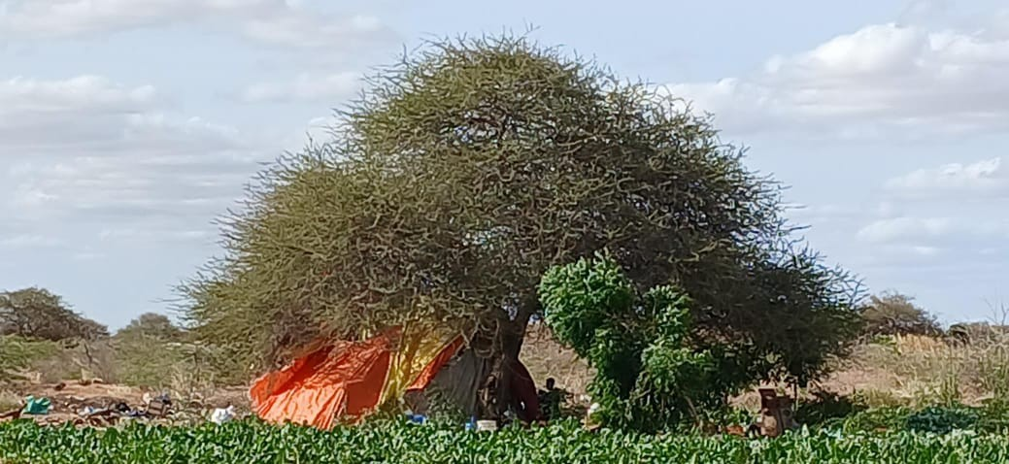

Figure 14: Manyatta house at homestead.

Youth
The youth population is faced with myriad of challenges that include: high unemployment, illiteracy, drug abuse, radicalization and lack of basic life skills. The multidimensional poverty incidence for the youth between age 18-34 years is 87.4 percent. The government shall institute policies to upscale programs for youth job creation and empowerment initiatives, as well as programs for family affairs, eradication of drug abuse and counter violent extremism.

Cultural and archeological baseline

Cultural baseline
Wajir, located in northeastern Kenya, is a region rich in cultural and archaeological significance, with a deep history influenced by various factors, including its geographic location and the diverse communities that have lived there.
Wajir is predominantly inhabited by Somali ethnic groups, primarily the Ogaden, Ajuran, and Degodia clans. The Somali culture in Wajir is characterized by a nomadic pastoralist lifestyle, where livestock herding, particularly of camels, goats, and sheep, is central to their way of life. The Somali language is widely spoken in Wajir, alongside Swahili, which is common across Kenya. Islam is the predominant religion, with the majority of the population adhering to Sunni Islam, which plays a significant role in shaping the cultural practices, social norms, and daily life in the region.
The people of Wajir maintain a strong connection to their traditional practices, including oral literature, poetry, and traditional music. The region is also known for its traditional conflict resolution mechanisms, such as the "Xeer" system, which is a customary law practiced among the Somali people.

Archaeological Baseline

Wajir has a rich history that dates back centuries. The county has several archaeological sites that indicate early human settlement and activity. Located in Wajir town, there is a museum showcases artifacts and exhibits that highlight the cultural history of the region, including traditional tools, weapons, and household items used by the local communities.
The region contains several rock art sites, which are important archaeological and cultural landmarks. These rock paintings and carvings are thought to represent the lives and beliefs of the early inhabitants of the region.
Archaeological evidence in Wajir also points to the influence of Islamic culture, which arrived in the region through trade routes from the coast. This is evident in the ruins of old mosques and Islamic graves, which are part of the region’s historical heritage.
Presents the procedure to be followed in the event of a chance find within the project sites.

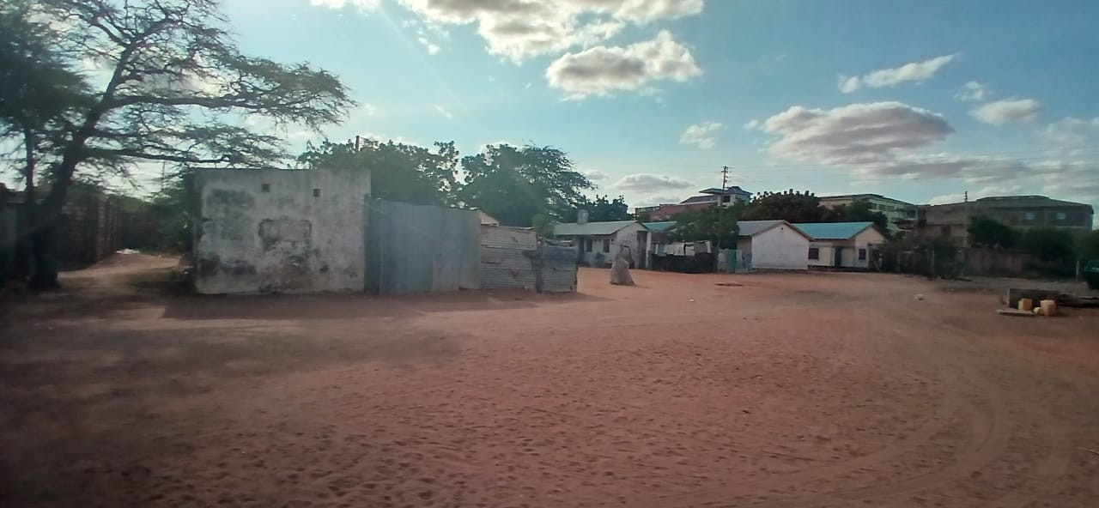

Figure 15: Old buildings in the Wajir prisons compound

There is the small Wajir War Cemetery containing only two graves, which measures approximately 78 square meters, which is a pale shadow of the far-reaching history of wars witnessed in Wajir. It contains one of the two graves that was brought in during 1929 from Rhamu, found 318 km further north. The war cemetery is attached to a Government station (formerly known as Archer’s Post) set close to the boundary of Italian Somaliland (Somalia).
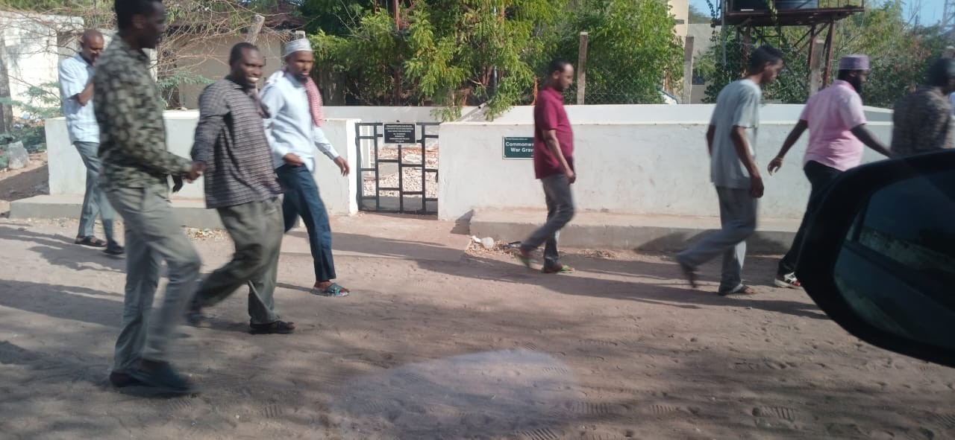

Figure 16: Common wealth war graves

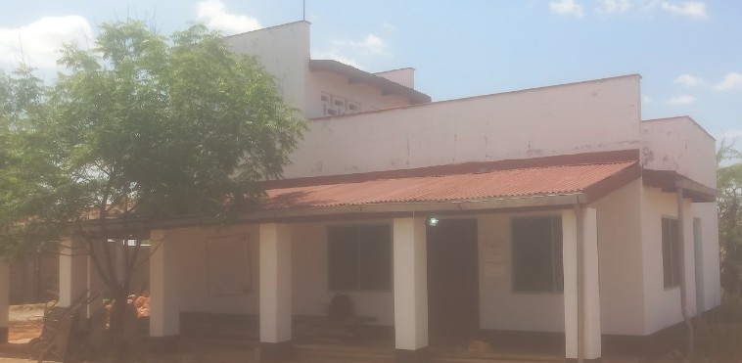

Figure 17: Wajir museum

POLICIES, LEGAL AND INSTITUTIONAL FRAMEWORKS

National Laws and Regulations

Table 10: Applicable National Laws and Regulations

Law/Regulation | Objective | Application
The Environmental Management and Co- ordination Act, (EMCA) 1999 and amended in 2015 and subsequent Regulations. | Supervision and coordination of all matters relating to the environment | Guidelines for mitigating adverse environmental impacts
Occupational Health and Safety Act 2007 CAP 514 | Makes provision for the health, safety and welfare of persons employed | The contractor will have to follow this law as he is expected to have employees during the project period.
The Public Health Act 1986 revised 2012 (Cap  242) | Principle instrument for ensuring the health and safety of the people. | Measures need to be placed to ensure the health and safety of the community during the project period.
The Physical and Land Use Planning Act, (PLUPA) 2019 | Provides for the preparation and implementation of physical and land use development plans | The legislation provides mechanisms for spatial planning and land use management and addresses the management land resources.
National Construction Authority Act No. 41 of 2011 | Encourages the standardization and improvement of construction techniques | The project involves construction activities
Sustainable Waste Management Act 2021 | Provide guidelines on solid waste management on project cycle | Mitigate potential solid waste productions during construction stages and the entire proposal on waste management systems
Children Act (2001) and revised 2016 | Children are being protected from child labour and all forms of violence | Construction camps are likely to interact with children it is mandatory the follow the law to avoid child exploitation. This act also prevents sexual exploitation and child labour.
County Government Act (2012) | Outlines the framework for the establishment, functions, and operations of county governments in Kenya.  It also aims to empower citizens by ensuring inclusive public | Promotes decentralization, enhancing local governance, and fostering sustainable development in Kenya by empowering county governments to effectively manage resources and deliver services to their constituents.

Law/Regulation | Objective | Application
 | participation in governance, enhancing transparency and accountability. | In the Wajir FSTP project, these provisions can be applied by engaging local communities in planning and decision-making, sharing information, and establishing feedback mechanisms to incorporate their input and concerns.
Work Injury Benefits Act, 2007 | Provides for compensation to employees for work related injuries and diseases contracted in the course of their employment and for connected purposes. | During construction works cases like injuries and diseases may occur on site, this law is meant to protect all employees.
Water Act (2016) | The Act states that every person in Kenya has the right to clean and safe water in adequate quantities and to reasonable standards of sanitation | The Act defines ownership of and rights in water resources of Kenya.
Sexual Offences Act (2006) | Protection of all persons from harm from unlawful sexual acts, and for connected purposes.  The Act aims to protect individuals from sexual abuse and violence, providing mechanisms for addressing, preventing, and mitigating sexual offenses. | Sexual vices are expected to impact the society and as such a law will regulate such Incidences from occurring  By implementing these mechanisms under the Sexual Offences Act (2006), the Wajir Faecal Sludge Treatment Plant (WFSTP) can minimize the risks of sexual offenses and ensure the safety and protection of both the project workforce and the surrounding community. Active enforcement, awareness, and support services are key to creating a safe working and living environment during the project's lifecycle.
Climate Act (2016)  Revised 2023. | It includes more ambitious greenhouse gas reduction targets, enhanced climate adaptation strategies, and new areas of focus like renewable energy and carbon capture. | It encourages public and private sector collaboration, public awareness, and aligns national efforts with international climate goals. The aim is to accelerate progress toward mitigating climate change and ensuring sustainability.
Urban Areas and Cities Act(2011) | Promote efficient governance, sustainable development, and inclusive participation in urban areas. | The Act focuses on economic development, infrastructure investment, environmental management, and enforcement of regulations.
EMCA regulations on  ( Noise, Waste | The Act provides a framework for  regulating various environmental | The Act has specific procedures and  practices aimed at addressing

Law/Regulation | Objective |  |  | Application
management, Air | concerns | through | specific | environmental concerns effectively
Pollution, Excessive | regulations.
Vibrations and Noise,
Water Quality
Regulations, Extended
Producer Responsibility
Regulations

County Laws and Regulation

Table 11: County Laws and Regulations

Law | Objective | Application
County Government Act No.17 of 2012 | The Act empowers the county government to be in charge of function described in Article 186 of the constitution, (county roads, water and Sanitation, Health), Part XI of the Act vest the responsibility of planning and development facilitation to the county government with collaboration with national government.  The County Government Act No.  17 of 2012 of Kenya outlines comprehensive provisions for public participation, emphasizing the involvement of residents in governance and decision-making processes at the county level. | The proponent will work in liaison with Wajir County Government.  For the Wajir Faecal Sludge Treatment Plant (WFSTP), these provisions mean that the county government must involve the local community in decision- making, from planning and design to monitoring and feedback, ensuring transparency, accountability, and alignment with public needs
Wajir County Climate Change Fund Act, 2016 | The Act puts in place the framework and mechanisms for mobilization and facilitation of communities and other stakeholders in the county to respond effectively to climate change and for connected purposes. | The project aligns with this act reason it involves construction of shallow wells that will increase water supply during the drought seasons.

National Policy Framework

Table 12: Applicable Policies

Policy |  | Objective |  |  | Application
Kenya Vision 2030 |  | Transform Kenya into a middle- income country.  Kenya Vision 2030 aims for economic growth, social equity, political stability, infrastructure development, environmental sustainability, and technological innovation. |  |  | The Wajir FSTP project contributes to these objectives by enhancing local economic activities, ensuring inclusive participation, improving sanitation infrastructure, promoting environmental protection, and fostering innovative waste management practices.
The National Environmental Action Plan (NEAP) 1994 |  | Integrate environmental considerations into the country’s economic and social development initiatives/plans. |  |  | Help in minimizing environmental impacts of project activities.
Policy Paper on Environment and Development 2014 |  | To ensure projects take environmental considerations into account projects take environmental considerations into account |  |  | Potential impacts on the environment and involvement of the public in project planning
The National Water Resources Management Policy (1999) |  | It, calls development of appropriate sanitation systems to protect people’s health and water resource from any source of pollution. |  |  | Provides measures to minimize the disruption of natural drainage patterns
HIV and AIDS Policy 2009 |  | Setting Minimum Internal Requirements (MIR) for managing HIV and AIDS |  |  | The Contractor will in cooperate in tender document and implement HIV awareness initiatives during implementation of the project.
Gender Policy 2011 |  | Mainstream gender concerns |  |  | This policy will be referred to during Project implementation especially during hiring of staff to be involved in the project to ensure men , women and youth are provided with equal opportunities in project
Sessional Paper No. 7 of 2005 on National Employment Policy and Strategies for Kenya |  | Guarantee safe working environment | and | peaceful | During construction and demolition phase of the project there will be employment.
Sustainable Management 2021 | Waste Policy | The goal of this Act is to promote environmentally sound and economically viable practices for managing waste. |  |  | The project designed to effectively implement the policy’s objectives, ensuring a comprehensive and sustainable approach to waste management.
Kenya | Youth | Highlights the importance of youth |  |  | The Wajir FSTP project offers a

Policy | Objective | Application
Development Policy 2019 | in the development of Kenya and the country's Big Four Agenda, Vision 2030, and Sustainable Development Goals. The policy places an obligation on the youth to be productive, patriotic, and active participants in society. | unique platform for youth to actively participate in Kenya's development. By engaging in such projects, young people not only fulfill their obligation to be productive, patriotic, and active participants in society but also contribute to national goals such as the Big Four Agenda, Vision 2030, and the SDGs. The project can empower the youth to drive change in the sanitation sector while enhancing their economic prospects and contributing to a healthier, more sustainable Kenya. Youth will be provided priority in project activities.
The National Museums And Heritage Act | The National Museums and Heritage Act (2006) aims to conserve Kenya’s cultural and natural heritage, promoting sustainable management, education, and research. It provides legal protection for historical monuments, archaeological sites, and natural heritage, ensuring they are preserved and safeguarded from damage due to development activities. The Act also fosters public awareness and involvement in heritage conservation, emphasizing the integration of heritage protection into national development efforts. | By adhering to the National Museums and Heritage Act, the Wajir FSTP project can ensure that it respects and preserves Kenya’s rich cultural and natural heritage while contributing to sustainable development in the region.
HIV and AIDS  Prevention and Control Act | Aims to prevent the spread of HIV, ensure access to treatment and care, protect the rights of people living with HIV/AIDS, and promote education and research. It also mandates confidentiality and non- discrimination regarding HIV status. | By integrating the HIV and AIDS Prevention and Control Act, the Wajir FSTP project can enhance the well- being of its workers and the local community, supporting both public health and the overall success of the project.

County Policy Framework

Table 13: County Policy Framework

Instrument | Objective | Application
Wajir County integrated development goals 2023-  2027 | Obligates a county to develop an integrated plan, designate planning unit at all County administrative units and promote public participation and engagement by non-state actors in the planning units. | The project would contribute to the realization of the CIDP's vision for an improved water and sanitation system, thereby supporting broader socioeconomic development goals outlined in the plan.

Sustainable Development Goals

Table 14: SDGs

Instrument |  | Objective |  |  | Application
SDG 1 | Goal | No poverty |  |  | Through the development of the area, it enhances economic opportunities, improving living conditions, and empowering communities. Applicable
SDG 2 | Goal | Zero Hunger |  |  | Water and sanitation improvements and other project developments improve access to food, resilience to climate change, environmental sustainability, and social inclusion. Applicable
SDG 3 | Goal | Good health & well Being |  |  | The project contributes to the improved health and productivity through the provision of a clean environment. Applicable
SDG 4 | Goal | Quality education |  |  | The project contributes to modern and quality education to the school-going children of Alimaow and Furaha area and its environs through improved sanitation facilities and water supply. Applicable
SDG 5 | Goal | Gender equality |  |  | By considering the specific needs and priorities of women and girls in these communities during the project phases Applicable
SDG 6 | Goal | Clean Sanitation | Water | and | Sanitation and water supply improvement within the area can contribute to advancing the broader objectives of sustainable water management, sanitation access. Applicable
SDG  7 | Goal | Affordable  energy | and | clean | The project entails the sustainable usage of energy to  power the water pumps and other operations of the

Instrument |  | Objective |  | Application
 |  |  |  | project. Applicable
SDG 8 | Goal | Decent work and economic growth |  | Employment creation that will contribute to reducing the proportion of youth not in employment. Applicable
SDG 9 | Goal | Industry, Innovation infrastructure | and | Through infrastructure development of the area, it promotes resilience, inclusivity, sustainable development, and innovation within the community. Applicable
SDG 10 | Goal | Reduced inequalities |  | Services provided by each project infrastructure is intended to be accessible to all for example the roads constructed. Applicable
SDG 11 | Goal | Sustainable cities communities | and | The proposed project plans to improve/develop Alimaow ward in Wajir county. Applicable
SDG 12 | Goal | Responsible consumption and production |  | It is indirectly applicable through considerations such as waste management, pollution prevention, and Use of resources sustainably affects semi-arid and indigenous communities. Applicable
SDG 13 | Goal | Climate action |  | Integrating climate action principles into the project aligns with SDG Goal 13's objectives by mitigating climate change impacts, Applicable
SDG 15 | Goal | Life on land |  | Implementing Sustainable development and environmental conservation into the design and implementation of the projects in Alimaow helps achieve SDG 15. Applicable
SDG 16 | Goal | Peace justice and strong institutions |  | Through the development of the informal settlement, it enhances economic opportunities, improving living conditions, and empowering communities. Applicable
SDG 17 | Goal | Partnerships for the goals |  | Sanitation improvement and other project developments improve access to food, resilience to climate change, environmental sustainability, and social inclusion. Applicable

Multilateral Environmental Agreements

Kenya is signatory to several international conventions and treaties that would need to be adhered to in implementing this project and are geared towards environmental protection and conservation. Some of these include;

United Nations Framework for Convention on Climate Change (UNFCCC)

The convention addresses the principles of common but differentiated responsibility and precautionary action. Its main objective is to achieve the stabilization of greenhouse gas concentrations in the atmosphere at a level that prevents dangerous anthropogenic interference with climate systems and within a specific timeframe, which will allow ecosystems to adapt naturally to climate change, to ensure that food production is not threatened and to enable economic development to proceed in a sustainable manner. Kenya signed the Kyoto protocol to the UNFCCC in 1997, which provided limitations and reduction commitments for developed countries and those in transition. Kyoto Protocol to the United Nations Framework Convention on Climate Change aim is to reduce or limit the emission of gases contributing to the "greenhouse effect" and causing climate change in the industrialized countries. United Nations Framework Convention on Climate Change (UNFCCC) aim is to achieve stabilization of greenhouse gas concentrations.
In 2015, the Paris Agreement was adopted as a more comprehensive and inclusive successor to the Kyoto Protocol. Unlike Kyoto, the Paris Agreement includes commitments from all countries, both developed and developing, to reduce their greenhouse gas emissions, with the goal of limiting global warming to well below 2°C above pre-industrial levels, and ideally to 1.5°C.
While the Kyoto Protocol is technically still in force, its role has been largely superseded by the Paris Agreement, which reflects the current international framework for addressing climate change.
The Paris Agreement aims to limit global warming to well below 2°C, preferably 1.5°C, by reducing greenhouse gas (GHG) emissions. Waste management is a significant GHG source, especially methane. The proposed project is relevant because it aligns with the Paris Agreement by reducing emissions through sustainable practices like recycling and waste-to-energy technologies. It supports national climate goals (NDCs), promotes innovation, and offers economic and environmental benefits. Additionally, the project should include monitoring and reporting to track its impact on emission reductions

Vienna Convention for the Protection of Ozone Layer

Inter-governmental negotiations for an international agreement to phase out ozone depleting substances concluded in March 1985 with the adoption of this convention to encourage intergovernmental co-operation on research, systematic observation of the ozone layer, monitoring of CFC production and the exchange of information.
The treaty could be triggered in the proposed FSTP project if the project involves activities that could release ozone-depleting substances (ODS), such as the use of certain chemicals in treatment processes, or the disposal of equipment containing ODS. Therefore, both the proponent and the contractor are obliged to minimize or phase out the generation of CFCs into the atmosphere during the project cycle.

Convention on Biological Diversity (1992)

The convention promotes the protection of ecosystems and natural habitats, respects the traditional lifestyles of indigenous communities, and promotes the sustainable use of resources.
The Fecal Sludge Treatment Plant (FSTP) project in Wajir could trigger the Convention on Biological Diversity (CBD) and its Cartagena Protocol as it may impact local biodiversity, such as through habitat disruption and pollution. The project activities especially during construction will impact negatively to the flora and fauna of the respective construction areas.

As such both the proponent and the contractor must ensure that the activities of the proposed project do not affect the immediate ecosystems negatively and that the livelihoods of the local people are not negatively affected but rather enhanced.

African Union- Agenda 2063

“A prosperous Africa based on inclusive growth and sustainable development” requires that Africa makes significant investments in education with the aim of developing human and social capital through an education and skills revolution emphasizing innovation, science and technology.

African Charter on the Rights and Welfare of the Child.

It calls for protection against abuse and bad treatment, negative social and cultural practices, and all forms of exploitation. Article 2(5) & (6) of the Constitution ratifies international treaties and conventions to form part of Kenyan law.

Montreal Protocol on Substances that Deplete the Ozone Layer (1987)

The Montreal Protocol on Substances that Deplete the Ozone Layer, adopted in 1987 and enforced in 1989, stands as a testament to the global commitment to safeguard Earth's delicate ozone layer. This monumental international agreement signifies a decisive move to tackle the urgent issue of ozone layer depletion by recognizing the imperative need to regulate and control the production and emission of ozone-depleting substances (ODS). The primary objective of the Montreal Protocol is to protect the ozone layer by implementing precautionary measures to mitigate global emissions of ODS. This objective entails a comprehensive strategy to address ozone depletion, acknowledging the pivotal role of the ozone layer in shielding life on Earth from the harmful effects of ultraviolet (UV) radiation originating from the sun.
The Wajir Fecal Sludge Treatment Plant (FSTP) project could trigger the Montreal Protocol as it involves the use, release, and disposal of ozone-depleting substances (ODS) in chemical processes, and waste handling. To comply, the project contractor must phase out ODS, adopt safer alternatives, and ensure proper disposal practices to protect the ozone layer.

World Bank Operational Safeguards

Instrument |  | Objective |  | Application
Operational (OP)/Bank Procedure 4.01, 2001 | Policy (BP) | Environmental Ensure that environmentally sustainable. | Assessment; projects are  sound and | The WSTP project was identified as a Category A
Operational (OP)/Bank Procedure 4.04 | Policy (BP) | Natural Habitats; Protect and conserve natural habitats and biodiversity. |  | Sets out the requirements and procedures for environmental assessment and management in World Bank-financed projects.
Operational (OP)/Bank Procedure 4.10 | Policy (BP) | Indigenous Peoples; Ensure that the development process fully respects the dignity, human rights, economies, and cultures |  | The Somali and Borana communities are among the earliest known inhabitants of the area. These two communities are considered indigenous. In the Wajir FSTP  project, this can be applied by assessing

Instrument | Objective | Application
 | of Indigenous Peoples | the presence and needs of Indigenous Peoples, engaging them in decision- making, ensuring cultural sensitivity, sharing project benefits, and implementing monitoring and capacity-building initiatives. These actions will help foster a respectful and inclusive approach to project development.
The Bank's Operational Policy 4.11 | Physical Cultural Resources; aims to preserve cultural heritage and prevent damage during development projects. | Wajir is inhabited by three ethnic Somali clans namely the Degodia, Ajuran and Ogaden. They have cultural sites for cultural ceremonies such as the guji, Traditional burial sites are sacred and hold cultural significance for the Somali community, Existing National museum, War cemetery grounds all exist in Wajir
 |  | In the Wajir FSTP project, recommended actions under the chance find will help ensure that cultural resources are respected and protected throughout the project's implementation.
World Bank Safeguard Policy BP 17.50, 2001 | Public Disclosure | The proposed project incorporated public participation and stakeholder consultation

PUBLIC PARTICIPATION AND STAKEHOLDER ENGAGEMENT
The assessment involved consultations with relevant stakeholders in target Project area as per social assessment requirements of cultural appropriateness and FPIC. The aim of stakeholder consultations was to give a platform for information sharing and opinion gathering in relation to the proposed Project.

Objectives of The Consultation and Public Participation (CPP)

The objective of the consultation and public participation was to:

- Disseminate and inform the stakeholders about the project with special reference to its key components and location.
- Gather comments, suggestions and concerns of the interested and affected parties.
- Sensitize the community on the project
- Incorporate the information collected in the ESIA study

Methods used for consultation and public participation

The public consultation and participation was conducted through:

- Key stakeholder interviews and meetings;
- Public Meetings;
- Questionnaires
- Focused group discussions

Stakeholder Consultations

The assessment involved consultations with relevant stakeholders in target Project area. The aim of stakeholder consultations was to give a platform for information sharing and opinion gathering in relation to the proposed Project. Consultations were done in form of public meetings and stakeholder engagement meetings
The stakeholders involved in this process were;

- Wajir Water and Sewerage Company (WAJWASCO).
- Director, National Drought Management Authority
- CEC Education
- CEC Public Health
- CEC Lands and physical planning
- CEC Water and sanitation
- Religious leaders
- Local Government and administration
- Wajir Municipality director
- County Commissioner
- Wajir County NEMA director
- Engineers
- NGOs

The issues were than analyzed and presented to the design team for finalization of Project designs and planning on how best to implement the Project.

A total of 15 stakeholders were interviewed through meetings in their respective offices, filled stakeholder engagement questionnaires and signed with an official stamp alongside each questionnaire.

Schedule of stakeholder engagement

The assessment involved consultations with relevant stakeholders in target Project area. The aim of stakeholder consultations was to give a platform for information sharing and opinion gathering in relation to the proposed Project. Consultations were done in form of public meetings, key informant interviews, and focused group discussions as shown in , Appendix 3, ,Appendix 5 and Appendix 6. The area chief combined efforts to reach out to the VMGs through their organized groups/associations existing in the area.
The issues were than analyzed and presented to design team for finalization of Project designs and planning on how best to implement the Project.
The main stakeholder engagement meeting was held on 31st July 2024, attendance of the meetings was from diverse sectors of the society. Some of the key stakeholders were notified through invitation letters, whereas others were notified through the Key informant interviews that were held in their respective departments and offices.
Public Participation was held on 1st August 2024. The attendants of this public participation meeting were selected by the main stakeholders from the stakeholder engagement meeting that was held on the 31st July 2024. The stakeholders made sure to adhere to the public participation regulations of ensuring that all categories of the two communities were well represented, with the presence or religious representatives, youths, women, persons with disabilities and the marginalized. These attendants had transport and refreshments as facilitation for the meeting

Table 15: Schedule of Public Consultation Meetings

Date | Meeting Venue | Stakeholder Consulted | Number of  Meeting Attendance | Gender
31st July | Midpoint Coffee | Wajir Water and Sewerage Company (WAJWASCO). | 31 | Male: 21  Female: 10
2024 | House | Director, National Drought Management Authority |  | Total: 31
 |  | CEC Education
 |  | CEC Public Health
 |  | CEC Lands and physical planning
 |  | CEC Water and sanitation
 |  | Religious leaders
 |  | Local Government and administration
 |  | Wajir Municipality director
 |  | County Commissioner
 |  | Wajir County NEMA director
 |  | Engineers
1st | Midpoint | Chief and locals of Alimaow and Furaha | 30-Alimaow | Male 50
Augu | Coffee | villages | 30-Furaha | Female 10
st 2024 | House | CEC Education WAJWASCO |  | Total: 60

Table 16: Summary of Stakeholder Consultation Issues

S  No  . | Concern/Comment/Question | Response/Recommendation
1 | Why shouldn’t the client do the sewer system that had been proposed initially? | The sewer system is not feasible given the area does not have sufficient water supply. Sewer system can only operate in areas where there is a lot of water sufficient to push the wastes in the trunks.  The area is also a flat plain, making it difficult for sewer system to operate as it is also dependent on gravity to enable the flow of the wastes down slope  to the FSTP.
2 | Are there design methods that have been considered to mitigate the possible negative impacts of the plant, given it is a high risk, where there will be production of  greenhouse gases in the ponds? | Yes, there are engineers who are still designing the plant with operation and maintenance considered, and a final design report shall be shared and discussed.
3 | With the existing court case on the management of the existing dumpsite, how is the client going to ensure it is handled to prevent conflicts with the locals | The client expressed his concern and said that he shall ensure every issue is addressed to enable the project progresses without fail for the better of the community and Wajir as a whole.
 |  | In order to ensure fair hearing, this question shall be anchored in the project SEP as an ongoing concern.
 |  | The Court has issued Stay Orders on the case and allowed parties to remedy the situation at the Dumpsite. The Environmental & Management Coordination Act that regulates the proceedings of Tribunal and Environmental Law Court provides an automatic stay under section 130 which states the following; No decision or order of the Tribunal shall be enforced until the time for lodging an appeal has expired or, where the appeal has been commenced, until the appeal has been determined.
 |  | The Appeal has been allowed by the Environment and Court and amention done. As of now one of the Petitioners out of the two who had filed the case has since withdrawn from the Petition and sent withdrawal to the Court email.
This Project is one of the definite actions that the County is taking in order to improve the site and ensure the site in question is managed well including
access control, solid waste management and air- fouling.
4 | A member proposed Public Private Partnerships during the proposed project  operation phase to enable proper management of the plant. | This was noted
5 | The attendees wanted to understand the | There will be production of waste water, that after

S  No  . | Concern/Comment/Question | Response/Recommendation
 | importance of the byproducts of the proposed plant. | undergoing treatment can be used for irrigation in farms.  The dried sludge could be used as manure, or processed into briquettes.
6 | This is a high risk project, it should be taken with a lot of seriousness, and ensure all the possible negative impacts are  addressed well. | There shall be an ESMMP available that shall be addressing all the anticipated negative impacts and the costs indicated.

Table 17: Summary of Public Participation Issues

S  No  . | Concern/Comment/Question | Response/Recommendation
1 | Already the existing dumpsite has not been well managed, how can the client assure us that it will not be the same with the proposed FSTP? | The consultant and client stated that there shall be operation and maintenance plans in place to manage the plant.  There shall also be PPPs which will help in this as well.
2 | There should be direct benefits to the locals of Alimaow and Furaha areas. | This was noted.
3 | With the existing court case on the management of the existing dumpsite, how is the client going to ensure it is handled to prevent conflicts with the locals | The client expressed his concern and said that he shall ensure every issue is addressed to enable the project progresses without fail for the better of the community and Wajir as a whole.
 |  | In order to ensure fair hearing, this question shall be anchored in the project SEP as an ongoing concern.
 |  | The Court has issued Stay Orders on the case and allowed parties to remedy the situation at the Dumpsite. The Environmental & Management Coordination Act that regulates the proceedings of Tribunal and Environmental Law Court provides an automatic stay under section 130 which states the following; No decision or order of the Tribunal shall be enforced until the time for lodging an appeal has expired or, where the appeal has been commenced, until the appeal has been determined.
 |  | The Appeal has been allowed by the Environment and Court and amention done. As of now one of the Petitioners out of the two who had filed the case has since withdrawn from the Petition and sent withdrawal to the Court email.
 |  | This Project is one of the definite actions that the County is taking in order to improve the site and

S  No  . | Concern/Comment/Question | Response/Recommendation
ensure the site in question is managed well including access control, solid waste management and air-
fouling.
4 | A member stated that other members of the community who had not attended the  meeting should also be consulted at a later stage before the project starts. | This was noted
5 | The attendees wanted to understand the importance of the byproducts of the proposed plant. | There will be production of wastewater, that after undergoing treatment can be used for irrigation in farms.  The dried sludge could be used as manure or processed into briquettes.
6 | The attendees expressed their concern with the client, thus were reluctant if the project will be successful given the past incidences of corruption that have led to project failures in the community, and thus were requesting that the project to be taken with the serious it deserves by  audits to prevent project failures. | This was noted.

Stakeholder Engagement Outcomes in the EIA report and Final Design of the Project

The stakeholders’ opinions on the design and operation of the proposed FSTP, were noted by the engineers and shall be in cooperated in the final design report.
All the stakeholders that were engaged in the exercise confirmed that they were fully aware of the proposed project, and that they were concerned about how long it has taken for such a vital project had taken too long to be approved and implemented, as the locals and residents of Wajir are facing sanitation challenges. The other main concerns noted from the interviews and questionnaires are that;

- the water table is high and should be prioritized for protection during project implementation,
- the community should be engaged through questionnaires, public participation and public awareness as it is a high risk project, and their views and perception are key, since they had initially rejected the proposed project as well as the existing dumpsite.

All the consulted stakeholders expressed their approval for the proposed project, as their departments would benefit more from the project. The positive impacts highlighted include but not limited to;

- Improved sanitation
- Better management of solid wastes
- Reduction in hygiene related illnesses
- Enhance compliance status to EMCA 1999 and other regulations
- Reduced threat of pollution of water, air and soil
- Improved aesthetic value of the County as a whole

The negative impacts highlighted include;

- Air pollution from the bad odor
- Soil pollution
- Water pollution
- Occupational health and safety risks

Public Disclosure of ESIA and Annual Monitoring Reports

In accordance with EMCA 1999 and amendment 2015 and World Bank OP 4.01, the Project Proponent in this case WAJWASCO, will ensure that the Results of Public Consultations including ESIA area disclosed on WSP website.
The Reports will also be made available at the chiefs’ office for ease of access by the project interested parties at location level and Project site office, the local Chiefs offices.
This disclosure will be done early before commencement of Project Works, 60 days before Contractor’s mobilization on site. In addition, WAJWASCO will ensure that the ESIA Reports are available throughout the project area. During the disclosure period, interested and affected parties will submit their final comments and concerns about the Reports.
The Reports and information will also be disclosed at the ESIA Stage by NEMA and during Project Implementation Stage by WAJWASCO. NEMA will require WAJWASCO to undertake a closeout audit after completion of the project and also undertake and initial Environment Audit (EA) immediately after commissioning of the project in the 1st year, these audits are essential in determining the performance of the project in addressing issues related to environment and social safeguards, gaps identified are corrected through implementation of recommendation of the Environment and Social Audit Action Plan (ESAAP).

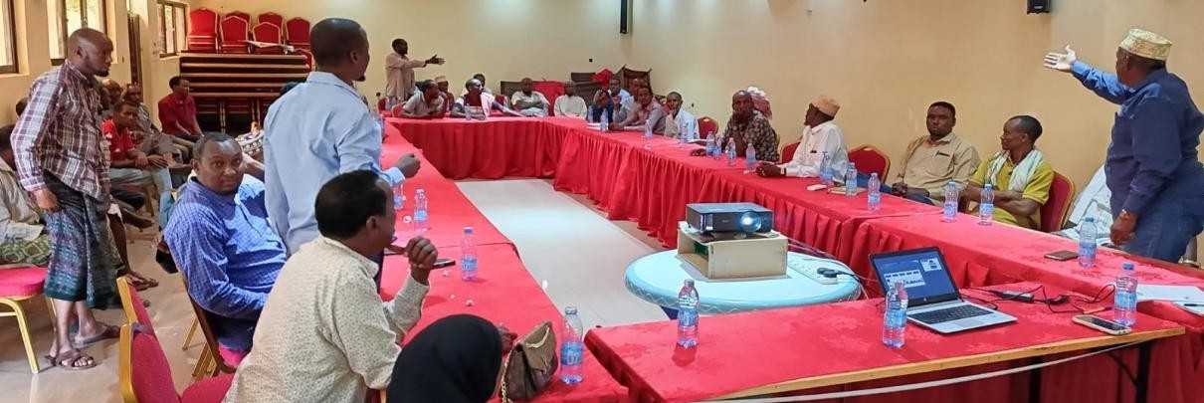
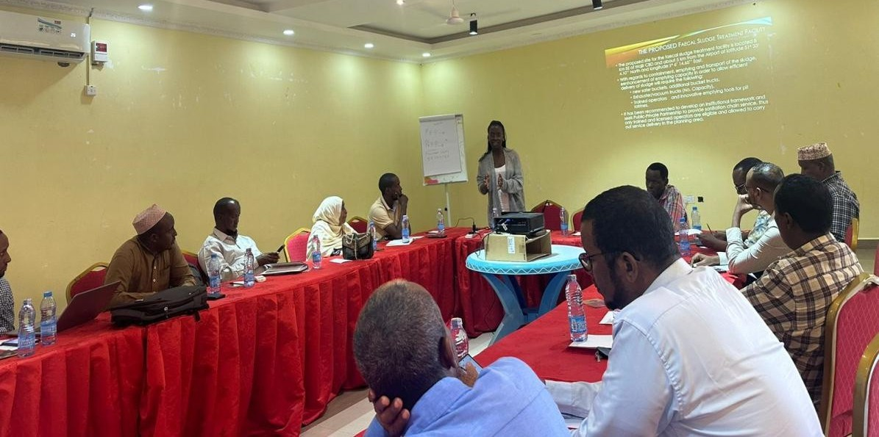
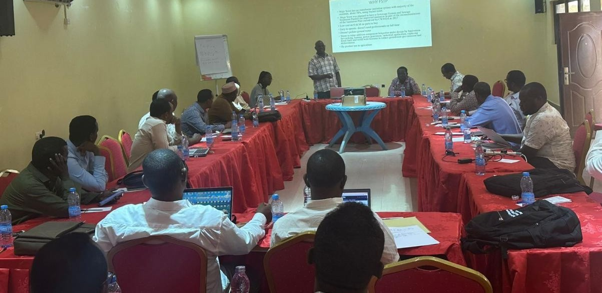
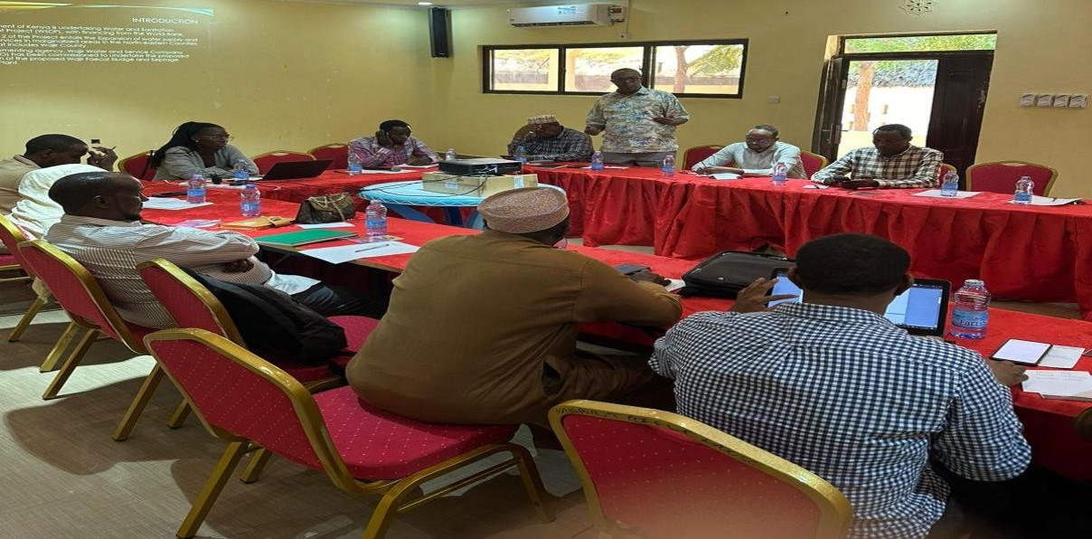

Figure 18: Stakeholder engagement meeting



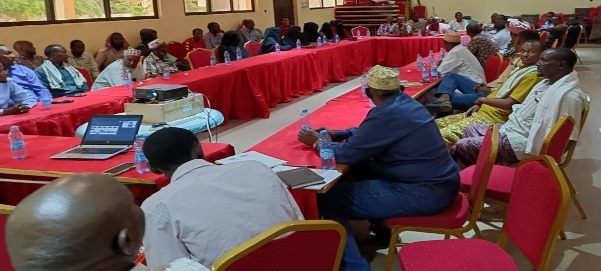

Figure 19: Public participation meeting
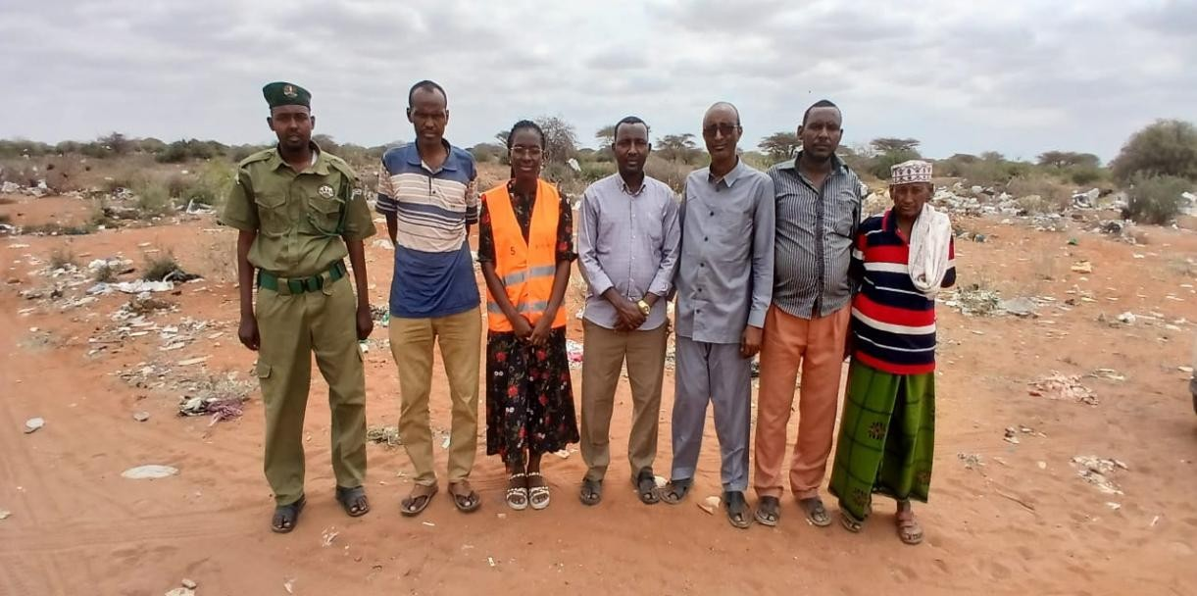

Figure 20:Photo with the area chiefs of Alimaow and Furaha
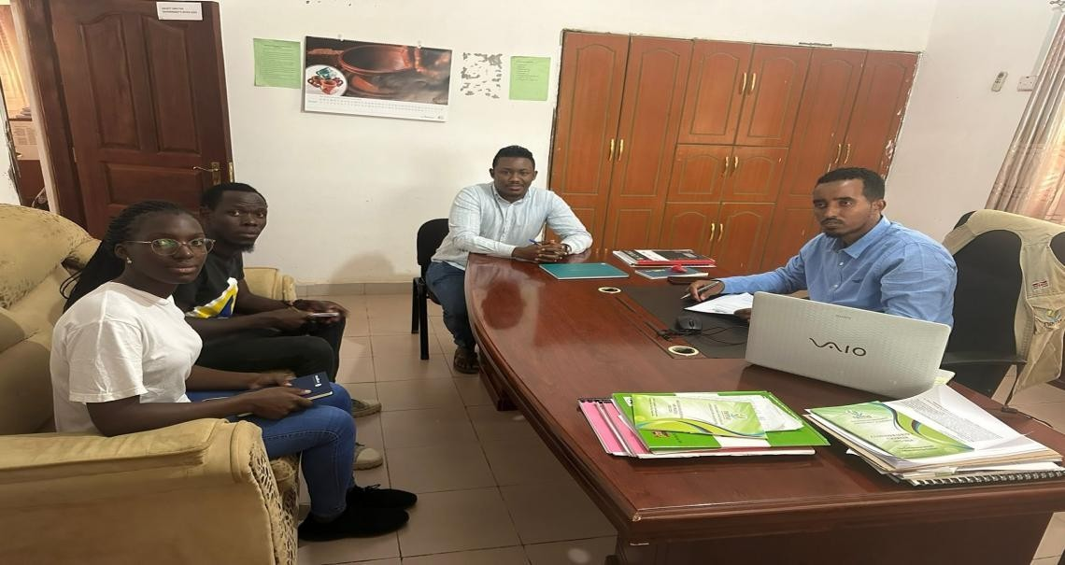

Figure 21: Interview with the NEMA County Director
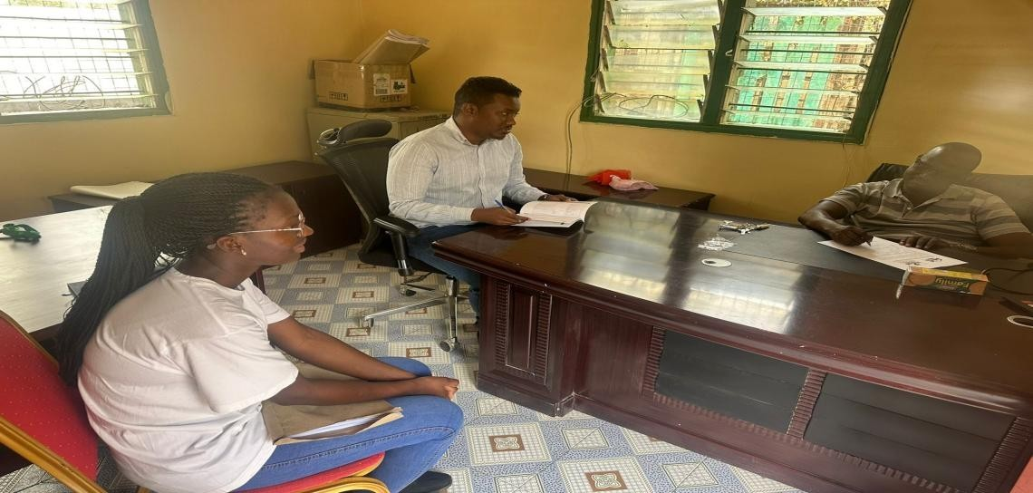

Figure 22: Interview with the NDMA Director
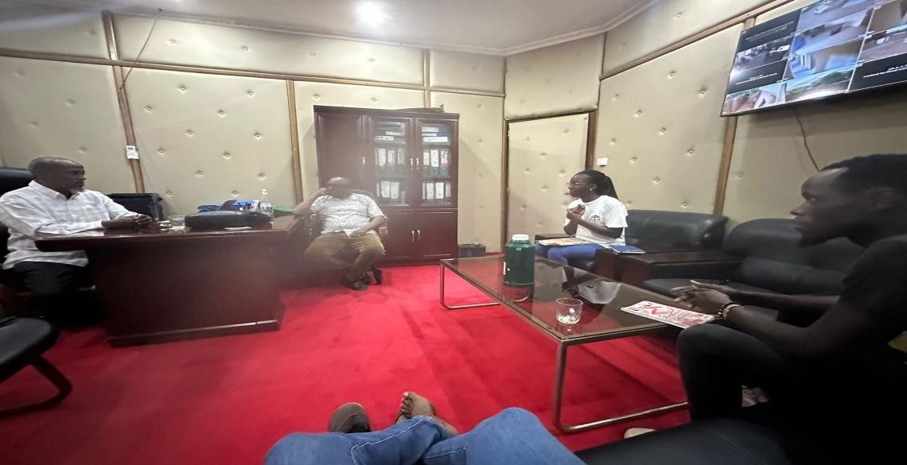

Figure 23: Interview with the Director of lands and Physical Planning Department

7.7. Continuous Public Participation and Engagement Outlook

Being a high risk project, the Client (WAJWASCO), with the help of the consultant shall carry out continuous public participation which is expected to ensure exclusive disclosure of the proposed project and its anticipated impacts through all the project phases.
The data and information collected in the process shall cover more cultural and social impacts that might have been missed in the initial public participation exercise. Through this process, organizations such as Kenya Airports Authority, NEMA, Ministry of Water, Sanitation and Irrigation, NGOs and other organizations and stakeholders will be involved to get their concerns and perspective with regard to the progress of the proposed project.
Additionally, the consultant shall ensure active involvement of the people of Alimaow and Furaha Villages. Institutions such as the dispensary, Furaha Primary school and Furaha Secondary School will also be consulted further throughout all the project Phases.

Water Quality, Air Quality and Soil assessments shall also be further done, data, analysed and represented in the report to ensure all aspects of the environment have been fully captured.

IDENTIFICATION OF ENVIRONMENTAL & SOCIAL IMPACTS AND MITIGATION MEASURES

Environmental and Social Impact Identification and Analysis/Rating

The identification and assessment of environmental and social impacts is a multi-faceted process, using a combination of quantitative and qualitative descriptions and evaluations. It involves applying scientific measurements and professional judgement to determine the significance of environmental impacts associated with a proposed project. Other potentially significant impacts or those of stakeholder concern, the impact identification and evaluation process.

The identified Impacts were categorized as negative and positive. Further, negative impacts were analyzed based on impacts consequence and impacts likelihood as shown below. Similarly, impacts rating was determined based on impacts consequence and impacts likelihood as shown below. Impacts prediction was made during all the phases of the proposed project. Mitigation measures were thereafter proposed with the hierarchy of avoidance, minimization, mitigation and offsetting the impacts.

Table 18: Impacts Consequences

Severity / Magnitude of Impact | Rating | Spatial Scope / Geographic Extent of Impact | Rating | Duration of Impact | Rating
Insignificant / non- harmful | 1 | Activity specific | 1 | One day to one month | 1
Small / potentially harmful | 2 | Area Specific | 2 | One month to one year | 2
Significant /slightly harmful | 3 | Whole Site | 3 | One year to ten years | 3
Great / harmful | 4 | Regional/Neighboring areas | 4 | Life of operation | 4
Disastrous / Extremely harmful | 5 | National | 5 | Post closure / permanent | 5

Note: Total Rating of Impact Consequence = Rating of Severity/Magnitude + Rating of Spatial Scope of Impact + Rating of Impact Duration

Table 19: Impacts Likelihood

Frequency / duration of activity | Rating | Frequency of impact | Rating
Annually or less | 1 | Almost never / Impossible | 1
6 monthly / temporary | 2 | Very seldom / highly unlikely | 2
Monthly / infrequent | 3 | Infrequent / unlikely / seldom | 3
Weekly / life of operation | 4 | Often / regularly / likely / possible | 4
Post closure | 5 | Daily / highly likely / definitely | 5

Total Rating of Impact Likelihood = Rating of Frequency/Duration of Activity + Rating of Impact Frequency

The definitions used in the impact assessment are given below:

- Frequency of activity refers to how often the proposed activity will take place.
- Frequency of impact refers to the frequency with which a stressor (aspect) will impact on the receptor.
- Severity refers to the degree of change to the receptor status in terms of the reversibility of the impact; sensitivity of receptor to stressor; duration of impact (increasing or decreasing with time); controversy potential and precedent setting; threat to environmental and health standards.
- Spatial scope refers to the geographical scale of the impact.
- Duration refers to the length of time over which the stressor will cause a change in the resource or receptor.

Table 20: Significance Rating Matrix

Consequence (Magnitude+ Geographic extent + Duration of the Impact)
Likelihood (Frequency of Activity + Frequency of Impact) | 1 | 2 | 3 | 4 | 5 | 6
 | 2 | 4 | 6 | 8 | 10 | 12
 | 3 | 6 | 9 | 12 | 15 | 18
 | 4 | 8 | 12 | 16 | 20 | 24
 | 5 | 10 | 15 | 20 | 25 | 30
 | 6 | 12 | 18 | 24 | 30 | 36

Note: Rating of Impact Significance = Rating of Likelihood X Rating of Consequence

Table 21: Negative Impacts ratings and associated color codes

Significance rating | Value | Color Code | Negative Impact Management Recommendation
Very high | 30 and above |  | Propose mitigation measures
High | 25-29 |  | Propose mitigation measures
Medium high | 19-24 |  | Propose mitigation measures
Low medium | 12-18 |  | Maintain current management
Low | 8-11 |  | Maintain current management
Very low | 4-7 |  | Maintain current management

Anticipated project positive impacts During Pre-Construction Phase Inclusivity in decision-making
Diversity and inclusion practices may be of massive impact on project performance. Having a decision- making system that is not bias and is largely transparent to the stakeholders and the community at large may lead to project acceptance.

Enhancement

This impact could be enhanced by ensuring all members of the community are well represented and consulted through all the phases of the project.

Anticipated Positive Impacts During Construction Phase Creation of employment
The project is predicted to create employment for the skilled and semiskilled locals such as

socioeconomics, trainers, casual laborers for construction and cooks and cleaners at the construction camps and casual workers

Enhancement

- Prioritizing the hire of locals for all unskilled labour.
- Implementing a local recruitment plan that is fair and transparent (including recruitment processes that ensure inclusivity of both men and women, vulnerable individuals, minority clans, ethnic groups etc.
- Adhering to labour laws and labour management practices (timely remuneration, equitable compensation for both genders for equal work etc.)
- Creating awareness to workers and the community on worker and project grievance redress mechanisms.

Increased business opportunities

The project may lead to flourishing of businesses, mainly business centers located along the road due to increased demand of basic commodities and services such as food, accommodation and construction materials.

Enhancement

This can be enhanced by ensuring the contractor sources materials that can be acquired locally from available suppliers within the settlement.

Food being used at the camp can also be sourced from local women who are in the business of selling food. This can be further enhanced by creating mechanisms of purchasing items locally to also prohibit workers purchasing from local children who might be under age.

Community Engagement

Construction projects often involve community consultation and participation, allowing residents to provide input on design aspects and priorities. This fosters a sense of ownership and pride in the local infrastructure.

Environmental Protection

Modern construction practices often incorporate sustainable methods and materials, which help to minimize environmental impacts and promote biodiversity.

Skills Development

Construction projects provide opportunities for skill development and training for local workers. These skills can be valuable for future employment opportunities beyond the project's duration. Only those who get employment opportunities are the one to benefit so significance of the benefit will be moderate.

Enhancement

As a way to magnify this positive benefit to the youth a Corporate Social Responsibility (CSR) can be done during the construction stage to take the participated youth to technical colleges. Incorporating a CSR initiative that focuses on providing technical education and vocational training to local youth during the construction stage of the Wajir FSTP project can magnify positive benefits for the community. By empowering youth with the skills they need to succeed in the workforce, the initiative supports both

individual growth and broader community development.

Anticipated positive impacts during Operation Phase Improved sanitation
The proposed FSTP will lead to improved solid waste management within Alimaow and Furaha area as well as Wajir would lead to an improved sanitation status of the area. This will reduce the cases of open dumping.

Reduction in waterborne diseases

The proposed project in the area will lead to improved sanitation/hygiene practices in the area, thus leading to a reduction in the outbreaks of diseases such as cholera, typhoid and dysentery.

Enhancement

These impacts should be enhanced by engaging the community, promoting education, improving access to sanitation, and ensuring sustainability are critical to achieving long-term benefits and reducing the prevalence of waterborne diseases.

Improvement of quality of life

The Wajir FSTP project aims to improve the quality of life for local residents by providing enhanced sanitation facilities, reducing waterborne diseases, creating economic opportunities, and promoting environmental protection.

Enhancement

By implementing educational programs, fostering community engagement, and integrating the project with local development plans, the positive impact on quality of life can be significantly enhanced. Ultimately, this initiative contributes to healthier, more sustainable, and empowered communities in Wajir.

Anticipated Positive Impacts During Decommissioning Phase Adaptation to Changing Needs
Decommissioning allows for the removal of infrastructure that no longer meets the needs of the community, facilitating the reallocation of resources towards more pressing priorities such as sustainable sanitation options or climate resilience measures.

Environmental Restoration

Decommissioning allows for the restoration of natural habitats and ecosystems that were disrupted during the construction phase. This can include vegetation of areas and removal of impervious surfaces.

Cost Savings

Decommissioning outdated or underutilized infrastructure can result in long-term cost savings by reducing maintenance and operational expenses associated with maintaining and repairing aging

infrastructure.

Anticipated Negative impacts during pre-construction phase Approval delays from NEMA and other Agencies (Medium High)
There is a possibility of having delays that may lead to the project taking a longer period than the expected. This may lead to delay of the project’s kickoff period, thus delay in implementation.
Criteria |  | Rating
Consequences | Severity/Magnitude of Impact | 3
 | Spatial Scope/Geographic Extent of Impact | 1
 | Duration of Impact | 2
Likelihood | Frequency/duration of activity | 3
 | Frequency of impact | 1
Impact Significance Rating  (Consequence × likelihood) | Medium High | 24

This can be

mitigated by ensuring all the aspects of the reports are handled keenly and well addressed, with less or no comments at all to allow swift movement of the project activities as with the schedule.

Divided opinion on project implementations (High)

Divided opinions can lead to prolonged debates and conflicts, delaying the implementation of the project. This delay may result in missed opportunities, increased costs, and frustration among stakeholders who are eager to see tangible improvements in their communities. Persistent disagreements may erode trust between stakeholders and project implementers, undermining the legitimacy and credibility of the initiative. Without trust, collaboration and cooperation become more challenging, hindering the project's overall effectiveness.

Criteria |  | Rating
Consequences | Severity/Magnitude of Impact | 1
 | Spatial Scope/Geographic Extent of Impact | 2
 | Duration of Impact | 2
Likelihood | Frequency/duration of activity | 3
 | Frequency of impact | 3
Impact Significance Rating (Consequence  × likelihood) | High | 30

Mitigation measures

- To address these impacts, it's essential for project implementers to adopt inclusive and participatory approaches that facilitate constructive dialogue, consensus-building, and conflict resolution.
- Engaging stakeholders early and regularly throughout the project lifecycle.
- Conduct extensive public participation and consultation with key stakeholders

High Expectations of the Local Communities in relation to Jobs (Medium High)
There is within the local population, expectations about jobs creation. Indeed, during the design and survey process, the project will create employment opportunities especially areas neighboring the

proposed faecal sludge treatment plant. The jobs will be limited due to the short-term nature of the survey and design period.

Criteria |  | Rating
Consequences | Severity/Magnitude of Impact | 3
 | Spatial Scope/Geographic Extent of Impact | 1
 | Duration of Impact | 2
Likelihood | Frequency/duration of activity | 3
 | Frequency of impact | 1
Impact Significance Rating (Consequence ×  likelihood) | Medium High | 24

Mitigation Measures:
- The hiring requirements must be clear, properly publicized before the start of the recruitment process and respected by the design team. For a better impact on the communities this process shall be conducted with the involvement of local leaders;
- In the event there are local expectations for employment that cannot be met by the project, the limited availability of places shall be made known to the interested parties through local authorities; and
- The principles and procedures for hiring shall, as far as possible, give priority to the hiring of skilled local workers.

Anticipated Negative Impacts during Construction Noise and Excessive Vibrations. (Very High)
Noise may pose a nuisance to people living or working close to construction sites and along transportation routes due to the use of heavy equipment and vehicles. The intensity of this impact will vary depending on the location.

Criteria |  | Rating
Consequences | Severity/Magnitude of Impact | 3
 | Spatial Scope/Geographic Extent of Impact | 1
 | Duration of Impact | 1
Likelihood | Frequency/duration of activity | 4
 | Frequency of impact | 4
Impact Significance  Rating (Consequence × likelihood) | Very High | 40

Proposed mitigation measures

    - Contractor will comply with provisions of EMCA 1999 and amendments 2015 (Noise and Excessive Vibrations Regulations of 2009)
    - The Contractor shall keep noise level within acceptable limits (55 Decibels during the day and 35 Decibels during the night) and construction activities shall, where possible, be confined to normal working hours in the residential areas.
    - Hospitals and other noise sensitive areas such as schools shall be notified by the Contractor at least 5 days before construction is due to commence in their vicinity.

    - Undertake Noise and Excessive Vibration Assessments.
    - Effective use of appropriate PPE by exposed workers and Proper maintenance of machines.
    - Any complaints received by the Contractor regarding noise will be recorded and communicated to the Supervising Engineer for appropriate action.

Soil Pollution (Low)

Use of construction chemicals, adhesives, sealants, additives and other construction-related chemicals could introduce contaminants into the soil, affecting its composition and quality. Additionally, accidental spills or leaks of construction chemicals, fuels, and lubricants. Dumping or improper disposal of construction debris, concrete waste, and hazardous materials on the other hand can lead to soil pollution. Improper disposal of concrete washout water, which contains alkaline substances and may be contaminated with cementitious materials, can harm aquatic environments present at the project areas.

Criteria |  | Rating
Consequences | Severity/Magnitude of Impact | 1
 | Spatial Scope/Geographic Extent of Impact | 1
 | Duration of Impact | 1
Likelihood | Frequency/duration of activity | 1
 | Frequency of impact | 1
Impact Significance  Rating (Consequence × likelihood) | Low | 6

Proposed Mitigation measures

    - Any polluted soil should be handled with care for proper disposal.
    - Concrete mixing shall be done on concrete slabs or a large metal sheet or mortar boards.
    - Maintenance of vehicles to be done strictly at a designated place/Drip tray to be used to avoid oil spills.
    - Excavation materials to be stockpiled at the demarcated location.

Air Pollution (Very High)

Dust and engine emission fumes may be formed in areas subject to excavation for pits or ponds, along transportation routes and at the construction site. This is likely to happen during dry periods.

Criteria |  | Rating
Consequences | Severity/Magnitude of Impact | 2
 | Spatial Scope/Geographic Extent of Impact | 1
 | Duration of Impact | 1
Likelihood | Frequency/duration of activity | 4
 | Frequency of impact | 5
Impact Significance Rating (Consequence ×  likelihood) | Very High | 36

Proposed Mitigation measures

    - Vegetation and Greenery; Incorporate green infrastructure elements such as vegetative

barriers to help absorb pollutants and improve air quality in the surrounding area.
    - Regulatory Compliance; Ensure compliance with relevant environmental regulations and permits governing air quality standards and emissions limits for construction activities.
    - Water sprinkling to reduce the dust at the construction sites.
    - Use of dust masks to operators and those working in the dusty areas.
    - Use of goggles for all operators.
    - Construction machines/equipment will be well maintained to ensure total fuel combustion. All vehicles involved in construction works will be frequently checked and well serviced during the whole construction period so that the level of exhaust emissions is reduced.
    - Speed of vehicles hauling construction materials shall be reduced and the construction materials will be covered with tarpaulins.

Increased Crime and Insecurity (Very High)

The Wajir FSTP project may lead to increased insecurity through population influx, resource competition, theft, vandalism, extremist threats, gender-based violence, and corruption. Key risks include social tensions, crime, and potential extremist attacks.

Criteria |  | Rating
Consequences | Severity/Magnitude of Impact | 2
 | Spatial Scope/Geographic Extent of Impact | 2
 | Duration of Impact
Likelihood | Frequency/duration of activity | 4
 | Frequency of impact | 4
Impact Significance  Rating (Consequence × likelihood) | Very High | 32

Mitigation measures

    - Contractor and Supervision Team to liaise regularly with the Local Administration and Police Service to address any security and crime arising during project implementation.
    - Contractor to provide 24 hours’ security to Workforce Camps, Yards, Stores and to the Supervising Team’s Offices.
    - In order to mitigate security challenges accros the project cycle and considering the flare ups that could occur in the general area, it is propose that a security management plan be developed to manage all the construction activities, commissioning and the operationalization.

Occupational Health and Safety Risks (Very high)

These are work related risks during construction they include all accidents and incidents, that maybe caused by fatigue, drug abuse, ignorance etc.

Criteria |  | Rating
Consequences | Severity/Magnitude of Impact | 3
 | Spatial Scope/Geographic Extent of Impact | 2
 | Duration of Impact | 1
Likelihood | Frequency/duration of activity | 4
 | Frequency of impact | 5

Impact Significance Rating (Consequence × likelihood) | Very High | 54

Mitigation measures

    - Contractor to provide a Health and Safety Plan prior to the commencement of works to be approved by the Supervising Engineer.
    - Construction Workers and the Supervising Team to be provided with Personal Protective Equipment including gloves, gum boots, overalls and helmets. Use of PPE to be enforced by the Supervising Engineer.
    - Fully stocked First Aid Kits to be provided within the Sites, Camps and in all Project Vehicles
    - Isolate the site from access by the local communities during the construction for their safety and health
    - Contractor to provide clean water for drinking and healthy food to all the workers
    - Contractor to adhere to maximum eight hour working rule
    - Contractor to ensure only qualified personnel operate machinery.

Sexual Exploitation and Abuse (Low Medium)

Defined as acts perpetrated by workers or people associated with aid organization for this case contractors for example against the people the residents during construction period. The proposed development will lead to potential for employment opportunities and access to new services, which will draw people to the area more, specifically the project site.

This factor will further lead to a temporary increase in economic activities and employment of skills for the development. This will lead to population influx which might lead to changes in or unwanted behaviors in the area. This unwanted or change in behavior may be in the form of loose morality, an increase in school drop-out due to cheap Labor, child Labor, drug use and abuse, theft/robbery and increased incidences of HIV/AIDS and related infections/diseases and other communicable diseases.

Criteria |  | Rating
Consequences | Severity/Magnitude of Impact | 2
 | Spatial Scope/Geographic Extent of Impact | 2
 | Duration of Impact | 1
Likelihood | Frequency/duration of activity | 1
 | Frequency of impact | 2
Impact Significance Rating (Consequence ×  likelihood) | Low Medium | 15

Mitigation measures

    - Establish strict codes of conduct for all project staff and contractors, with clear penalties for SEA violations.
    - Conduct community awareness campaigns to educate local populations about their rights and reporting mechanisms.
    - Set up confidential and accessible reporting systems where victims can safely report SEA incidents without fear of retaliation.
    - Provide mandatory training for all project staff on SEA prevention, gender sensitivity, and appropriate workplace behavior.

    - Regularly monitor project sites and enforce policies through independent oversight and periodic audits.
    - Ensure that victims of SEA have access to medical, legal, and psychological support.

Inadequate stakeholder Engagement and Exclusion of disadvantaged and vulnerable groups

(Medium high)

When disadvantaged and vulnerable groups are excluded from the decision-making process, their voices, needs, and priorities are often overlooked. This can result in infrastructure projects that fail to address the unique challenges faced by these communities, perpetuating inequality and marginalization.

Exclusion from stakeholder engagement can erode trust between communities and project implementers, leading to resentment, frustration, and social tension. Without meaningful participation and inclusion, stakeholders may become disillusioned with the project and its objectives, hindering cooperation and collaboration.

Criteria |  | Rating
Consequences | Severity/Magnitude of Impact | 3
 | Spatial Scope/Geographic Extent of Impact | 2
 | Duration of Impact | 1
Likelihood | Frequency/duration of activity | 1
 | Frequency of impact | 3
Impact Significance Rating (Consequence × likelihood) | Medium high | 24

Mitigation measures;

    - Share project information widely and in a timely manner through diverse, feasible and accessible channels of communication e.g., public forums.
    - Introduce measures for affirmative action that would ensure especially persons with disability, the elderly and women have access to job opportunities.
    - Undertake recruitment transparently, while ensuring the inclusion of disadvantaged groups.
    - Develop and implementation of a stakeholder engagement plan.
    - Engage stakeholders throughout the project phase as guided by the approved stakeholder engagement plan.
    - Culturally appropriate consultations and early involvement of VMGs in the project.
    - Use of tailored communication channels to ensure VMGs can access project information.
    - Training and empowerment programs to enhance VMG participation.
    - Ensure VMGs have equal access to project benefits and opportunities.
    - Culturally sensitive systems for VMGs to safely report issues.
    - Adherence to policies that protect VMG rights.
    - Ongoing assessment involving VMGs to track the project’s impact on them.

Child labour and Abuse Risk (Medium high)

In impoverished communities, families may resort to child labor out of economic necessity. This can lead to children being pulled out of school to work in informal sectors such as street vending, domestic work, or agriculture, depriving them of their right to education and exposing them to exploitation and abuse. Children engaged in labor may be subjected to exploitative working conditions, including long hours, low wages, and hazardous environments. They may be forced to undertake tasks that are physically or mentally harmful, risking their health, well-being, and development.:

Criteria |  | Rating
Consequences | Severity/Magnitude of Impact | 2
 | Spatial Scope/Geographic Extent of Impact | 1
 | Duration of Impact | 1
Likelihood | Frequency/duration of activity | 4
 | Frequency of impact | 2
Impact Significance Rating (Consequence × likelihood) | Medium high | 24

Mitigation measures

    - Ensure each employee signs a code of conduct that covers child protection ensuring no children are employed on site in accordance with national labour laws.
    - Ensure that any child sexual relations offenses among contractors' workers are promptly reported to the police.
    - Employ workers who are 18 years and above, and with a valid national ID at the time of hire.
    - Implement and monitor the employment register regularly.
    - Comply with the national labour laws and labour management practices.
    - Put visible signage on site “No Jobs for children.”

Solid and liquid wastes (Very High)

The construction works may encounter poor quality excavated soil or rock which needs to be deposited somewhere. Construction work will generate organic and non-organic solid and liquid waste which is to be disposed of in accordance with government regulations at designated sites. Non-compliance will lead to littering and pollution of the environment.

Criteria |  | Rating
Consequences | Severity/Magnitude of Impact | 3
 | Spatial Scope/Geographic Extent of Impact | 2
 | Duration of Impact | 1
Likelihood | Frequency/duration of activity | 4
 | Frequency of impact | 5
Impact Significance Rating (Consequence × likelihood) | Very High | 54

Mitigation measures

    - Site housekeeping to minimize solid and liquid wastes generated from construction and other related activities such as food vending and petty businesses.
    - Allocate a special area for petty business such as food stalls provided with garbage bins.
    - Post appropriate signage such as “DO NOT LITTER” or “USITUPE TAKA” at all strategic sites.
    - Assign Contractor’s Environmental or Safety Officer the responsibility to ensure that the surroundings are kept clean.
    - All excavated spoil should be well managed through levelling or tipped into low-lying areas or borrow areas which are no longer useful.
    - Trash and waste shall be well collected and removed from the site to the waste collection point.
    - The community should instruct people to stay away from scavenging at the dumping sites.
    - Solid wastes generated from land clearing shall be collected and disposed of in sanitary land fill at authorized site.
    - Decomposable materials shall be collected and combined with wastes to the authorized

dumpsites; plastics and other recyclable materials will be collected and sent out for recycling.

Gender-Based Violence and Sexual Exploitation and Abuse (SEA) and Sexual Harassment (SH)

(Low Medium)

GBV, SEA, and SH can result in severe physical injuries, emotional trauma, and mental health issues for survivors. This can have long-lasting effects on their well-being, confidence, and ability to participate fully in community life. Incidents of GBV, SEA, and SH create an environment of fear and insecurity within the community, particularly for women and girls. They may feel unsafe in public spaces, at home, or even within their own families, leading to restrictions on their mobility and freedom.

Criteria |  | Rating
Consequences | Severity/Magnitude of Impact | 1
 | Spatial Scope/Geographic Extent of Impact | 1
 | Duration of Impact | 2
Likelihood | Frequency/duration of activity | 3
 | Frequency of impact | 1
Impact Significance Rating (Consequence × likelihood) | Low Medium | 16

Mitigation measures

    - Establish clear policies and codes of conduct against GBV, SEA, and SH.
    - Provide mandatory training for staff and community awareness campaigns.
    - Implement confidential reporting channels and support services for victims.
    - Involve local leaders and empower vulnerable groups to foster a supportive environment.
    - Ensure safe work environments and secure transportation for workers.
    - Partner with NGOs for enhanced support systems and referral services.
    - Tailor interventions to be culturally appropriate for the local context.
    - Develop and implement a plan to manage the risk of SEA/SH.
    - Map the GBV referral pathways and create awareness among women and men on the risk of SEA/SH.

HIV/AIDS (Low medium)
The project could lead to an increase in the spread of HIV/AIDS due to several factors, such as the influx of workers from outside the community, increased economic activities, and possible social interactions between workers and local residents. This could heighten the risk of unprotected sexual activity, exploitation, or risky behaviors, increasing the incidence of HIV/AIDS transmission.

Criteria |  | Rating
Consequences | Severity/Magnitude of Impact | 1
 | Spatial Scope/Geographic Extent of Impact | 1
 | Duration of Impact | 2
Likelihood | Frequency/duration of activity | 3
 | Frequency of impact | 1
Impact Significance Rating (Consequence × likelihood) | Low Medium | 16

Mitigation Measures:

    - HIV/AIDS Awareness Campaigns: Implement regular awareness and education programs on

HIV/AIDS prevention and safe practices for workers and local communities.
    - Health Screening and Support Services: Provide voluntary counseling, testing, and access to healthcare services, including antiretroviral treatment, for workers and nearby residents.
    - Promotion of Safe Sex Practices: Distribute condoms freely to workers and residents, alongside campaigns encouraging their use.
    - Code of Conduct for Workers: Establish a code of conduct that prohibits sexual exploitation and harassment, holding workers accountable for violations.
    - Collaboration with Health Authorities: Partner with local health institutions to ensure the availability of HIV/AIDS prevention, treatment, and support services.
    - Workforce Accommodation and Management: Manage workforce interactions by ensuring worker accommodation is separate from local communities and monitor social interactions to reduce risk behaviors.

Leakage of fuel and lubricants (Low medium)
Ground- and surface water contamination could occur if the Contractor does not follow pollution control measures. Groundwater can be contaminated through leaking of spilt fuels and lubricants.

Criteria |  | Rating
Consequences | Severity/Magnitude of Impact | 1
 | Spatial Scope/Geographic Extent of Impact | 1
 | Duration of Impact | 2
Likelihood | Frequency/duration of activity | 3
 | Frequency of impact | 1
Impact Significance Rating (Consequence  × likelihood) | Low Medium | 16

Mitigation Measures
    - Dripping pans to be used to contain all hydrocarbon leakages on construction equipment.
    - Re-fueling on designated areas.
    - In case of hydrocarbon spills, the contaminated soils will be collected and treated to remove the hydrocarbon and prevent the hydrocarbons from being washed away in storm water to the nearby water bodies
Community Safety Risks (Low Medium)
Construction of the FSTP and the road leading to it, like any other construction site, is inherently a potentially dangerous place. Once the construction site is active, there are chances that people may come as a matter of interest or look for employment. Free roaming at the construction site can be dangerous and may lead to accidents such as falling into open ponds.

Criteria |  | Rating
Consequences | Severity/Magnitude of Impact | 3
 | Spatial Scope/Geographic Extent of Impact | 2
 | Duration of Impact | 1
Likelihood | Frequency/duration of activity | 2
 | Frequency of impact | 2
Impact Significance Rating (Consequence ×  likelihood) | Low Medium | 24

Mitigation measures

    - Construction sites shall be provided with barricades to protect neighbors and those passing-by.
    - Therefore, the public particularly the children shall not be allowed to come closer to the swing area of excavators or other equipment at site.
    - In places where there are vehicles transporting construction materials and at turning places towards the construction site, appropriate warning signage shall be posted.
    - Sensitization and training of the surrounding communities regarding the risks associated with construction activities.
    - Constant surveillance from security to make sure that there are no “uninvited guests” in the project area

Anticipated Negative Impacts during Operation stage

Gender-Based Violence and Sexual Exploitation and Abuse (SEA) and Sexual Harassment (SH)

(Medium high)

This is likely to be caused by influx of people in the project area. Incidents of GBV, SEA, and SH create an environment of fear and insecurity within the community, particularly for women and girls. They may feel unsafe in public spaces, at home, or even within their own families, leading to restrictions on their mobility and freedom.

Criteria |  | Rating
Consequences | Severity/Magnitude of Impact | 1
 | Spatial Scope/Geographic Extent of Impact | 1
 | Duration of Impact | 4
Likelihood | Frequency/duration of activity | 2
 | Frequency of impact | 2
Impact Significance Rating (Consequence × likelihood) | Medium High | 24

Mitigation measures

    - Develop and implement a plan to manage the risk of SEA/SH.
    - Map the GBV referral pathways and create awareness among women and men on the risk of SEA/SH.

Inadequate stakeholder Engagement and Exclusion of disadvantaged and vulnerable groups

(Medium high)

Excluding disadvantaged and vulnerable groups from stakeholder engagement processes can bring social injustice, Loss of Trust and Credibility and increase the likelihood of misunderstandings, conflicts, and resistance to the project.

Criteria |  | Rating
Consequences | Severity/Magnitude of Impact | 3
 | Spatial Scope/Geographic Extent of Impact | 2
 | Duration of Impact | 1
Likelihood | Frequency/duration of activity | 1
 | Frequency of impact | 3
Impact Significance Rating (Consequence × likelihood) | Medium high | 24

Mitigation measures;

    - Share project information widely and in a timely manner through diverse, feasible and accessible channels of communication e.g., public forums.
    - Introduce measures for affirmative action that would ensure especially persons with disability, the elderly and women have access to job opportunities.
    - Undertake recruitment transparently, while ensuring the inclusion of disadvantaged groups.
    - Develop and implementation of a stakeholder engagement plan.
    - Engage stakeholders throughout the project phase as guided by the approved stakeholder engagement plan.
    - Culturally appropriate consultations and early involvement of VMGs in the project.
    - Use of tailored communication channels to ensure VMGs can access project information.
    - Training and empowerment programs to enhance VMG participation.
    - Ensure VMGs have equal access to project benefits and opportunities.
    - Culturally sensitive systems for VMGs to safely report issues.
    - Adherence to policies that protect VMG rights.
    - Ongoing assessment involving VMGs to track the project’s impact on them.

Water Pollution/Contamination (High)

If the proposed sludge treatment plant does not function as planned, there may be pollution of groundwater sources.

Contaminated water sources can lead to a range of health problems, including waterborne diseases such as cholera, typhoid, and diarrhea. These diseases can be especially dangerous for children, the elderly, and people with weakened immune systems, leading to illness, hospitalization, and even death.

Criteria |  | Rating
Consequences | Severity/Magnitude of Impact | 3
 | Spatial Scope/Geographic Extent of Impact | 2
 | Duration of Impact | 2
Likelihood | Frequency/duration of activity | 1
 | Frequency of impact | 2
Impact Significance Rating (Consequence × likelihood) | Very Low | 28

Mitigation measures

    - Use impermeable liners in ponds or lagoons to prevent leachate from seeping into the soil and groundwater.
    - Implement a system to collect and treat leachate before it is discharged.
    - Include sedimentation tanks to remove solids from the effluent before further treatment.
    - Use wetlands to naturally treat effluent, utilizing plants to absorb and break down contaminants.
    - Chlorination or UV treatment shall be used to disinfect the treated effluent before discharge.
    - Regularly test nearby water sources to monitor for potential contamination.
    - Ensure the treated effluent meets environmental standards before discharge.
    - Establish vegetation buffers around the plant to absorb and filter runoff.
    - Store sludge in covered facilities to prevent contamination from rainwater and minimize leachate.
    - Use lined drying beds with proper drainage to reduce the volume of sludge and safely manage

any runoff.
    - Educate the community about the importance of the plant and how it operates to prevent accidental contamination.
    - Develop and communicate emergency response plans for potential spills or leaks.
    - Construct the plant on a concrete or similarly impermeable base to prevent leachate infiltration.
    - Install groundwater monitoring wells around the plant to detect any potential contamination early.
    - Regular maintenance of all equipment and infrastructure to prevent leaks and overflows.
    - Train staff on best practices for operation and emergency procedures.

Foul smell (Low medium)

The frequent dumping of truckloads for faecal sludge may cause bad smell in and around the FSTP. However, as the FSTP is located southeast of the town amidst a low density population, foul smell is expected to be of minor significance.

Criteria |  | Rating
Consequences | Severity/Magnitude of Impact | 2
 | Spatial Scope/Geographic Extent of Impact | 2
 | Duration of Impact | 1
Likelihood | Frequency/duration of activity | 1
 | Frequency of impact | 2
Impact Significance Rating (Consequence × likelihood) | Medium high | 15

Mitigation Measures

    - Install biofilters, which use natural biological processes to filter and neutralize odorous compounds from the air.
    - Transport sludge and other materials in enclosed conveyors or pipelines to prevent the escape of odors.
    - Minimize the time sludge spends in open-air conditions by quickly processing and covering it to reduce odor generation.
    - Dewater and stabilize sludge as quickly as possible to reduce the biological activity that causes odors.
    - Create buffer zones with green belts or vegetation around the plant to absorb and disperse odors.
    - Place the most odor-intensive operations away from residential areas and near the center of the facility to minimize exposure to the community.
    - Implement regular cleaning schedules for all equipment and facilities to prevent the buildup of odorous materials.
    - Quickly repair any leaks, overflows, or broken equipment that could lead to increased odor emissions.
    - Regularly monitor odor levels in and around the plant and share the results with the community.
    - Establish a system for the community to report odors and ensure a rapid response to any issues raised.
    - Use trees and plants known for their odor-absorbing properties around the facility.
    - Avoid overloading treatment systems, as this can lead to incomplete processing and higher odor emissions.

    - Adjust operations during hot seasons when odor emissions might be higher due to increased microbial activity.

Mosquito nuisance (Very High)

The settling-thickening pond and the drying beds may form a suitable breeding ground for mosquitos and diseases.

Criteria |  | Rating
Consequences | Severity/Magnitude of Impact | 2
 | Spatial Scope/Geographic Extent of Impact | 2
 | Duration of Impact
Likelihood | Frequency/duration of activity | 4
 | Frequency of impact | 4
Impact Significance Rating (Consequence × likelihood) | Very High | 32

Mitigation measures

    - Establish a maintenance schedule to remove debris and organic matter from ponds, along with a monitoring program for mosquito populations.
    - Incorporate aeration systems in water retention ponds and introduce natural predators (e.g., fish) to control mosquito larvae. Use constructed wetlands for biological control.
    - Manage swampy areas with vegetation that repels mosquitoes and ensure drying beds are designed to prevent standing water.
    - Educate local communities on mosquito control and involve stakeholders in monitoring efforts.
    - Develop an IPM plan, considering biological, physical, and environmentally safe chemical controls, including the use of larvicides if necessary.
    - Use mosquito-repelling plants in landscaping and ensure proper drainage to prevent stagnant water accumulation.

Spill of septage during transportation to the FSTP (Low medium)

Spills of septage during transportation to a Faecal Sludge Treatment Plant (FSTP) can occur due to a variety of reasons such as;

    - Cracks, holes, or weak seals in the exhauster tanks can cause leaks, especially if the tank is old or poorly maintained.
    - Valves or hoses used for loading, unloading, or transferring septage can fail if they are worn out, improperly secured, or damaged.
    - Malfunctioning pumps used for moving septage into or out of the tank can cause overflows or leaks.
    - Filling the tank beyond its capacity can cause septage to spill out of vents or overflow during transport.
    - Failure to monitor the loading process can result in overfilling and subsequent spills.
    - Driving on bumpy, uneven, or poorly maintained roads can cause the tank to jostle, leading to leaks or spills.
    - Extreme temperature fluctuations can cause materials to expand or contract, potentially leading

to leaks or equipment failure.

Criteria |  | Rating
Consequences | Severity/Magnitude of Impact | 2
 | Spatial Scope/Geographic Extent of Impact | 1
 | Duration of Impact | 1
Likelihood | Frequency/duration of activity | 2
 | Frequency of impact | 2
Impact Significance Rating (Consequence × likelihood) | Very High | 16

Mitigation measures

    - Ensure that all vehicles used for transporting septage are regularly inspected for leaks, wear and tear, and proper sealing.
    - Use tanks with tight, secure seals to prevent spills during transit. Inspect seals frequently to ensure they are in good condition.
    - Equip vehicles with secondary containment systems like drip trays or double-walled tanks to catch any leaks or spills.
    - Provide each vehicle with an emergency spill kit that includes absorbent materials, containment booms, and personal protective equipment (PPE).
    - Train drivers on safe handling, transportation practices, and spill response procedures.
    - Implement strict speed limits and plan routes to avoid rough roads or sharp turns that could cause spills.
    - Ensure that septage is loaded properly and that tanks are not overfilled. Use secure connections when loading and unloading to prevent spills.
    - Perform loading and unloading in designated, well-contained areas with spill containment systems.
    - Inform the community about transportation routes and safety measures in place to handle spills.
    - Provide the community with emergency contact information in case they witness a spill or related incident.
    - Where possible, improve transportation routes to the FSTP to reduce the likelihood of accidents leading to spills.

Occupational Health and Safety Risks (Low Medium)

Workers handling untreated faecal sludge are at risk of exposure to harmful pathogens, including bacteria, viruses, and parasites. Direct contact with sludge during loading, unloading, or processing can lead to infections or illnesses. Operations such as pumping, agitation, or drying of sludge can release aerosolized particles, which workers might inhale, leading to respiratory infections or other health issues. Workers may be exposed to chemicals used in the treatment process, such as lime or disinfectants, which can cause skin irritation, respiratory problems, or chemical burns if not handled properly. Gases like hydrogen sulfide (H₂S) or methane, produced during the anaerobic digestion of sludge, can pose inhalation risks. These gases are toxic in high concentrations and can lead to dizziness, respiratory distress, or in severe cases, unconsciousness.

Workers involved in the manual handling of sludge, equipment, or other heavy materials may be at risk of musculoskeletal injuries, such as strains or sprains, particularly if proper lifting techniques are not followed. Repetitive tasks, such as operating machinery or performing maintenance, can lead to repetitive strain injuries over time. The presence of water, sludge, or other liquids on floors can create slippery surfaces, increasing the risk of slips, trips, and falls, which could result in injuries ranging from

minor bruises to fractures. Workers entering confined spaces like sludge tanks, pits, or sumps for cleaning or maintenance may face risks such as oxygen deficiency, toxic gas exposure, or entrapment. Confined spaces can also be challenging to evacuate in an emergency. Continuous operation of pumps, blowers, or other machinery can generate significant noise levels, potentially leading to hearing loss or stress if workers are exposed over long periods without proper hearing protection.

FSTPs can attract insects (e.g., flies, mosquitoes) and rodents, which can bite or spread diseases to workers. Exposure to mosquitoes and other vectors in or around the FSTP may increase the risk of diseases like malaria or dengue fever.

Criteria |  | Rating
Consequences | Severity/Magnitude of Impact | 2
 | Spatial Scope/Geographic Extent of Impact | 2
 | Duration of Impact | 1
Likelihood | Frequency/duration of activity | 1
 | Frequency of impact | 2
Impact Significance Rating (Consequence × likelihood) | Low Medium | 15

Mitigation measures

    - Provide PPE, enforce hygiene practices, and ensure workers are vaccinated against common diseases.
    - Train workers on chemical safety, use gas detection systems, and ensure proper ventilation.
    - Use mechanical aids, provide ergonomic training, and rotate tasks to prevent repetitive strain injuries.
    - Install slip-resistant flooring, ensure proper drainage, and maintain clear signage and lighting.
    - Provide specialized training, monitor and ventilate confined spaces, and have rescue plans in place.
    - Provide hearing protection, control noise levels, and conduct regular hearing checks.
    - Regularly inspect equipment, use GFCIs, and train workers in electrical safety.
    - Ensure access to hydration, rest breaks, and shaded areas, and schedule demanding tasks during cooler times.
    - Implement pest control, manage waste properly, and provide insect repellent.
    - Use machine guards, enforce lockout/tag out procedures, and provide safe operating procedures.
    - Use secondary containment, install emergency showers, and train workers in spill response.
    - Upgrade ventilation systems and regularly monitor air quality.

Attraction of Scavengers fauna (birds and small rodents)

Scavenger fauna such as birds and small rodents may be attracted to a proposed Faecal Sludge Treatment Plant (FSTP) due to:

    - Organic waste and residual sludge can provide food.
    - Pools of stagnant water and moist environments can attract birds and rodents.
    - Structures, equipment, and waste piles offer shelter and nesting sites.
    - Improper disposal and overflowing bins can be attractive to scavengers.
    - Strong odors from sludge and fermentation can draw scavengers.
    - Nearby dense vegetation or poorly maintained landscaping can provide additional habitat.

Mitigation measures

    - Maintain proper drainage to prevent stagnant water and reduce moist environments.
    - Seal gaps in structures, maintain equipment, and avoid creating shelters or nesting sites.
    - Implement odor control measures such as covering sludge and using odor-neutralizing agents.
    - Maintain landscaping to reduce potential shelter for animals and birds.

Emission of Greenhouse gases e.g. Methane

Methane emissions at an FSTP primarily result from anaerobic decomposition processes, both during treatment and storage of sludge, as well as from leaks and infrastructure failures. Effective management and mitigation measures are crucial to reducing these emissions.

Mitigation measures

    - Install systems to capture and utilize methane for energy or flare it safely.
    - Improve anaerobic digestion processes and maintain equipment to enhance efficiency and prevent leaks.
    - Use covered storage and advanced treatment technologies to reduce methane production.
    - Regularly inspect and maintain infrastructure to detect and repair leaks.
    - Optimize processes and monitor emissions to minimize methane generation.
    - Implement vegetative cover and biofilters to absorb and treat methane.

Anticipated Negative Impacts During Decommisioning Phase Disruption of Services (Low Medium)
Decommissioning may disrupt regular services like water supply, and sanitation, causing inconvenience to residents and commuters.

Criteria |  | Rating
Consequences | Severity/Magnitude of Impact | 2
 | Spatial Scope/Geographic Extent of Impact | 2
 | Duration of Impact | 4
Likelihood | Frequency/duration of activity | 1
 | Frequency of impact | 1
Impact Significance Rating (Consequence × likelihood) | Low Medium | 16

Mitigation measures

    - Implement phased decommissioning to minimize disruption to services.
    - Provide alternative routes water sources and sanitation options for affected people.
    - Schedule decommissioning activities during off-peak hours to reduce impact on service provision.

Environmental Disturbance (Low Medium)

Decommissioning activities can disturb natural habitats, soil, and underground water. The removal of infrastructure might also disrupt ecosystems that have adapted to their presence.

Criteria |  | Rating
Consequences | Severity/Magnitude of Impact | 3
 | Spatial Scope/Geographic Extent of Impact | 2
 | Duration of Impact | 2
Likelihood | Frequency/duration of activity | 1
 | Frequency of impact | 1
Impact Significance Rating (Consequence × likelihood) | Low Medium | 14

Mitigation measures

    - Conduct thorough environmental impact assessments prior to decommissioning.
    - Implement erosion and sediment control measures to prevent soil erosion and water pollution.
    - Replant native vegetation and restore habitats affected by decommissioning activities.

Health and Safety Concerns (Medium)

Decommissioning activities can pose health and safety risks to workers and nearby residents due to noise pollution, air pollution from construction vehicles, and potential accidents.

Criteria |  | Rating
Consequences | Severity/Magnitude of Impact | 2
 | Spatial Scope/Geographic Extent of Impact | 2
 | Duration of Impact | 1
Likelihood | Frequency/duration of activity | 2
 | Frequency of impact | 2
Impact Significance Rating | Medium High | 24

Mitigation measures

    - Enforce strict safety regulations and provide adequate training for workers.
    - Implement dust and noise control measures to minimize pollution and disturbance to nearby residents.
    - Communicate potential risks to the public and provide guidance on safety precautions

ENVIRONMENTAL & SOCIAL MONITORING & MANAGEMENT PLAN(ESMMP)
Environmental management is an important aspect of project management and in protecting the environment. The objectives of environmental management plan are to ensure smooth implementation of environmental protection measures, mitigate adverse environmental impacts of project implementation, and ensure environmental and social protection activities are carried out smoothly in the project areas. The Wajir Faecal Sludge Treatment Plant Project components have been subjected to comprehensive environmental and social impacts assessment in accordance with prevailing environmental laws and guidelines. Various potential adverse environmental and social impacts associated with the project have been identified and an EMP formulated to guide in mitigating the negative impacts.

However, the implementation of some of the ESMMP actions will require a response beyond the project level. There is need therefore to have a multi-sectoral approach that will require unified management structures for such proposed measures. The project proponent is required to identify the actions and respond appropriately. Where the expert team could not determine the realistic costs of some of the proposed environmental management activities due to the associated hidden costs, further actions will be proposed to come up with more accurate costs. It is upon the project proponent and the environmental enforcement agencies to ensure that the proposals are adhered to during the project implementation.

The ESMMP prepared below brings out the potential impact, mitigation measures, responsibility during the time of its implementation, time frame which the impact will occur (Implementation/construction, operation and decommissioning) and the cost of the mitigation measure.

Objectives of the ESMMP

- To serve as a commitment and reference for the project planners and implementers including conditions of approval from NEMA;
- To serve as a guiding document for the environmental and social monitoring activities for future studies, on requisite progress reports;
- To provide detailed specifications for the management and mitigation of activities that have the potential to impact negatively on the environment;
- To provide instructions to relevant project personnel regarding procedures for protecting the environment and minimizing environmental and social effects, thereby supporting the project goal of minimal or zero incidents;
- To document environmental and social concerns and appropriate protection measures; while ensuring that corrective actions are completed in a timely manner; and
- To address capacity building requirements within the project team, if necessary.

Impacts Classification Criteria

Table 22: The potential impacts classification formula

Impact Level | Definition
Low | Negligible Impact: The activity or event is expected to have minimal or insignificant consequences on the environment, social well-being, or project objectives.
 | Localized Impact: The effects are confined to a small area or a limited number of individuals or resources, and are easily manageable with routine measures.
 | Temporary Impact: The effect is short-lived and reversible, with no long-term or permanent

 | alterations to the environment or social conditions.
Medium | Moderate Impact: The activity or event may result in noticeable changes to the environment, social well-being, or project objectives, but these are generally manageable with appropriate  measures.
 | Regional Impact: The effects extend beyond the immediate project area, potentially impacting a broader geographical area or a larger population, requiring specific management strategies.
 | Potential for Reversible Impact: While the impact may be significant, it has the potential to be mitigated, restored, or rectified over time with proper intervention.
High | Significant Impact: The activity or event is expected to lead to substantial and potentially  irreversible changes to the environment, social well-being, or project objectives, necessitating intensive management efforts.
Widespread Impact: The effects are extensive, reaching a large area or a significant portion of the population, potentially affecting critical resources or services, requiring comprehensive
management actions.
 | Long-term Impact: The consequences are enduring and may persist even after the project has concluded, potentially influencing future generations or the overall sustainability of the area.

Implementation Arrangements for the Environmental and Social Management Plan

Implementing an Environmental and Social Management Plan (ESMP) for the Wajir Faecal Sludge Treatment Plant (FSTP) involves coordinated efforts from various stakeholders, including the project proponent, consultants, and contractors. Here’s a comprehensive overview of the implementation arrangements and capacity requirements for each party, as well as measures to ensure effective ESMP implementation;

Roles and Responsibilities

Project Proponent
- The proponent is responsible for ensuring compliance with the ESMP throughout the project lifecycle.
- Allocate necessary resources (financial, human, and technical) for the effective implementation of the ESMP.
- Facilitate communication between all stakeholders, including regulatory bodies, local communities, and contractors.

Consultant
- Provide expert guidance in the design and implementation of the ESMP, ensuring that environmental and social considerations are integrated.
- Develop monitoring frameworks and tools to assess the effectiveness of the ESMP and prepare periodic reports for the proponent and regulatory authorities.
- Conduct training sessions for project staff and contractors on ESMP requirements and best practices.

Contractor
- Responsible for implementing specific mitigation measures outlined in the ESMP during construction and operational phases.
- Maintain documentation of compliance with the ESMP and report any non-compliance incidents to the proponent and consultant.

- Engage with local communities to address concerns related to construction activities and ensure adherence to social safeguards.
- Capacity Requirements

Project Proponent
- Personnel should possess knowledge of environmental regulations, social impact assessments, and sustainability practices.
- Capacity-building programs may be necessary to equip staff with skills for effective ESMP oversight.

Consultant
- The consultant should have expertise in environmental and social management, relevant laws, and community engagement strategies.
- Availability of tools and methodologies for monitoring environmental and social impacts.

Contractor
- The contractor's workforce should be trained in environmental management practices, health and safety protocols, and community relations.
- Systems for regular monitoring and reporting on ESMP compliance should be established within the contractor’s organization.
- Measures for Ensuring ESMP Implementation

Inclusion in Bill of Quantities (BoQs) and Contract Documents
- Ensure that the BoQs include specific line items for environmental and social mitigation measures, such as waste management and community engagement activities.
- Incorporate ESMP compliance clauses in contracts with consultants and contractors, detailing responsibilities and consequences for non-compliance.

Monitoring and Reporting Framework
- Establish a schedule for regular site inspections and audits to assess compliance with the ESMP.
- Require contractors to maintain detailed records of environmental monitoring, community consultations, and any incidents related to non-compliance.

Training and Capacity Building
- Conduct regular training sessions for project staff, contractors, and relevant stakeholders to ensure everyone understands their roles and responsibilities related to the ESMP.
- Engage the community and stakeholders through awareness campaigns to inform them about the ESMP, their rights, and avenues for reporting grievances.

Stakeholder Engagement
- Involve local communities in the ESMP implementation process through regular meetings and feedback mechanisms.
- Establish accessible grievance redress mechanisms for community members to report issues or concerns related to the project.

ESMMP

ESMMP for Preconstruction Stage

Environmental impact | Impact level | Proposed Mitigation Measures | Monitoring Indicators | Responsibility | Performance | Frequency | Estimated Cost
Environmental
Approval delays from NEMA and other Agencies | Medium | The Proponent shall ensure that all pertinent permits, certificates, and licenses have been obtained prior to any activities commencing on- site and are strictly adhered to. | Environment licenses | WAJWASCO | EIA/ Number of EIA Permits obtained | Project Cycle | 300,000.00
 |  |  | Degree of completion of set of required  approvals/ permits issued | Contractor
Social impacts
Divided opinion on project implementations | Medium | Conduct extensive public participation and consultation with key stakeholders | Public opinion, Satisfaction to the relevant authority | Consultant  Local administration | -Total project support by all | Throughout all stages from onset | 300,000.00
 |  |  |  | WAJWASCO
High Expectations of the Local Communities in relation to Jobs | Low | The hiring requirements must be clear, properly publicized before the start of the recruitment process and respected by the design team. For a better impact on the communities this process shall be conducted with the involvement of local leaders;  In the event there are local expectations for employment that cannot be met by the project, the limited availability of places shall  be made known to the interested parties | Number of locals employed in the project. | WAJWASCO  Contactor Consultant  Local administration | Stakeholder consultation meetings | All Stages | No cost

Environmental impact | Impact level | Proposed Mitigation Measures | Monitoring Indicators | Responsibility | Performance | Frequency | Estimated Cost
through local authorities; and

The principles and procedures for hiring
shall, as far as possible, give priority to the hiring of skilled local workers.

ESMMP for Construction Phase

Possible Impact | Impact Rating level | Management Actions | Monitoring Indicators | Target Areas and Responsibilities | Monitorin g Frequenc  y | Estimated Budget (Kshs)
Environmental

Possible Impact | Impact Rating level | Management Actions | Monitoring Indicators | Target Areas and Responsibilities | Monitorin g Frequenc  y | Estimated Budget (Kshs)
Noise pollution and Excessive Vibrations | Moderat e | Enforce EMCA 1999, Revised 2015 (Noise and Excessive Vibrations Regulations of 2009)  Maintain noise level within acceptable limits (55 Decibels during the day and 35 Decibels during the night) and construction activities shall, where possible, be confined to normal working hours in the residential areas  Hospitals and other noise sensitive areas such as schools shall be notified by the Contractor at least 5 days before construction is due to commence in their vicinity  Undertake Noise and Excessive Vibration Assessments  Effective use of appropriate PPE (earmuffs) for exposed workers.  Proper maintenance of machines.  Record and communicated to the Supervising Engineer all noise and excess vibration complains for  appropriate action. | Reported complaints from neighbour community and institutions  Records of machine and vehicle maintenance  Availability and use of Ear Muffs | Environmental Consultants  Contractor | Continuou s | 500,000.00
Air pollution | Moderat e | Vegetation and Greenery; Incorporate green infrastructure elements such as vegetative barriers and green roofs into construction projects to help absorb pollutants and improve air quality in the surrounding area. | Cases of respiratory complication at nearby health centre.  Records of machine and | Environmental Consultants  Contractor | Continuou s | 400,000.00

Possible Impact | Impact Rating level | Management Actions | Monitoring Indicators | Target Areas and Responsibilities | Monitorin g Frequenc  y | Estimated Budget (Kshs)
 |  | Regulatory Compliance; Ensure compliance with relevant environmental regulations and permits governing air quality standards and emissions limits for construction activities.  Water sprinkling to reduce the dust at the construction sites.  Use of dust masks to operators and those working in the dusty areas.  Use of goggles for all operators.  Construction machines/equipment will be well maintained to ensure total fuel combustion. All vehicles involved in construction works will be frequently checked and well serviced during the whole construction period so that the level of exhaust emissions is reduced.  Speed of vehicles hauling construction materials shall be  reduced and the construction materials will be covered with tarpaulins. | vehicle maintenance  Low dust generation during construction  Availability and use of Nose Masks
Soil pollution | Low | Implement soil erosion control measures to prevent the release of contaminants during construction.  Regularly monitor soil quality in construction areas and implement corrective measures.  Collaborate with environmental agencies to ensure | Ground cover in Constructed areas | Environmental Management Team/consultant  Contractor | Monthly | 400,000.00

Possible Impact | Impact Rating level | Management Actions | Monitoring Indicators | Target Areas and Responsibilities | Monitorin g Frequenc  y | Estimated Budget (Kshs)
 |  | compliance with soil quality standards.
Increased Waste Generation | Moderat e | Site housekeeping to minimize solid and liquid wastes generated from construction and other related activities such as food vending and petty businesses.  Allocate a special area for petty business such as food stalls provided with garbage bins.  Post appropriate signage such as “DO NOT LITTER” or “USITUPE TAKA” at all strategic sites.  Assign Contractor’s Environmental or Safety Officer the responsibility to ensure that the surroundings are kept clean.  All excavated spoil should be well managed through levelling or tipped into low-lying areas or borrow areas, which are no longer useful.  Trash and waste shall be well collected and removed from the site to district waste collection point.  Consult the district council about the suitable trash/waste dumping site and their procedures.  The community should instruct people to stay away from scavenging at the dumping sites.  Solid wastes generated from land clearing shall be | Clean, Organized, Neat Site  Presence of waste collection receptacle  Contract with NEMA Registered Waste  Disposal Firm | Environmental Management  Contractor | Throughou t Project | 500,000.00

Possible Impact | Impact Rating level | Management Actions | Monitoring Indicators | Target Areas and Responsibilities | Monitorin g Frequenc  y | Estimated Budget (Kshs)
collected and disposed of in district sanitary landfill at authorized site.

Decomposable materials shall be collected and combined with district wastes to the authorized dumpsites; plastics and other recyclable materials will be
collected and sent out for recycling.
Leakage of fuel and lubricants | Low medium | Dripping pans to be used to contain all hydrocarbon leakages on construction equipment.  Re-fueling on designated areas.  In case of hydrocarbon spills, the contaminated soils will be collected and treated to remove the hydrocarbon and prevent the hydrocarbons from being washed away in  storm water to the nearby water bodies | Incidences of leakages and spills | WAJWASCO  Contactor Consultant | Monthly | 150,000
Social Risks
Sexual Exploitation and Abuse | Low Medium | - Establish strict codes of conduct for all project staff and contractors, with clear penalties for SEA violations.  - Conduct community awareness campaigns to educate local populations about their rights and reporting mechanisms.  - Set up confidential and accessible reporting systems where victims can safely report SEA incidents without fear of retaliation.  - Provide mandatory training for all project staff on SEA prevention, gender sensitivity, and appropriate workplace behavior.  - Regularly monitor project sites and enforce | Number of SEA-related reports filed.  Reported incidence rate of SEA cases.  Regular audits of SEA policy compliance.  Participation of local stakeholders in monitoring. | Sociologists  Environmental and Safety Management Manager  Contractor | Throughou t Project | 300,000.00

Possible Impact | Impact Rating level | Management Actions | Monitoring Indicators | Target Areas and Responsibilities | Monitorin g Frequenc  y | Estimated Budget (Kshs)
 |  | policies through independent oversight and periodic audits.  - Ensure that victims of SEA have access to medical, legal, and psychological support. | Number of partnerships with NGOs addressing SEA.
Occupational Safety and Health issues | Moderat e | Enforce strict safety protocols and provide regular training for all construction personnel.  Conduct routine safety inspections and audits to identify and address potential hazards.  Establish an emergency response plan to handle accidents promptly and efficiently.  Provide all workers with appropriate full protective gear. These include working boots, overalls, helmets, earmuffs, masks, and gloves.  Make available a fully equipped First aid kit that is manageable by a trained qualified first aider.  Use of signage’s at work construction site for communication to non-workers and other road users  Conduct regular training  Document all near misses, incidents and accidents. Conduct risk assessments for all general, standard and | Accidents occurrence incidences recorded in the Incidence Book  Workers have Safety Gear(PPEs)  Emergency contacts  for Hospital and Police available | Environmental and Safety Management Manager  Contractor | Weekly | 300,000.00

Possible Impact | Impact Rating level | Management Actions | Monitoring Indicators | Target Areas and Responsibilities | Monitorin g Frequenc  y | Estimated Budget (Kshs)
high risk jobs

Engage only qualified personnel on operating or conducting high risk jobs

Issue work permits after risk assessment is successfully and all workers verified to be fit for work

Conduct physical fitness test regularly for all worker

Report all work related injuries and health concerns for action to be taken.
Child Exploitation and Abuse | Medium | Ensure each employee signs a code of conduct that covers child protection ensuring no children are employed on site in accordance with national labor laws.  Ensure that any child sexual relations offenses among contractors' workers are promptly reported to the police.  Employ workers who are 18 years and above, and with a valid national ID at the time of hire.  Implement and monitor the employment register regularly.  Comply with the national labor laws and labour management practices.  Put visible signage on site “No Jobs for children.” | List of workers that does not contain underage persons | WAJWASCO  Local Administration Contractor | Daily | 200,000.00

Possible Impact | Impact Rating level | Management Actions | Monitoring Indicators | Target Areas and Responsibilities | Monitorin g Frequenc  y | Estimated Budget (Kshs)
Increased Crime and Insecurity | Very High | Contractor and Supervision Team to liaise regularly with the Local Administration and Police Service to address any security and crime arising during project implementation.  Contractor to provide 24 hours’ security to Workforce  Camps, Yards, Stores and to the Supervising Team’s Offices | Availability of security officers  Number of security concerns reported. | Environmental and Safety Management Manager  Wajir County Government | Daily | 900,000.00
Inadequate stakeholder Engagement and Exclusion of disadvantaged and vulnerable groups | Medium high | - Share project information widely and in a timely manner through diverse, feasible and accessible channels of communication e.g., public forums.  - Introduce measures for affirmative action that would ensure especially persons with disability, the elderly and women have access to job opportunities.  - Undertake recruitment transparently, while ensuring the inclusion of disadvantaged groups.  - Develop and implementation of a stakeholder engagement plan.  - Engage stakeholders throughout the project phase as guided by the approved stakeholder engagement plan.  - Culturally appropriate consultations and early involvement of VMGs in the project.  - Use of tailored communication channels to ensure VMGs can access project information.  - Training and empowerment programs to enhance VMG participation.  - Ensure VMGs have equal access to project benefits and opportunities.  - Culturally sensitive systems for VMGs to safely report issues. | Number of stakeholders involved and proof of their support.  Diversity of stakeholder representation.  Total number of engagement activities conducted.  Accessibility and clarity of shared information.  Number of training sessions conducted for vulnerable groups.  Representation of disadvantaged groups in decision-making bodies  Community satisfaction | Contractor  Local administration  County Government officials, Department of water and sanitation management  Environmental And Safety Management Manager | Throughou t Project | 250,000.00

Possible Impact | Impact Rating level | Management Actions | Monitoring Indicators | Target Areas and Responsibilities | Monitorin g Frequenc  y | Estimated Budget (Kshs)
 |  | - Adherence to policies that protect VMG rights.  - Ongoing assessment involving VMGs to track the project’s impact on them. | measured through surveys.  Number of partnerships with local organizations.  Joint activities conducted with NGOs to promote  engagement.
Gender-Based Violence and Sexual Exploitation and Abuse  (SEA) and Sexual Harassment (SH) | Low Medium | - Develop and implement a plan to manage the risk of SEA/SH.  - Map the GBV referral pathways and create awareness among women and men on the risk of SEA/SH.  - Implement confidential reporting channels and support services for victims.  - Involve local leaders and empower vulnerable groups to foster a supportive environment.  - Ensure safe work environments and secure transportation for workers.  - Partner with NGOs for enhanced support systems and referral services.  - Tailor interventions to be culturally appropriate for the local context.  - Develop and implement a plan to manage the risk of SEA/SH.  - Map the GBV referral pathways and create awareness among women and men on the risk of SEA/SH. | Number of GBV cases reported and solved.  GBV Awareness trainings  Average time taken to respond to and investigate reports.  Number of victims accessing services such as counseling, legal assistance, or medical care.  Frequency of audits or evaluations conducted to ensure adherence to GBV, SEA, and SH policies.  Percentage of reported cases that are resolved | Local administration Contractor  Wajir County Governmen t Officials | Throughou t Project | 150,000.00

Possible Impact | Impact Rating level | Management Actions | Monitoring Indicators | Target Areas and Responsibilities | Monitorin g Frequenc  y | Estimated Budget (Kshs)
 |  |  | satisfactorily.
HIV/AIDS | Low Medium | HIV/AIDS Awareness Campaigns: Implement regular awareness and education programs on HIV/AIDS prevention and safe practices for workers and local communities.  Health Screening and Support Services: Provide voluntary counseling, testing, and access to healthcare services, including antiretroviral treatment, for workers and nearby residents.  Promotion of Safe Sex Practices: Distribute condoms freely to workers and residents, alongside campaigns encouraging their use.  Code of Conduct for Workers: Establish a code of conduct that prohibits sexual exploitation and harassment, holding workers accountable for violations.  Collaboration with Health Authorities: Partner with local health institutions to ensure the availability of HIV/AIDS prevention, treatment, and support services.  Workforce Accommodation and Management: Manage workforce interactions by ensuring worker  accommodation is separate from local communities and monitor social interactions to reduce risk behaviors. | Number of HIV/AIDS infected persons reported. | Local administration Contractor  Wajir County Government Officials | Throughou t Project | 350,000PM
Disruption of public Services | Low Medium | Coordinate with relevant public service providers to adapt services during construction. | Number of complaints from community due to lack of certain services | Environmental and Safety Management | Throughou t Project | 100,000.00

Possible Impact | Impact Rating level | Management Actions | Monitoring Indicators | Target Areas and Responsibilities | Monitorin g Frequenc  y | Estimated Budget (Kshs)
 |  | Communicate service disruptions in advance to minimize inconvenience for residents.  Establish a hotline or platform for residents to report service disruptions and address concerns. |  | Manager Contractor  Relevant County Government department with  help of WAJWASCO coordinator
Safety Risks | High | Construction sites shall be provided with barricades to protect neighbors and those passing-by.  Therefore, the public particularly the children shall not be allowed to come closer to the swing area of excavators or other equipment at site.  In places where there are vehicles transporting construction materials and also at turning places towards the construction site, appropriate warning signage shall be posted.  Sensitization and training of the surrounding communities regarding the risks associated with construction activities.  Constant surveillance from security to make sure that there are no “uninvited guests” in the project area | Number of accidents recorded | WAJWASCO  Contactor Consultant | Initial and Ongoing | 200,000.00

ESMMP for Operation Phase

Possible Impact, | Impact Rating  Level | Management Actions | Monitoring Indicators | Responsibilities | Monitoring Frequency | Estimated Budget (Kshs)
Gender-Based | Medium | Develop and implement a plan to | Number of GBV cases | County | Throughout | No additional
Violence and Sexual Exploitation and Abuse | high | manage the risk of SEA/SH.  Map the GBV referral pathways and | reported and solved. GBV Awareness trainings | Government of Wajir; Department | Project | cost
(SEA) and Sexual |  | create awareness among women and |  | of water and
Harassment (SH) |  | men on the risk of SEA/SH. |  | sanitation
 |  | Ensure the GRM is SEA/SH-responsive. |  | management, WAJWASCO
Water Pollution/Contamination | Very High | Use impermeable liners in ponds or lagoons to prevent leachate from seeping | Water quality standards and tests | Local administration | Ongoing | No additional cost
 |  | into the soil and groundwater.  Implement a system to collect and treat |  | WAJWASCO
 |  | leachate before it is discharged.
 |  | Include sedimentation tanks to remove
 |  | solids from the effluent before further
 |  | treatment.
 |  | Use wetlands to naturally treat effluent,
 |  | utilizing plants to absorb and break down
 |  | contaminants.
 |  | Chlorination or UV treatment shall be
 |  | used to disinfect the treated effluent
 |  | before discharge.
 |  | Regularly test nearby water sources to
 |  | monitor for potential contamination.
 |  | Ensure the treated effluent meets
 |  | environmental standards before
 |  | discharge.
 |  | Establish vegetation buffers around the
 |  | plant to absorb and filter runoff.
 |  | Store sludge in covered facilities to

Possible Impact, | Impact  Rating Level | Management Actions | Monitoring Indicators | Responsibilities | Monitoring Frequency | Estimated Budget (Kshs)
prevent contamination from rainwater and minimize leachate.
Use lined drying beds with proper drainage to reduce the volume of sludge and safely manage any runoff.
Educate the community about the importance of the plant and how it operates to prevent accidental contamination.
Develop and communicate emergency response plans for potential spills or leaks.
Construct the plant on a concrete or similarly impermeable base to prevent leachate infiltration.
Install groundwater monitoring wells around the plant to detect any potential contamination early.
Regular maintenance of all equipment and infrastructure to prevent leaks and overflows.
Train staff on best practices for operation and emergency procedures.
Inadequate stakeholder Engagement and  Exclusion of  disadvantaged and vulnerable groups | Medium high | Share project information widely and in a timely manner through diverse, feasible and accessible channels of communication e.g., public forums.  Introduce measures for affirmative action that would ensure especially persons with disability, the elderly and women have access to job opportunities.  Undertake recruitment transparently, | Number of stakeholders involved and proof of their support. | Local administration WAJWASCO | Monthly | 200,000.00

Possible Impact, | Impact  Rating Level | Management Actions | Monitoring Indicators | Responsibilities | Monitoring Frequency | Estimated Budget (Kshs)
while ensuring the inclusion of disadvantaged groups.
Develop and implementation of a stakeholder engagement plan.
Engage stakeholders throughout the project phase as guided by the approved
stakeholder engagement plan.
Foul smell | Medium High | Install biofilters, which use natural biological processes to filter and neutralize odorous compounds from the air.  Transport sludge and other materials in enclosed conveyors or pipelines to prevent the escape of odors.  Minimize the time sludge spends in open- air conditions by quickly processing and covering it to reduce odor generation.  Dewater and stabilize sludge as quickly as possible to reduce the biological activity that causes odors.  Create buffer zones with green belts or vegetation around the plant to absorb and disperse odors.  Place the most odor-intensive operations away from residential areas and near the center of the facility to minimize exposure to the community.  Implement regular cleaning schedules for all equipment and facilities to prevent the buildup of odorous materials.  Quickly repair any leaks, overflows, or broken equipment that could lead to | - | WAJWASCO  Contactor Consultant | Daily | 100,000

Possible Impact, | Impact  Rating Level | Management Actions | Monitoring Indicators | Responsibilities | Monitoring Frequency | Estimated Budget (Kshs)
increased odor emissions.
Regularly monitor odor levels in and around the plant and share the results with the community.
Establish a system for the community to report odors and ensure a rapid response to any issues raised.
Use trees and plants known for their odor-absorbing properties around the facility.
Avoid overloading treatment systems, as this can lead to incomplete processing and higher odor emissions.
Adjust operations during hot seasons
when odor emissions might be higher due to increased microbial activity.
Mosquito nuisance | Very High | Regular maintenance of the facility, including avoidance of pools of dirty stagnant waters and spills.  Covering swampy parts of the settlement  and drying beds with a layer of earth or sand. | Number of malaria cases recorded | WAJWASCO  Contactor Consultant | Daily | 200,000
Spill of septage during transportation to the FSTP | Low medium | Ensure that all vehicles used for transporting septage are regularly inspected for leaks, wear and tear, and proper sealing.  Use tanks with tight, secure seals to prevent spills during transit. Inspect seals frequently to ensure they are in good condition.  Equip vehicles with secondary containment systems like drip trays or | Incidences of spillages experienced. | WAJWASCO  Contractor | Throughout project operation | 250,000

Possible Impact, | Impact  Rating Level | Management Actions | Monitoring Indicators | Responsibilities | Monitoring Frequency | Estimated Budget (Kshs)
double-walled tanks to catch any leaks or spills.
Provide each vehicle with an emergency spill kit that includes absorbent materials, containment booms, and personal protective equipment (PPE).
Train drivers on safe handling, transportation practices, and spill response procedures.
Implement strict speed limits and plan routes to avoid rough roads or sharp turns that could cause spills.
Ensure that septage is loaded properly and that tanks are not overfilled. Use secure connections when loading and
unloading to prevent spills.
Exposure of workers to disease causing pathogens | Low medium | Provide PPE, enforce hygiene practices, and ensure workers are vaccinated against common diseases.  Train workers on chemical safety, use gas detection systems, and ensure proper ventilation.  Use mechanical aids, provide ergonomic training, and rotate tasks to prevent repetitive strain injuries.  Install slip-resistant flooring, ensure proper drainage, and maintain clear signage and lighting.  Provide specialized training, monitor and ventilate confined spaces, and have  rescue plans in place. | Number of cases recorded Number of workers affected during and after project operation activities | WAJWASCO  Contractor | Throughout project operation | 100,000

Possible Impact, | Impact  Rating Level | Management Actions | Monitoring Indicators | Responsibilities | Monitoring Frequency | Estimated Budget (Kshs)
Provide hearing protection, control noise levels, and conduct regular hearing checks.
Regularly inspect equipment, use GFCIs, and train workers in electrical safety.
Ensure access to hydration, rest breaks, and shaded areas, and schedule demanding tasks during cooler times.
Implement pest control, manage waste properly, and provide insect repellent. Use machine guards, enforce lockout/tag out procedures, and provide safe operating procedures.
Use secondary containment, install emergency showers, and train workers in spill response.
Upgrade ventilation systems and
regularly monitor air quality.
Attraction of  Scavengers fauna (birds and small rodents) |  | Maintain proper drainage to prevent stagnant water and reduce moist environments.  Seal gaps in structures, maintain equipment, and avoid creating shelters or nesting sites.  Implement odor control measures such as covering sludge and using odor- neutralizing agents.  Maintain landscaping to reduce potential  shelter for animals and birds. | Number of birds and animals in the site | WAJWASCO  Contractor | Throughout project operation | 200,000
Emission of |  | Install systems to capture and utilize | Amount of GHGs emitted | WAJWASCO | Throughout | 250,000

Possible Impact, | Impact  Rating Level | Management Actions | Monitoring Indicators | Responsibilities | Monitoring Frequency | Estimated Budget (Kshs)
Greenhouse gases e.g. Methane |  | methane for energy or flare it safely. Improve anaerobic digestion processes and maintain equipment to enhance efficiency and prevent leaks.  Use covered storage and advanced treatment technologies to reduce methane production.  Regularly inspect and maintain infrastructure to detect and repair leaks. Optimize processes and monitor emissions to minimize methane generation.  Implement vegetative cover and biofilters  to absorb and treat methane. |  | Contractor Consultant | project operation

ESMMP for Decommissioning Phase

Possible Impact | Impact Level | Management Actions | Monitoring Indicators | Responsibilities | Monitoring Frequency | Estimated Budget  (Kshs)
Disruption of Services | Low Medium | Implement phased decommissioning to minimize disruption to services.  Provide alternative routes or transportation options for affected commuters.  Schedule decommissioning activities during off-peak hours to reduce impact  on traffic flow. | Number of services affected Duration of service disruptions.  Percentage of planned versus unplanned disruptions. | Local administration WAJWASCO | Throughout Decommissioning | No additional cost
Environmental Disturbance | Low Medium | Conduct thorough environmental impact assessments prior to decommissioning. Implement erosion and sediment control measures to prevent soil erosion and water pollution.  Replant native vegetation and restore habitats affected by decommissioning  activities. | Compliance with environmental regulations and permits.  Inspection frequency and compliance with erosion control practices  Survival rates of replanted native vegetation | Environmental Management Team/Consultant, WAJWASCO | Throughout Decommissioning | To be  established
Health and Safety Concerns | Medium | Enforce strict safety regulations and provide adequate training for workers.  Implement dust and noise control measures to minimize pollution and disturbance to nearby residents.  Communicate potential risks to the public and provide guidance on safety precautions. | Adherence to safety regulations and incident rates.  Monitoring dust and noise levels, and compliance with pollution limits.  Public awareness and feedback on risk communication  effectiveness. | Local administration WAJWASCO | Throughout Decommissioning | 200,000.00

GRIEVANCE REDRESS MECHANISM
This section describes the project’s Grievance Redress Mechanism. The overall objective of the GRM is to establish an effective communication channel among project stakeholders for providing a timely and efficient two-way feedback mechanism to address any grievances and complaints against the project from multiple stakeholders and Project Affected. This GRM complies with the Law of Kenya and international best practices. During the proposed implementation of Wajir Faecal Sludge Treatment Plant project, grievances, complaints as well as disputes are expected to arise from several stages of the project including design and implementation phase.
Effective and timely response to community complaints is essential for maintaining good community relations. WAJWASCO is committed to having an effective complaint handling system that reflects the needs, expectations and rights of complainants.

Objectives of the GRM

The project implementation team will work to prevent grievances through the implementation of proposed mitigation measures as per the ESMMP and as identified through the Grievance Redress Mechanism (GRM). Specific objectives of the GRM are:
- To ensure that comments, responses and grievances are handled in a fair and transparent manner in line with WAJWASCO internal mechanisms;
- To structure and manage the handling of comments, responses and grievances, and allow monitoring of effectiveness of the mechanism;
- To provide stakeholders in general with a clear process for providing comment and raising grievances; and
- To provide a platform for stakeholders to raise comments and concerns.

Proposed Grievance Redress Procedure

The Chief Grievance Handling Officer will be the Resident Engineer (RE). Everybody else, members of Grievance Redress Committee, will act on RE’s behalf and reports to him/her. Anyone will be able to submit a grievance to the project, if they believe any practice by the project is having a detrimental impact on the community, the environment, or on their quality of life. They may also submit comments and suggestions on how such issues can be handled or prevented. Stakeholder sensitization on the GRM will be undertaken during stakeholder meetings scheduled under the project’s Stakeholder Engagement Plan.

Table 23: GRC Guiding Principles

Guiding Principles | Description
Fairness | The grievance redress system treats complainants with respect and courtesy. The rules of natural justice apply, and all parties involved have the opportunity to respond to raised issues.
Transparency and Accessibility | The complaints handling system is well-known to stakeholders, staff, and contractors. It includes information on the right to complain, the process, locations, and how complaints will be handled. Details are easily accessible, and there is no charge for complainants. The system aims to be easy to understand, use, and

Guiding Principles | Description
 | presented in plain language. Interpreter services are provided for non-English speakers if possible.
Responsivenes s | Complaints are dealt with quickly, courteously, and fairly within established timelines. Complainants are informed of the expected resolution time and kept updated on progress. If additional time is needed, the complainant is notified with reasons for the delay. If unresolved, clear explanations are provided, and alternative actions or review opportunities are offered.
Privacy and Confidentiality | The complaint handling process ensures complainant confidentiality, including cases against staff. Complaint details are limited to those directly concerned.
Accountability | The system is open to public and oversight scrutiny, such as by the Ombudsman. A reporting mechanism on the complaints process is maintained. WAJWASCO maintains a complaints register and conducts regular audits, formulating action plans to address any deficiencies.
The general steps of the grievance process have been summarized in the table below and comprise:
- Registration/receipt/Acknowledgment of Complaints
- Investigate and determine solution to the complaint
- Implementing the Redress Action;
- Verifying the Redress Action;
- Monitoring and Evaluation; and
- Recourse or Alternatives

Table 24: Grievance Redress Mechanism

Ste p | Process | Description | Timeframe | Responsibility
1 | Grievance receipt and registration/ logging | Face to face; phone; letter, recorded during public/community meetings; WhatsApp etc. Significance assessed and grievance recorded or logged using the model complaint form and filed. | 1-2 Days | An aggrieved party or PAPs Lodging complaint to the GRC. GRCs- Receive, registering and logging grievances
2 | Development and implementation of response | GRC meets or takes a decision on the grievance. Grievance assigned to appropriate party for resolution if necessary.  Response development with input from relevant stakeholders. Redress response/action approved by GRC and logged. Redress response/update of progress on resolution communicated to the complainant. Start implementing redress action | 5- 10 Days | GRC
3 | Verifying the implementation of redress action | Redress action implemented and verified by GRC. GRC satisfied with implementation of redress action. Complainant duly signed the grievance resolution form | 10-15 Days | Environmental (Social) Officer/Safeguard Specialist at WAJWASCO
4 | Close grievance or refer grievance to 2nd tier resolution | Completion of redress action recorded or logged. Confirm with complainant that grievance can be closed or determine what follow up is necessary. Record final sign off of grievance. If grievance cannot be closed, return to step 2 or recommend to the next tier- County, National. | 15-25 Days | Environmental (Social) Officer/Safeguard Specialist at WAJWASCO/ Grievance Officer
5 | Court of law | If 2nd and third level settlement does not address dispute, complainant can resort to court of law | Unknown | Safeguard Specialist under WAJWASCO
6 | Monitoring and evaluation, and | Grievance Redress Mechanism Process is documented and |  | Safeguard Specialist under

Ste p | Process | Description | Timeframe | Responsibility
 | reporting | monitored |  | WAJWASCO

The Four Tiers of Grievance Redress Mechanism

The Grievance Redress Mechanism (GRM) for the Wajir FSTP is structured into several tiers to ensure that grievances are addressed efficiently and effectively, promoting accountability and community trust. Each tier serves a specific purpose and provides stakeholders with multiple avenues for grievance resolution. Below are the proposed tiers;

Tier 1: Community Level
- Grievance Submission: Community members can submit grievances directly to local project representatives, community leaders, or designated grievance officers.
- Initial Resolution: Community representatives will attempt to resolve grievances informally through dialogue and negotiation, aiming for immediate solutions.
- Documentation: All grievances will be recorded in a local logbook, including details of the issue, parties involved, and resolution efforts.

Tier 2: Project Management Level
- Escalation: If grievances are not resolved at the community level, they can be escalated to the project management team.
- Formal Review: The project management team will conduct a formal review of the grievance, assessing the documentation and communication from the community level.
- Resolution Plan: The team will develop a resolution plan and communicate the findings to the complainant within a specified timeframe (e.g., 14 working days).

Tier 3: Stakeholder Advisory Committee
- Independent Review: For grievances that remain unresolved or are complex in nature, the issue can be referred to a Stakeholder Advisory Committee (SAC) composed of community representatives, project staff, and independent stakeholders.
- Facilitated Discussions: The SAC will facilitate discussions between the affected parties and project management, seeking a fair and impartial resolution.
- Recommendations: The SAC may provide recommendations for resolving the grievance, which project management will consider seriously.

Tier 4: External Mediation
- Final Escalation: If grievances are still unresolved after engagement with the SAC, they can be referred to an external mediator or an independent ombudsman.
- Third-Party Review: The external mediator will conduct an impartial review and recommend solutions based on established principles of fairness and equity.
- Binding Decisions: Depending on the agreement, the mediator's recommendations may be binding for the project management.

Worker Grievance Procedure

Contractor shall commit to enforce WAJWASCO’s comprehensive labor and employment policies, including its requirements on workplace discrimination and harassment, across the entire workforce.

This policy requires that all contractor workers are to be treated fairly, with dignity and respect, and have equal employment opportunities.
Therefore, contractors shall be required to develop a Labour Management Plan that includes an authorized process for workers to raise grievances and concerns to senior management, covering any issues that are work related, that affect an employee or contractor, or that an employee deems unfair. Such concerns may relate (but are not limited) to the following:
- Management decisions;
- Occupational health and safety concerns;
- The behavior or conduct of another employee, manager, or contractor; and
- The effects of WAJWASCO’s contractors’ Human Resources policy or procedures.
Contractor shall ensure that all grievances raised by workers are treated impartially, respectfully and confidentially.

World Bank Group Grievance Redress Service

The World Bank Group's Grievance Redress Service (GRS) is an essential mechanism for addressing complaints and grievances related to projects funded by the World Bank Group. The GRS aims to provide affected communities, also known as Project Affected People (PAPs), with a platform to voice their concerns and seek resolutions.

Purpose of GRS
The primary purpose of the Grievance Redress Service is to ensure that affected individuals and communities have a voice in projects financed by the World Bank Group. It is designed to address complaints related to social and environmental issues, human rights violations, resettlement concerns, and other project-related grievances.

Types of Complaints
The GRS handles various types of complaints, including but not limited to:
- Social issues: Such as community displacement, loss of livelihoods, cultural heritage preservation.
- Environmental concerns: Such as pollution, deforestation, water contamination.
- Human rights violations: Such as labor rights abuses, discrimination, lack of consultation with affected groups.
PAPs, including individuals, communities, or organizations directly affected by World Bank-funded projects, have the right to lodge a complaint with the GRS. The affected parties can be from both the public and private sectors. Complaints can be lodged through the following;
Identify the Issue: Clearly identify the specific issue or grievance you want to raise. Provide details, evidence, and supporting documents if available.
Contact GRS: PAPs can contact the Grievance Redress Service directly through various channels, such as:
- GRS Online Platform: Many complaints can be submitted through the World Bank's online grievance portal.
- Local World Bank Office: In some cases, PAPs can lodge complaints at the local World Bank office responsible for the project.
- Community Liaison Officers: Some projects have designated Community Liaison Officers who can assist in lodging complaints.
Submit the Complaint: Follow the instructions provided by the GRS for submitting your complaint. Include all relevant information and documents to support your case.

Wait for Acknowledgment: Once the complaint is submitted, the GRS will acknowledge receipt and begin the review process. The review process is as follows;
  - Initial Assessment: The GRS team conducts an initial assessment of the complaint to determine its validity and relevance to World Bank Group policies and guidelines.
  - Investigation: If the complaint is deemed valid, the GRS team may conduct further investigations, which may involve site visits, consultations with stakeholders, and gathering additional information.
  - Resolution: Based on the findings of the investigation, the GRS works toward resolving the complaint through various means, such as mediation, corrective actions, or policy recommendations.
  - Feedback and Follow-up: Throughout the process, the GRS provides feedback to the complainant and ensures follow-up actions are taken to address the grievances effectively.
Confidentiality and Protection: The GRS respects the confidentiality of complainants and ensures protection against any reprisals or retaliation for lodging a complaint. PAPs' identities are generally kept confidential unless consent is provided otherwise.
Monitoring and Evaluation: After a complaint is resolved, the GRS may conduct monitoring and evaluation to assess the effectiveness of the resolution and identify lessons learned for future projects.
By providing an accessible and transparent platform for addressing grievances, the World Bank Group's Grievance Redress Service plays a crucial role in promoting accountability, transparency, and sustainable development in its funded projects.

CONCLUSION AND RECOMMENDATIONS

CONCLUSION

From the preliminary study, impacts have been identified and all the mitigation measures taken into consideration. After a few conflicts between the locals and the client (WAJWASCO), regarding the poor management of the already existing dumpsite, locals have welcomed the project as long as it’s construction and operation management shall not depend entirely on WAJWASCO, but also on the consultant, and they wish for quick implementation to improve the sanitation status in the dumpsite. Minimal vegetation will be lost in the project implementation. No significant waste shall be produced by the project installation and operation.
The project will offer employment to the locals both direct and indirect. The project will cause no displacement of households. With implementation of the project following the EMMP provided, negative impacts shall be reduced to the minimum maximizing on positive impacts;

The entire project cost is KES 547,066,420 (Five Hundred and Forty-Seven Million, Sixty-Six Thousand, and Four Hundred and Twenty)

From the above bills, the law requires that the Client pays 0.1% of the project cost or a minimum of Kshs 10,000 as NEMA licensing fee. Based on the total cost of the project of Kshs 547,066,420. The Client will pay Kshs 547,066.42 to NEMA for the processing of the NEMA license for the entire project.

RECOMMENDATION

The Lead expert recommends the following;

    - There should be continuous public participation, household questionnaires, focused group discussions and stakeholder engagement administered within the project location to ensure total project acceptance.
    - ESMP measures should be effectively implemented during project implementation, and operation phase of the project under the strict supervision of the proponent and consultant to achieve maximum project acceptability;
    - Where complains arise, the contractor, WAJWASCO and Wajir County should solve the problem according to the requirements of ESMP.
    - The management should look for other relevant approvals where possible including National Construction Authority before commencement of the project activities.
    - Since all the insignificant negative impacts have been addressed, the consultant recommends that NEMA should approve the ESIA report so that it is implementation to benefit the communities in Alimaow and Furaha location and areas of Wajir County.

REFERENCES
    - Kenya gazette supplement Acts 2000, Environmental Management and Coordination Act Number 8 of 1999. Government printer, Nairobi
    - Kenya gazette supplement number 56. Environmental Impact Assessment and Audit Regulations 2003. Government printer, Nairobi
    - Kenya gazette supplement Acts, Environmental Management and Coordination (Water Quality) Regulations, 2006. Government printer, Nairobi
    - Kenya gazette supplement Acts, Environmental Management and Coordination (Waste Management) Regulations, 2006. Government printer, Nairobi
    - Kenya gazette supplement Acts, Environmental Management and Coordination (Noise and Excessive Vibrations Pollution) Regulations, 2009. Government printer, Nairobi
    - Kenya gazette supplement Acts Building Code 2000. Government printer, Nairobi
    - Kenya gazette supplement Acts Physical and Land Use Planning Act, 2019. Government printer, Nairobi
    - Kenya gazette supplement Acts Public Health Act (Cap. 242). Government printer, Nairobi
    - Kenya gazette supplement Acts Water Act, 2002. Government printer, Nairobi
    - The Occupational Safety and Health Act, 2007. Government Printer, Nairobi
    - International Finance Corporation/World Bank Group (2007): Environmental Assessment sourcebook volume I: Policies, procedures and cross-sectoral issues, World Bank, Washington.
    - International Finance Corporation/World Bank Group (2007): Environmental, Health, and Safety (EHS) Guidelines.99p
    - International Finance Corporation/World Bank Group (2007): Cultural Heritage Guidelines.8p
    - International Finance Corporation/World Bank Group (2012): Performance Standard 1: Assessment and Management of Environmental and Social Risks and Impacts
    - International Finance Corporation/World Bank Group (2012): Performance Standard 2: Labor and Working Conditions.
    - International Finance Corporation/World Bank Group (2012): Performance Standard 3: Resource Efficiency and Pollution Prevention.
    - International Finance Corporation/World Bank Group (2012): Performance Standard 4: Community Health, Safety, and Security.
    - International Finance Corporation/World Bank Group (2012): Performance Standard 5: Land Acquisition and Involuntary Resettlement.
    - International Finance Corporation/World Bank Group (2012): Performance Standard 6: Biodiversity Conservation and Sustainable Management of Living Natural Resources.
    - International Finance Corporation/World Bank Group (2012): Performance Standard 7: Indigenous Peoples.
    - International Finance Corporation/World Bank Group (2012): Performance Standard 8: Cultural Heritage.
    - Wajir County, (2018); County Integrated Development Plan (2023-2027)
    - The Equator Principles (2007)
    - World Bank (2007): Environmental Health and Safety Guidelines for Toll Roads, International Finance Corporation

ANNEXES

Appendix 1: Lead Expert License

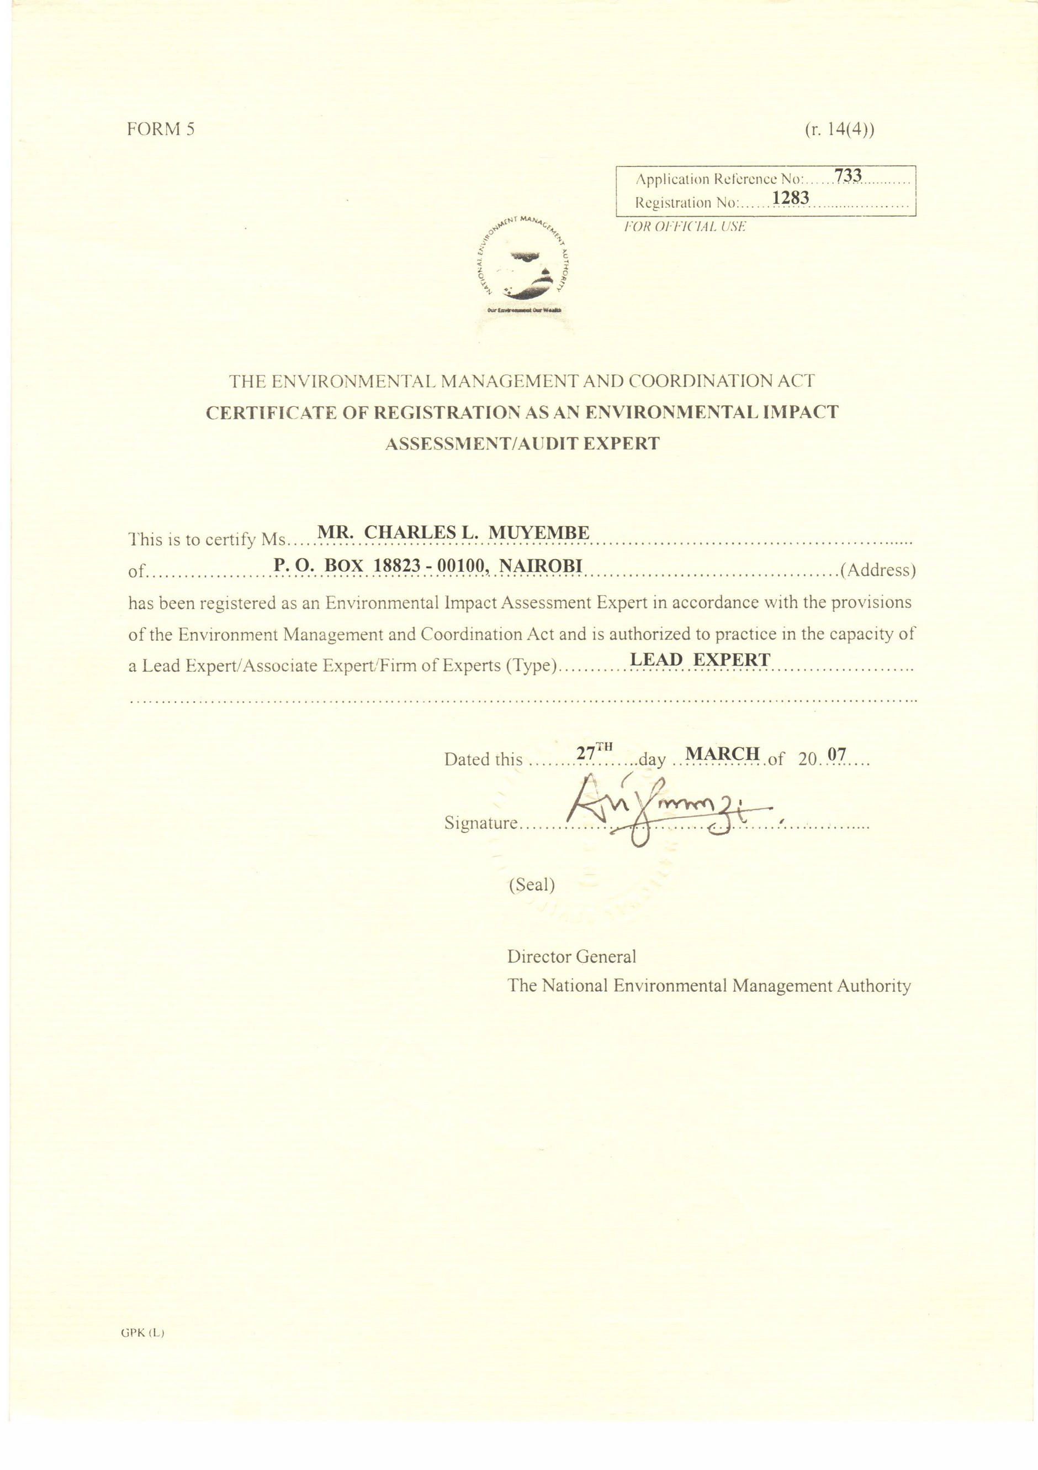

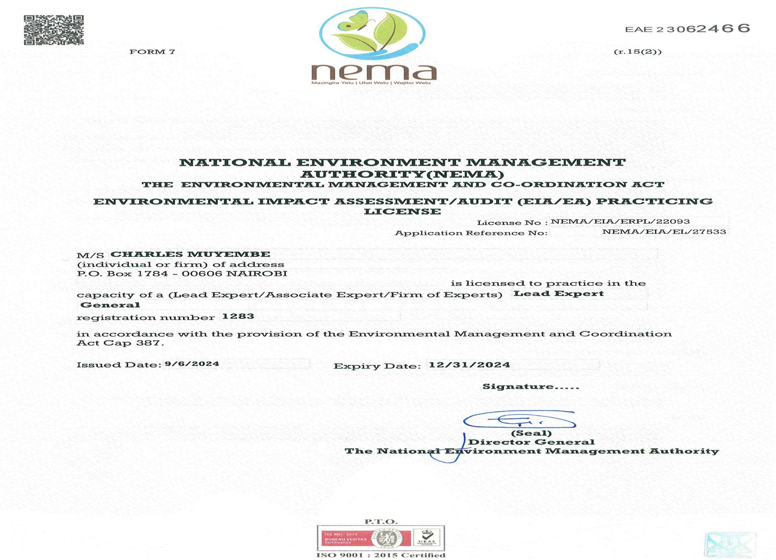

Appendix 2: List of participants in the Stakeholder Engagement Meeting

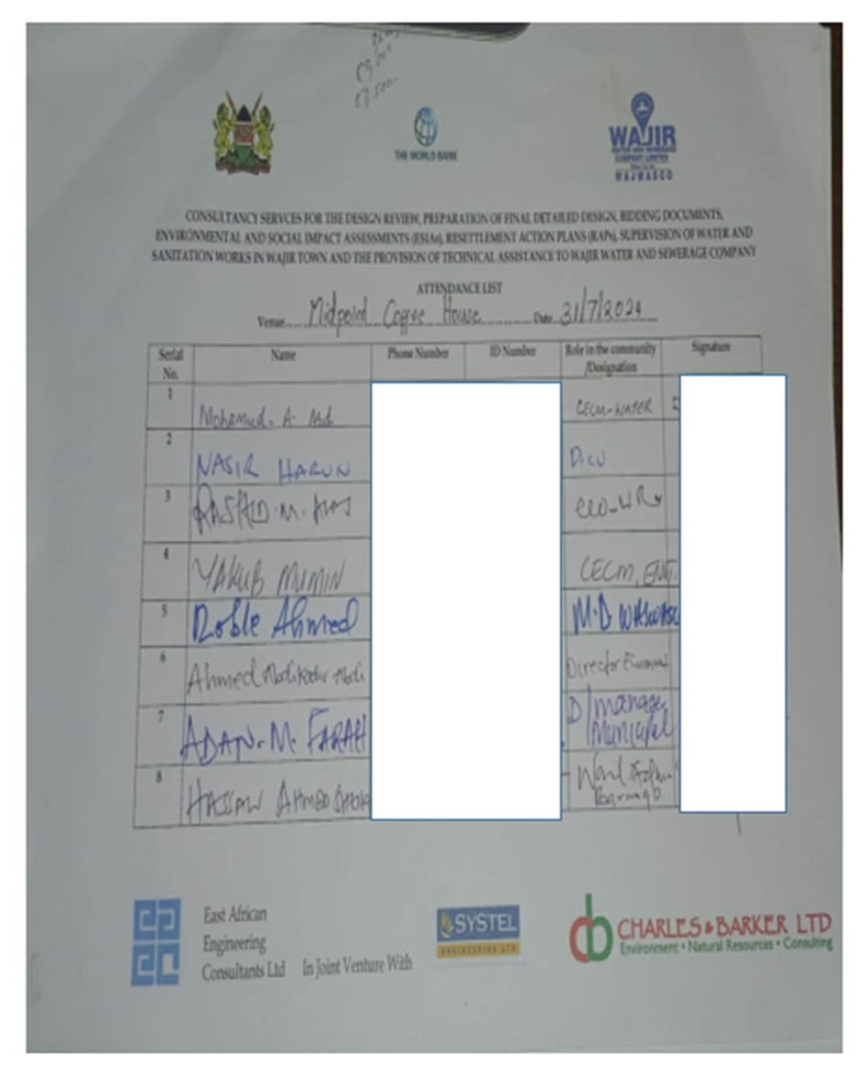

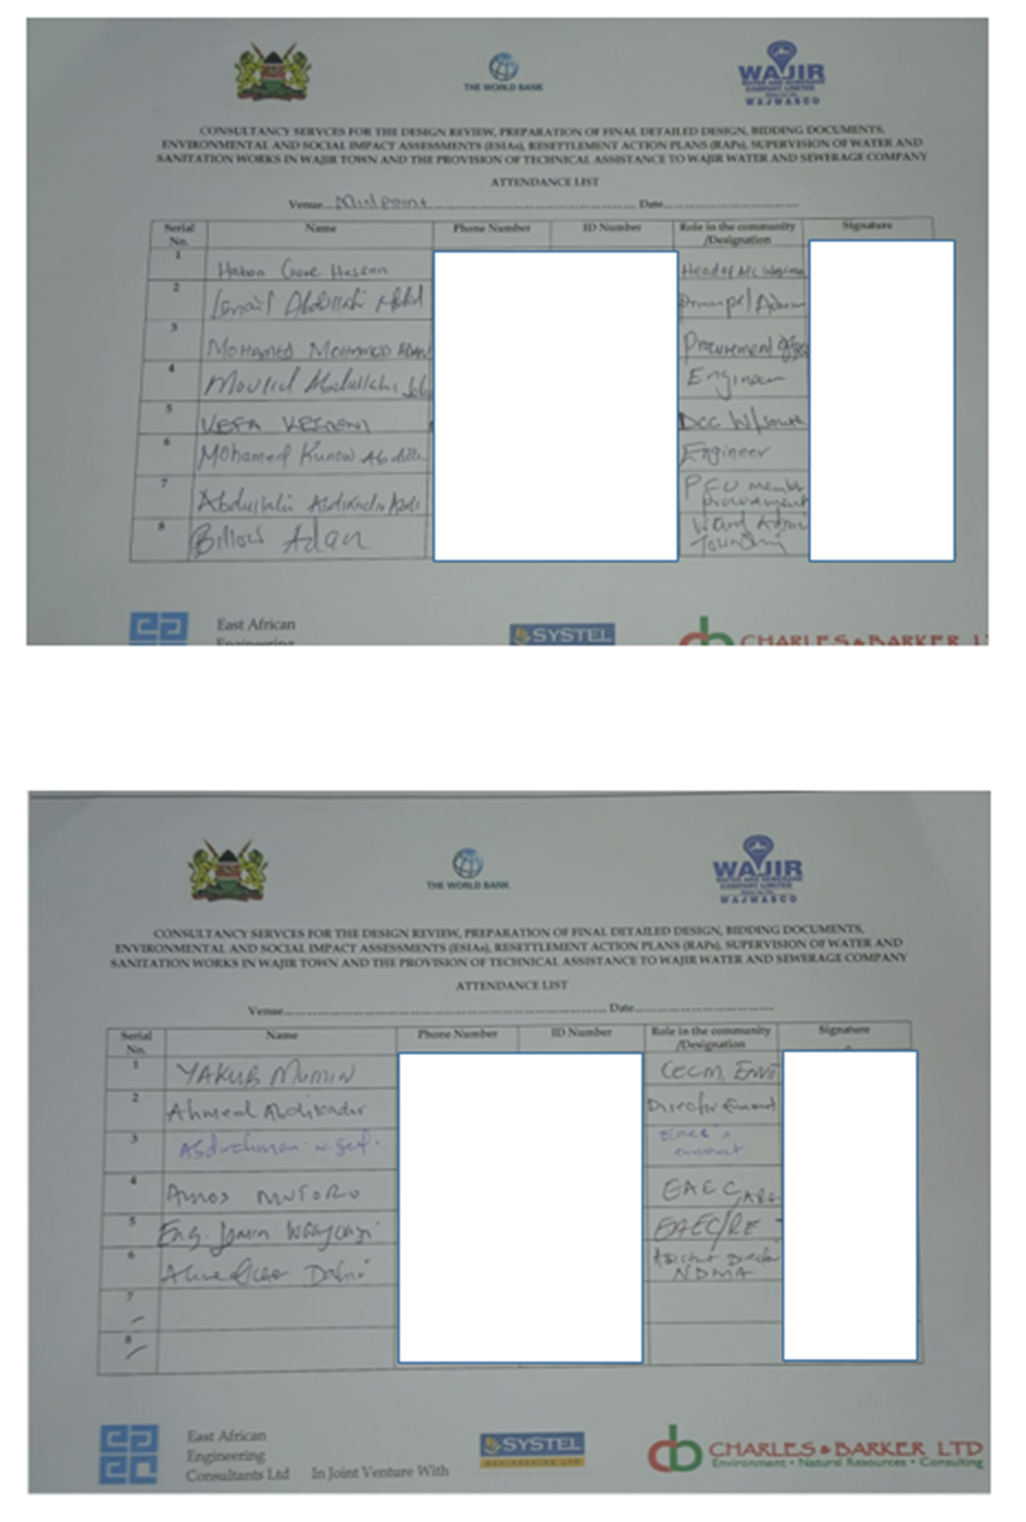

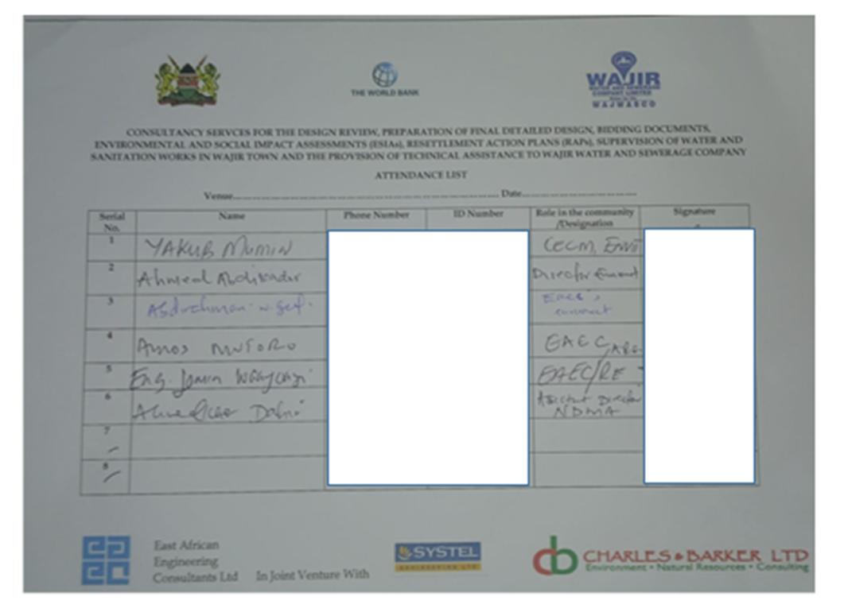

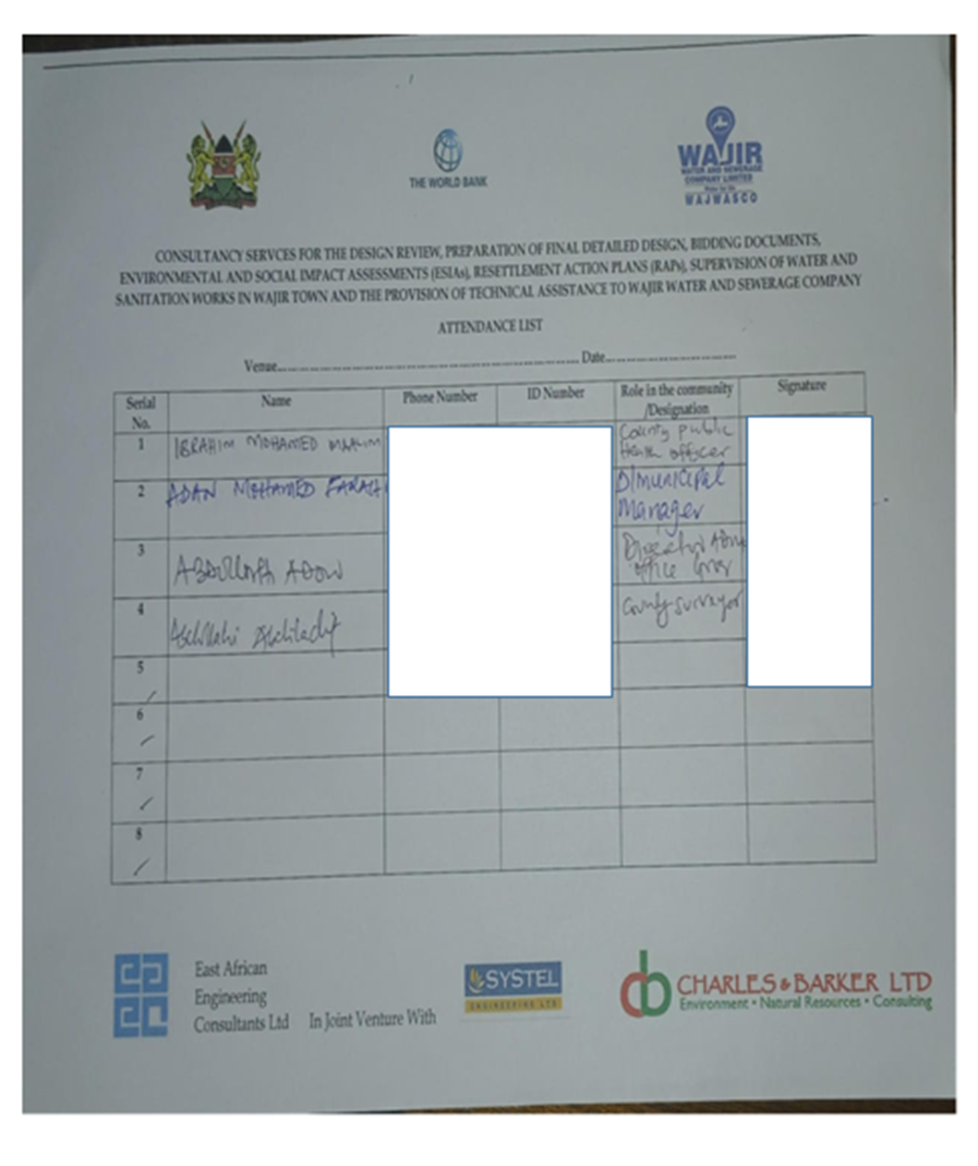

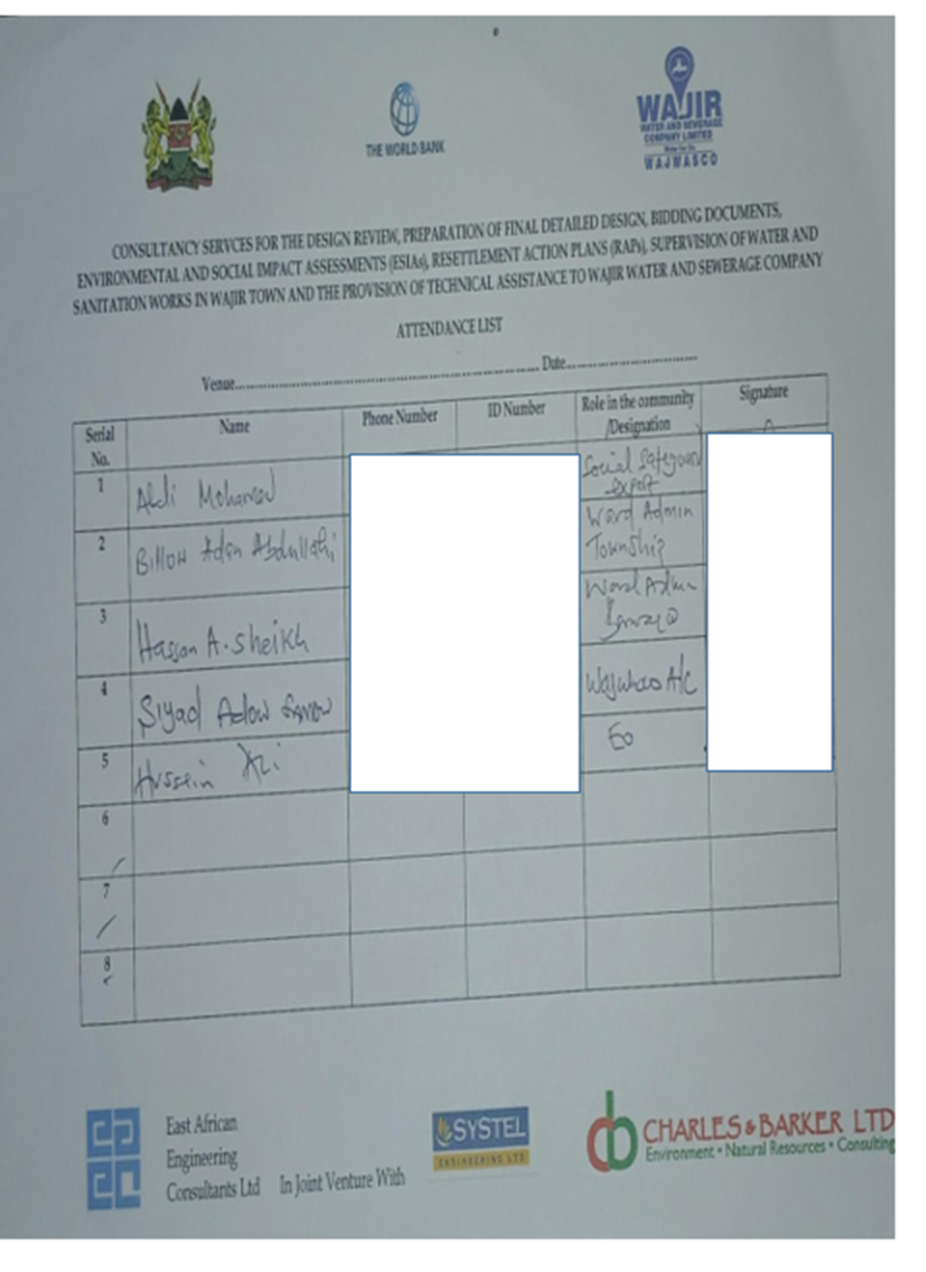

Appendix 3: Minutes of the Stakeholders Meeting

STAKEHOLDER ENGAGEMENT MEETING FOR THE PROPOSED WAJIR FAECAL SLUDGE TREATMENT PLANT HELD ON 31st JULY, 2024 AT THE MIDPOINT COFFEE HOUSE

MEMBERS PRESENT

- Wajir Water and Sewerage Company (WAJWASCO).
- Director, National Drought Management Authority
- CEC Education
- CEC Public Health
- CEC Lands and physical planning
- CEC Water and sanitation
- Religious leaders
- Local Government and administration
- Wajir Municipality director
- County Commissioner
- Wajir County NEMA director
- Engineers

AGENDA

APOLOGIES
NIL

- Introductions
- Proposed project presentations
- Public participation Guidelines
- Stakeholder feedback and discussions
- Closing remarks

MIN 01/03/2024: Introduction

The meeting was called in order by the WAJWASCO Managing Director, it started with a word of prayer at 11.32 AM. The MD called in for all consultants for introduction before welcoming the other members for self-introduction.

MIN 02/03/2024: Project awareness

The MD thanked the consultant representative for sharing the important information with the community. He told the meeting that the agenda of the day on awareness of the proposed project. The consultant took the meeting through the procedures and processes of the project and the importance the community members plays in such consultative meetings of the proposed project. The project is a consultative and community input and contributions is key that’s why they should be consulted. She told the meeting that both environmental and social issues affect members of the community during project implementation phase.

She then took the members through the anticipated project impacts and proposed mitigation measures.

MIN 03/03/2024: Stakeholders’ Concerns and matters arising

S  No. | Concern/Comment/Question | Response/Recommendation
1 | Why shouldn’t the client do the sewer system that had been proposed initially? | The sewer system is not feasible given the area does not have sufficient water supply. Sewer system can only operate in areas where there is a lot of water sufficient to push the wastes in the trunks.  The area is also a flat plain, making it difficult for sewer  system to operate as it is also dependent on gravity to enable the flow of the wastes down slope to the FSTP.
2 | Are there design methods that have been considered to mitigate the possible negative impacts of the plant, given it is a high risk, where there will be production of greenhouse  gases in the ponds? | Yes, there are engineers who are still designing the plant with operation and maintenance considered, and a final design report shall be shared and discussed.
3 | With the existing court case on the management of the existing dumpsite, how is the client going to ensure it is handled to prevent conflicts with the locals | The client expressed his concern and said that he shall ensure every issue is addressed to enable the project progresses without fail for the better of the community and Wajir as a whole.
 |  | In order to ensure fair hearing, this question shall be anchored in the project SEP as an ongoing concern.
 |  | The Court has issued Stay Orders on the case and allowed parties to remedy the situation at the Dumpsite. The Environmental & Management Coordination Act that regulates the proceedings of Tribunal and Environmental Law Court provides an automatic stay under section 130 which states the following; No decision or order of the Tribunal shall be enforced until the time for lodging an appeal has expired or, where the appeal has been commenced, until the appeal has been determined.
 |  | The Appeal has been allowed by the Environment and Court and amention done. As of now one of the Petitioners out of the two who had filed the case has since withdrawn from the Petition and sent withdrawal to the Court email.
This Project is one of the definite actions that the County is taking in order to improve the site and ensure the site in question is managed well including access control, solid
waste management and air-fouling.
4 | A member proposed Public Private Partnerships during the proposed project  operation phase to enable proper management of the plant. | This was noted
5 | The attendees wanted to understand the importance of the byproducts of the proposed plant. | There will be production of waste water, that after undergoing treatment can be used for irrigation in farms.  The dried sludge could be used as manure, or processed into briquettes.

6 | This is a high risk project, it should be taken  with a lot of seriousness, and ensure all the possible negative impacts are addressed well. | There shall be an ESMMP available that shall be  addressing all the anticipated negative impacts and the costs indicated.

Any Other Business

There being no any other business, the meeting ended with a word of prayer from Roble Ahmed.

Meeting Minutes prepared by;

Name ......Saraphina Nasimiyu...........

Signature ..............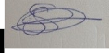............ Date ....31st July 2024............

Appendix 4: Sample of filled stakeholder questionnaire

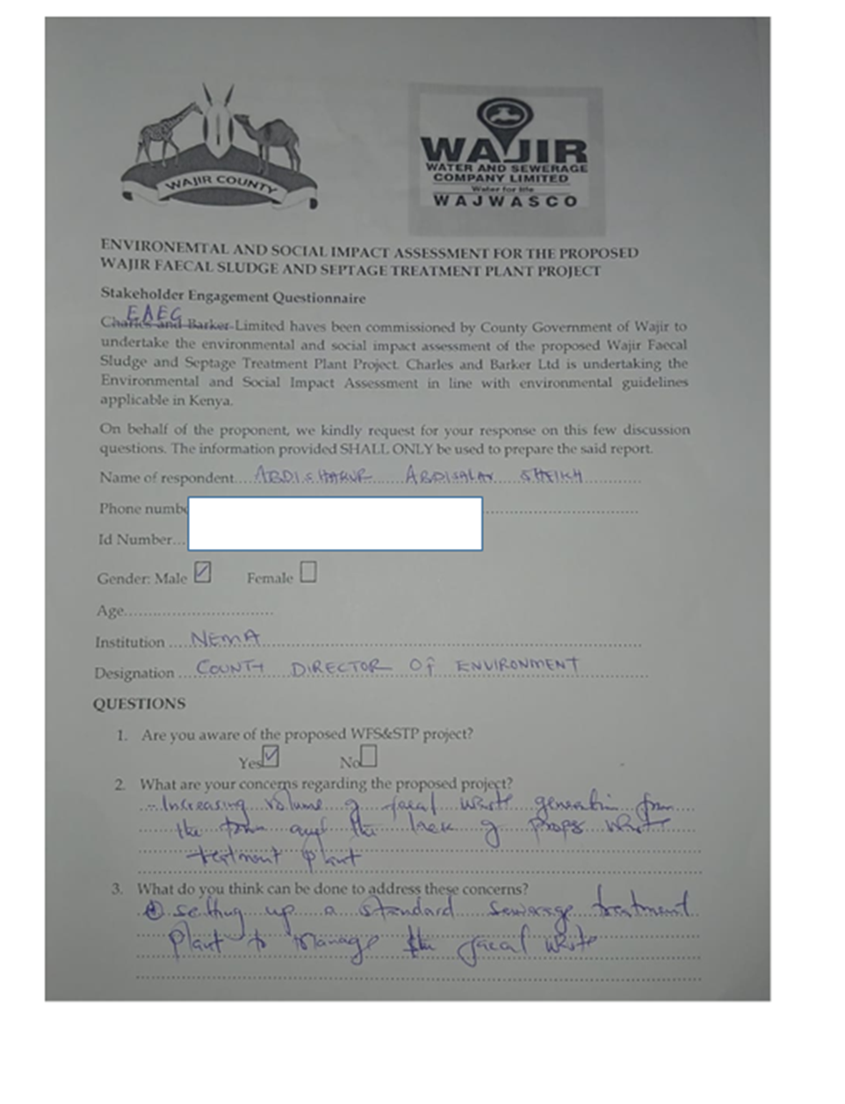

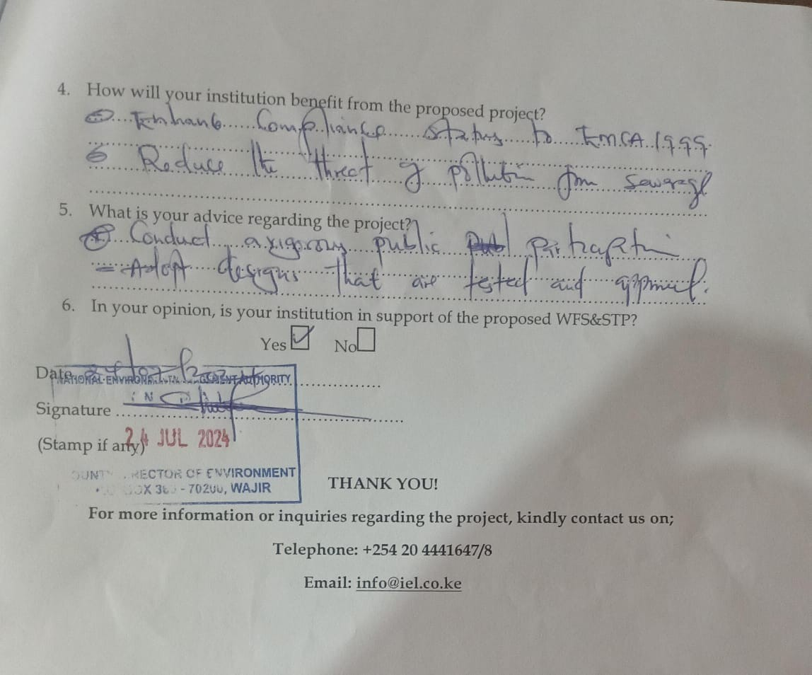

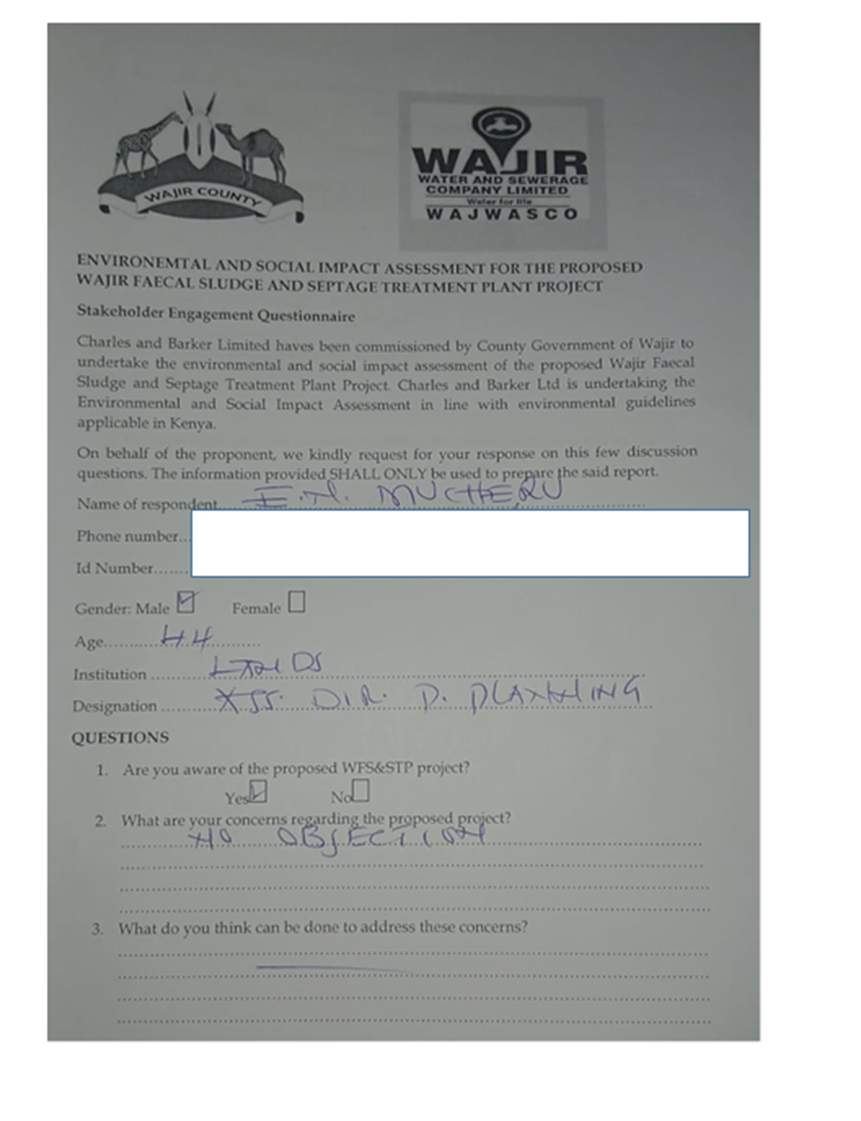

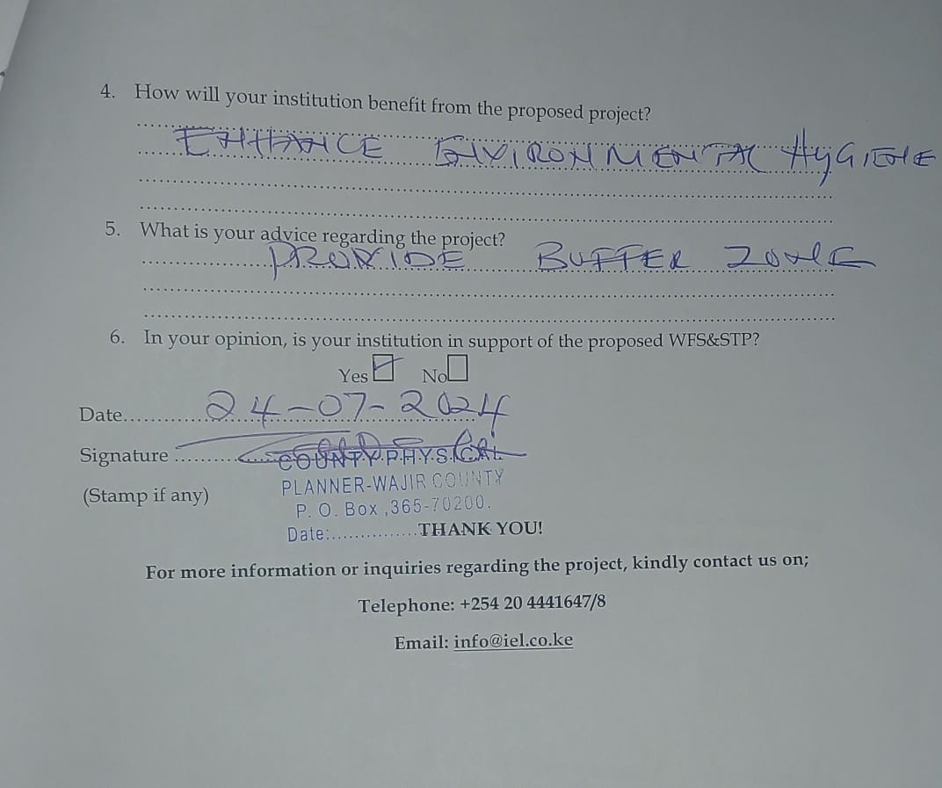

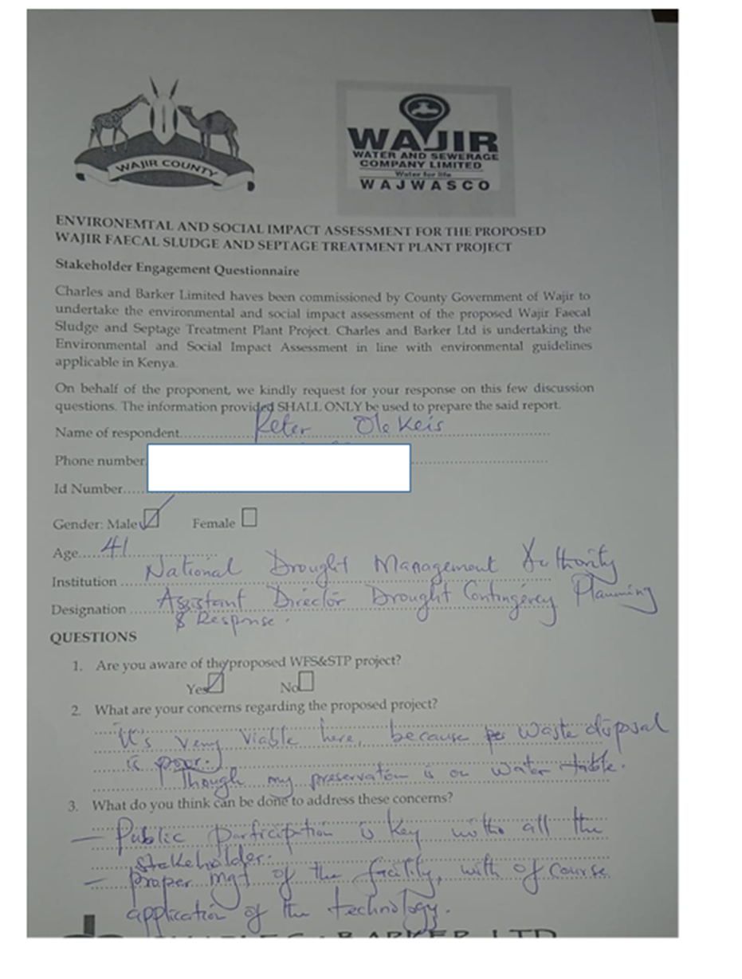

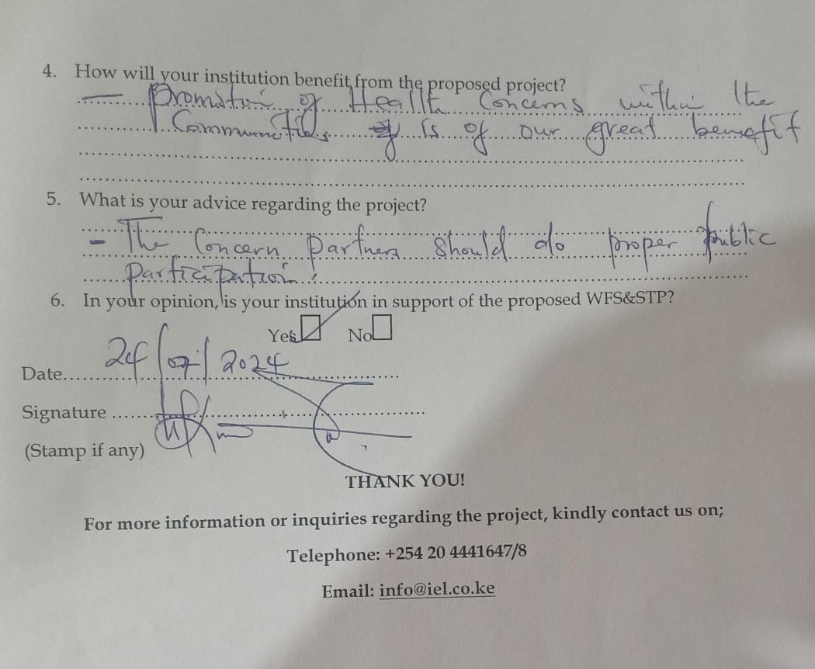

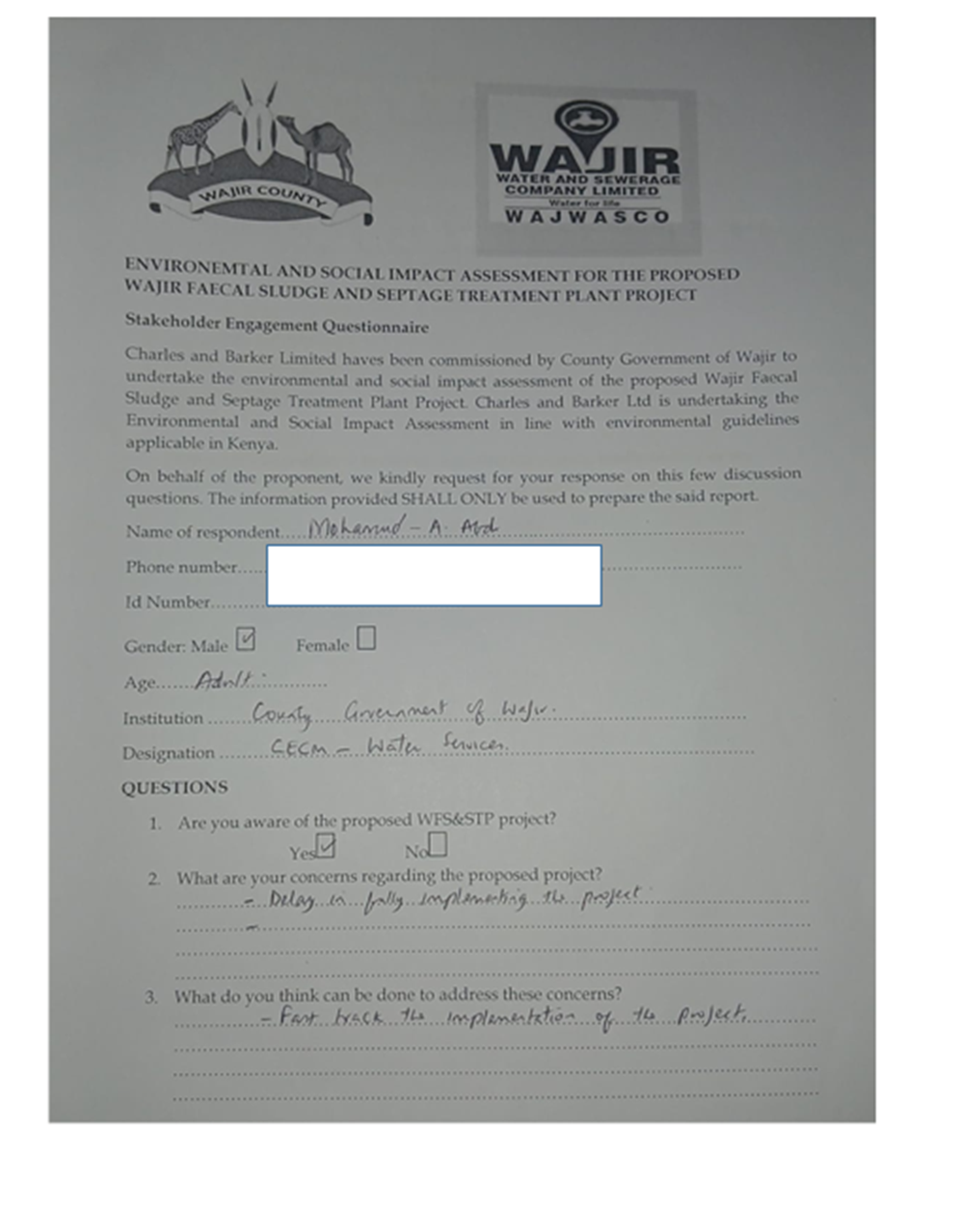

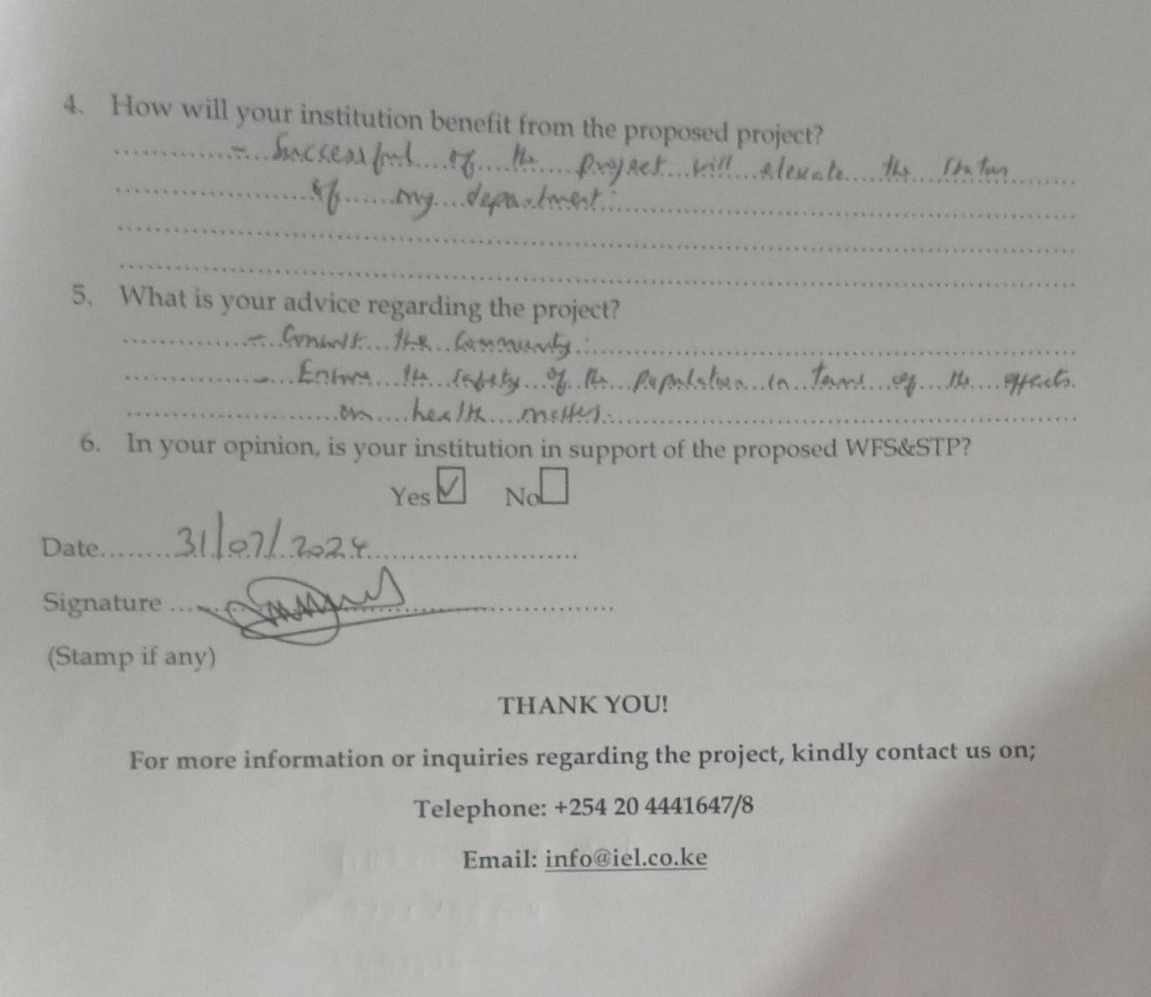

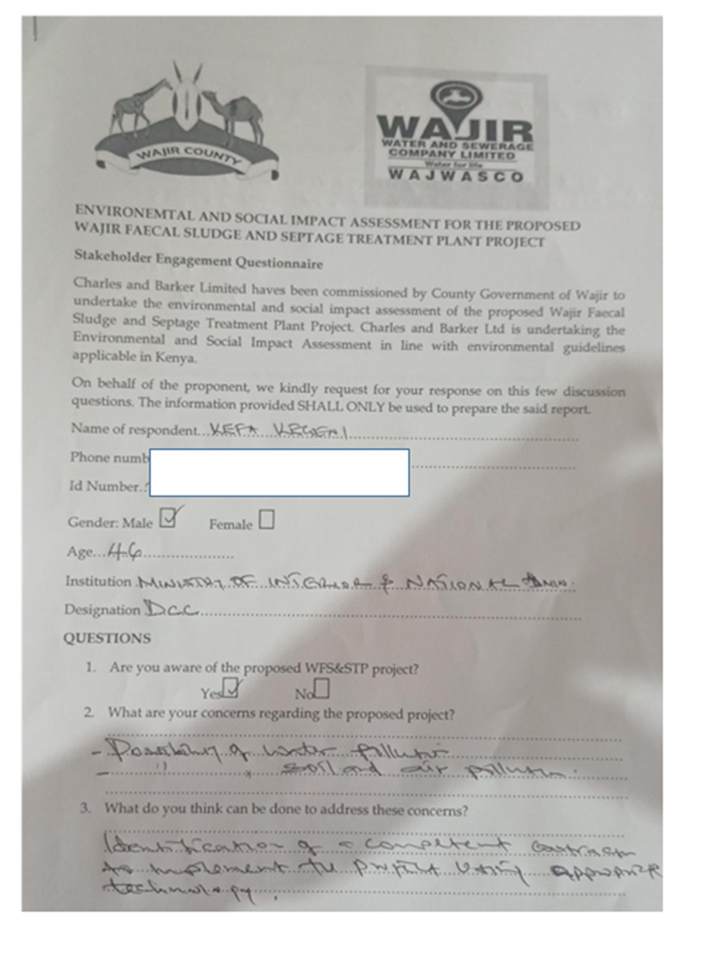

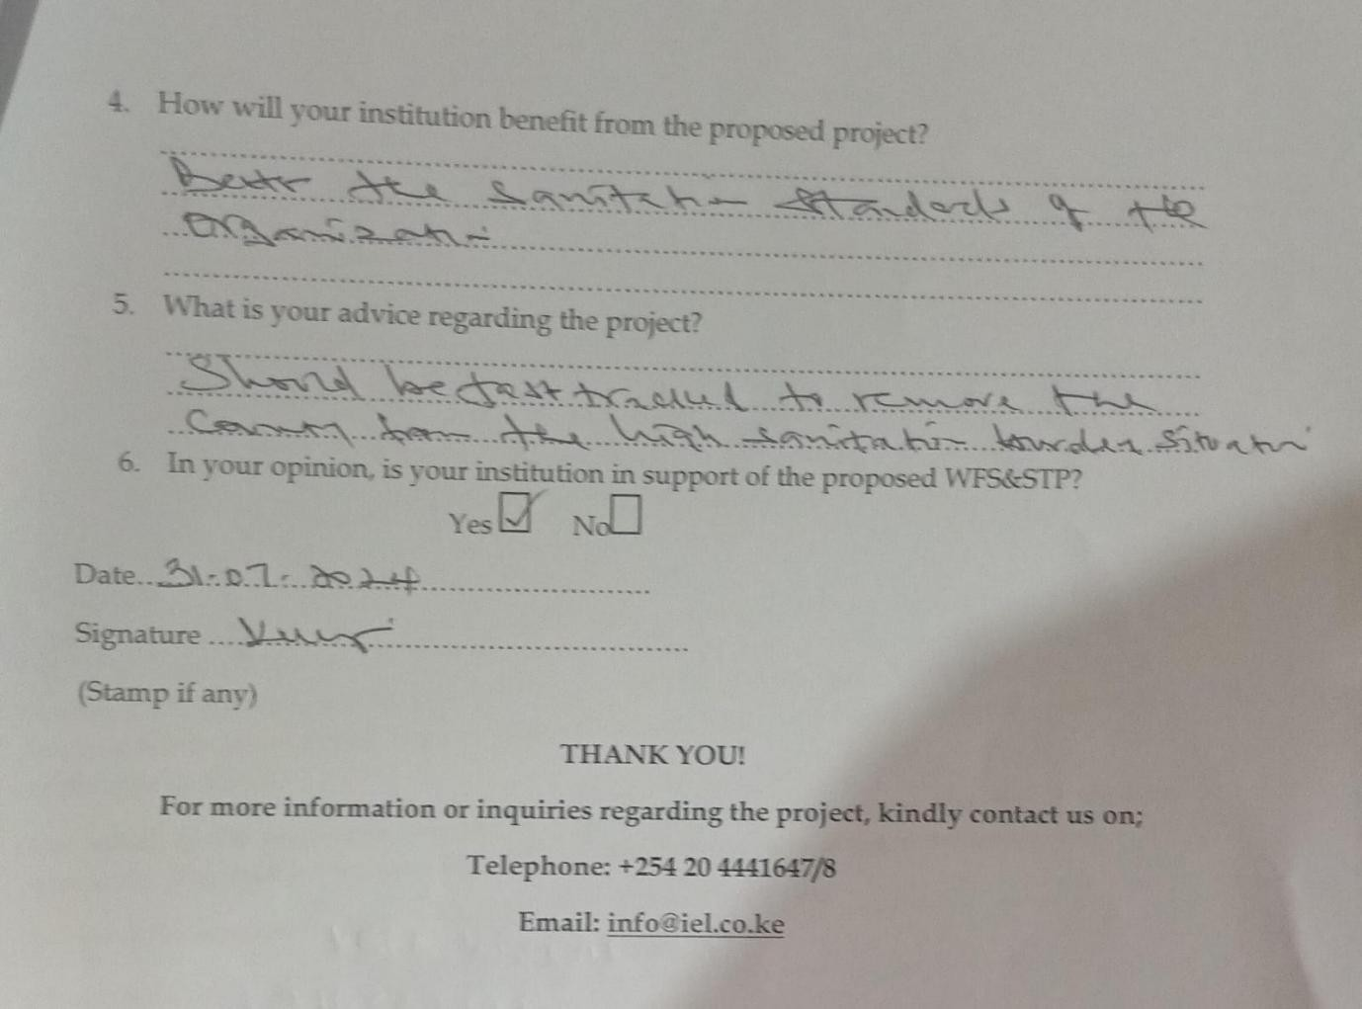

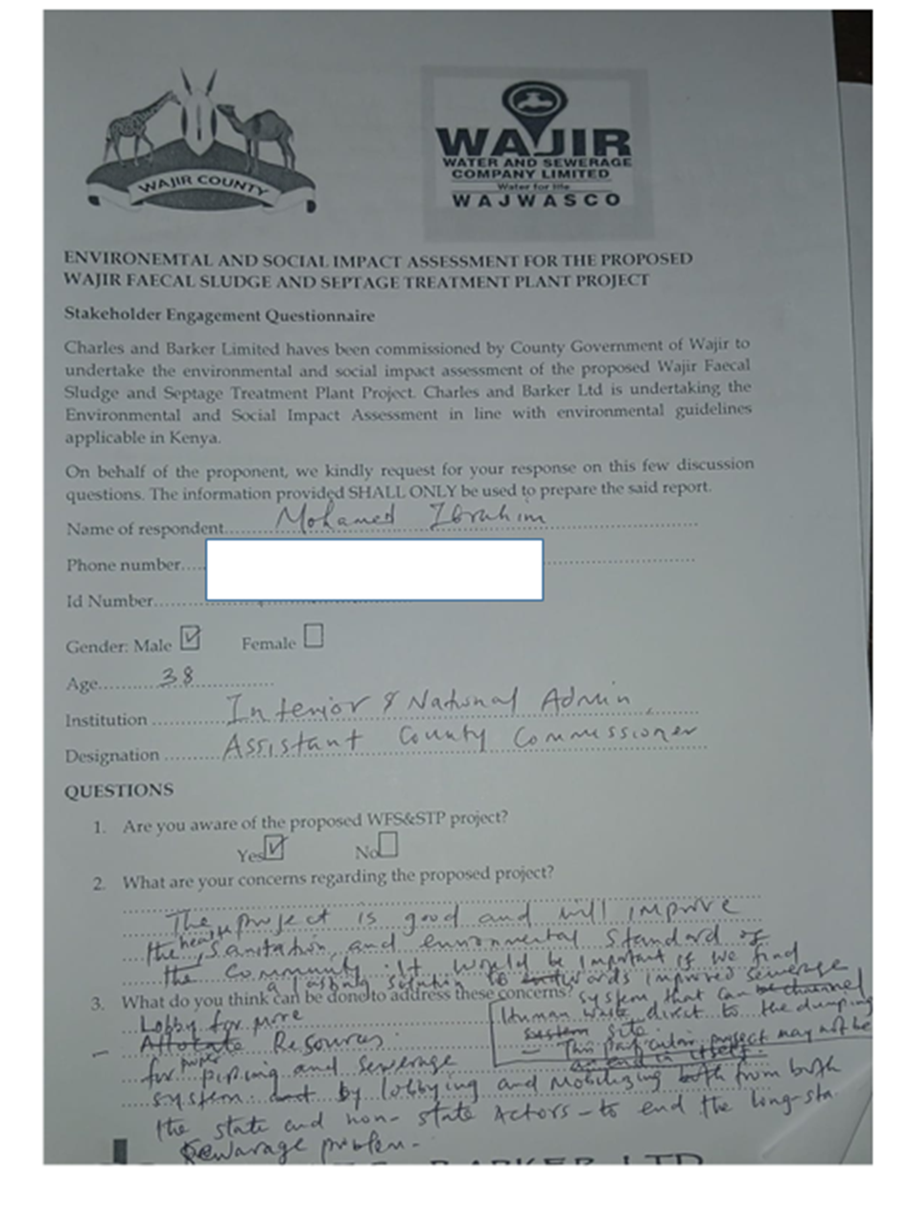

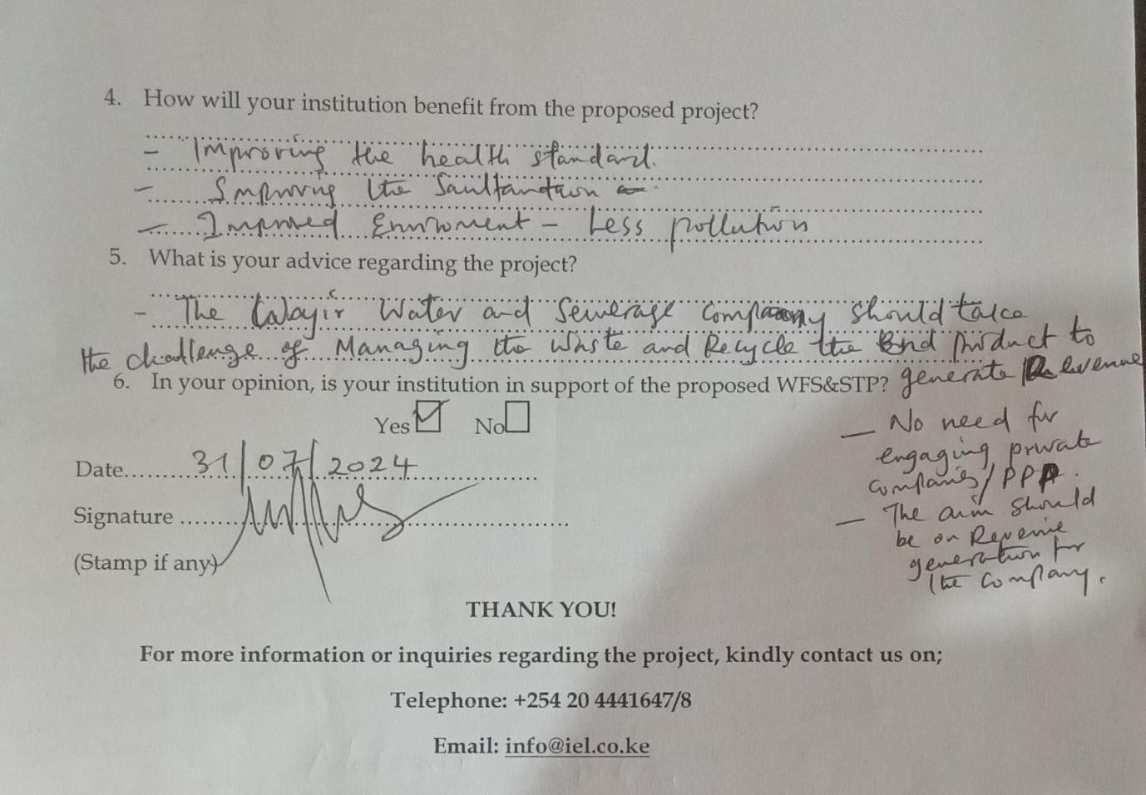

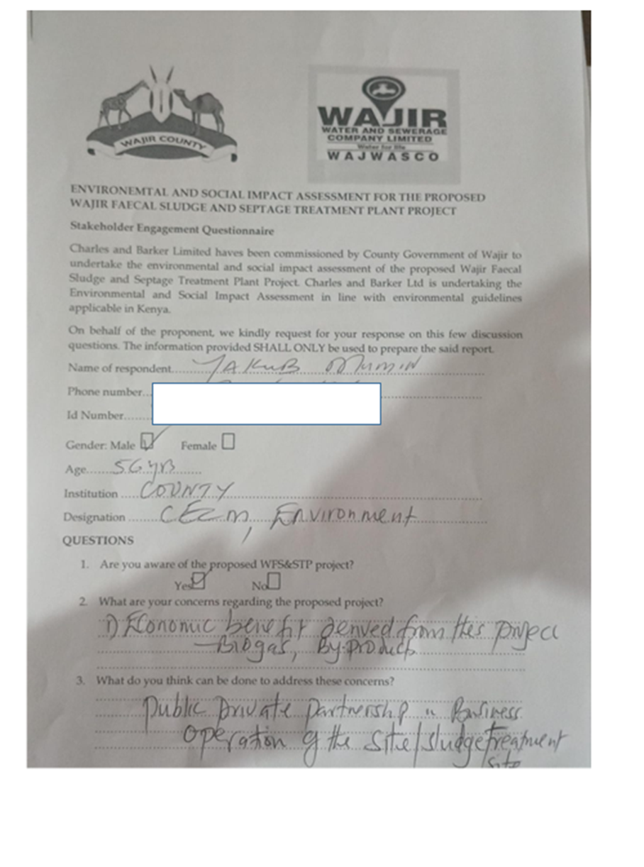

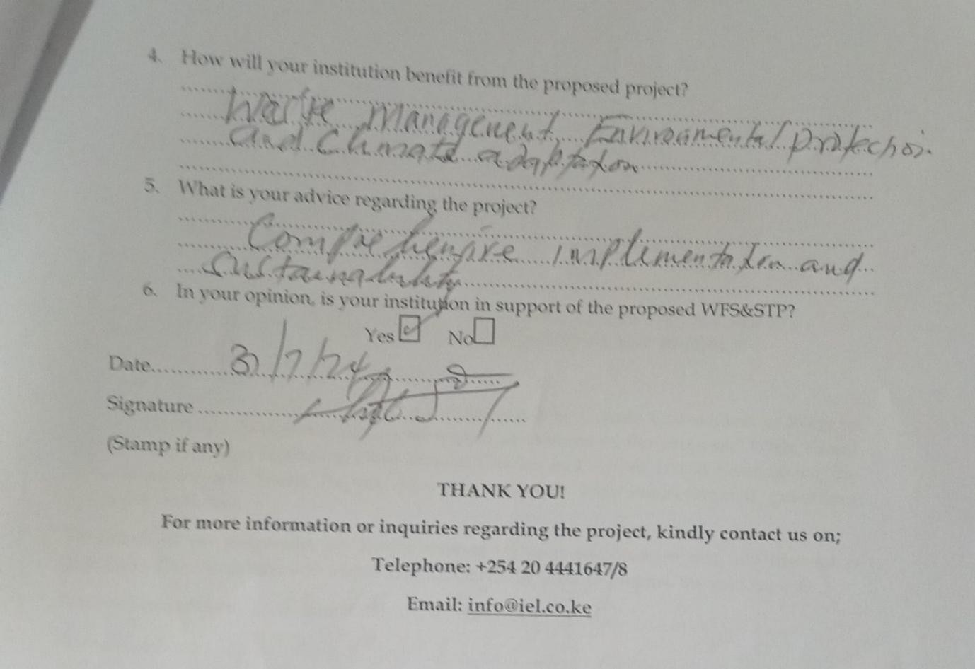

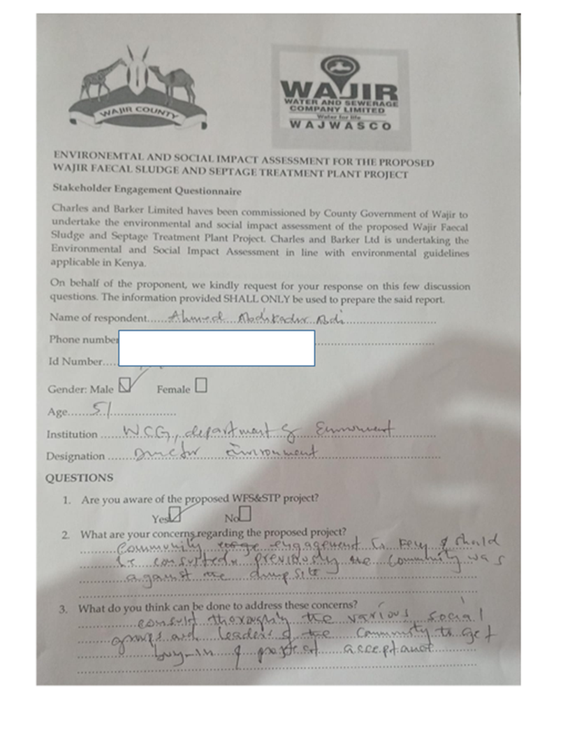

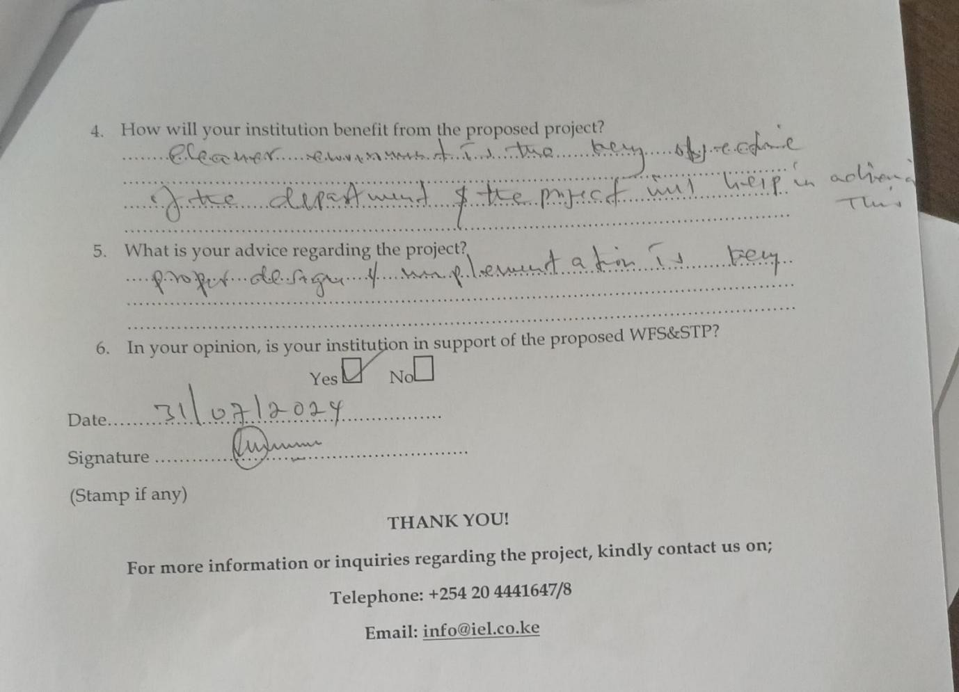

Appendix 5: Public participation Attendance List

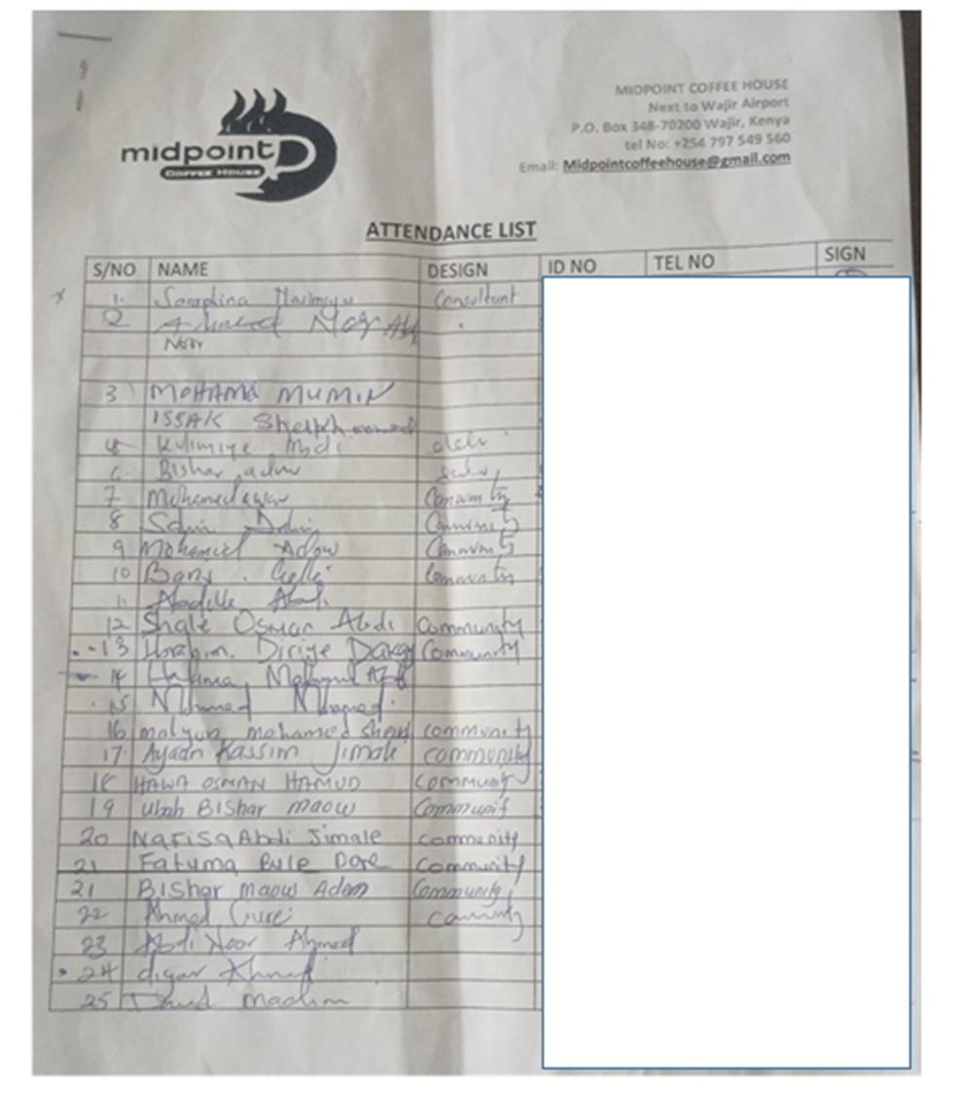

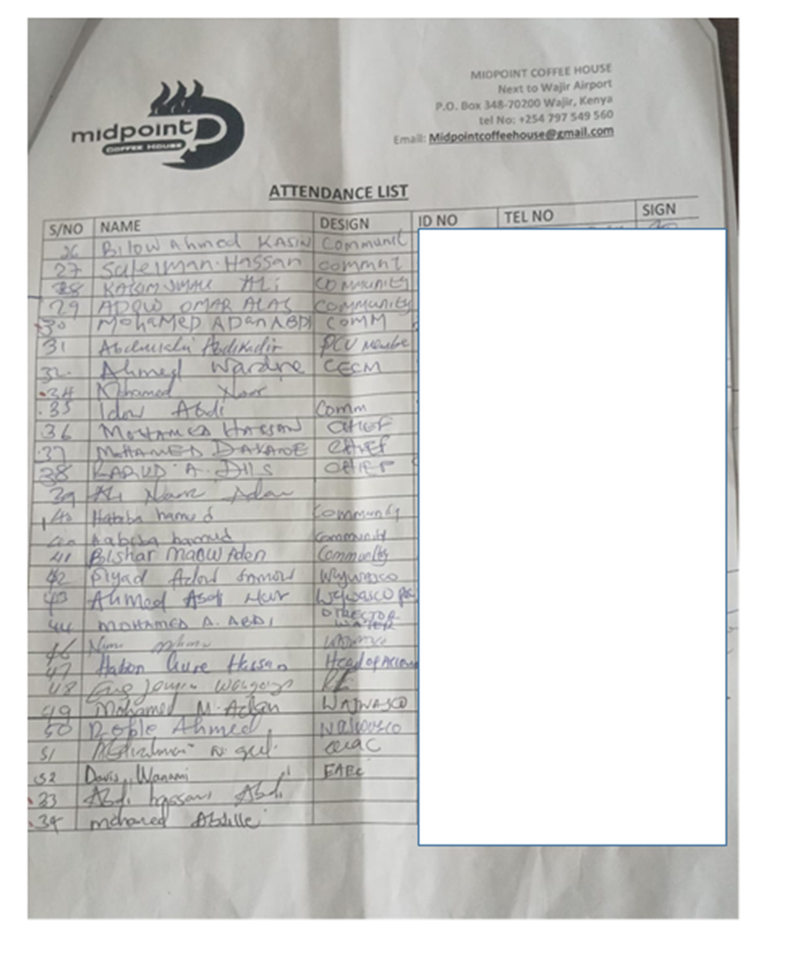

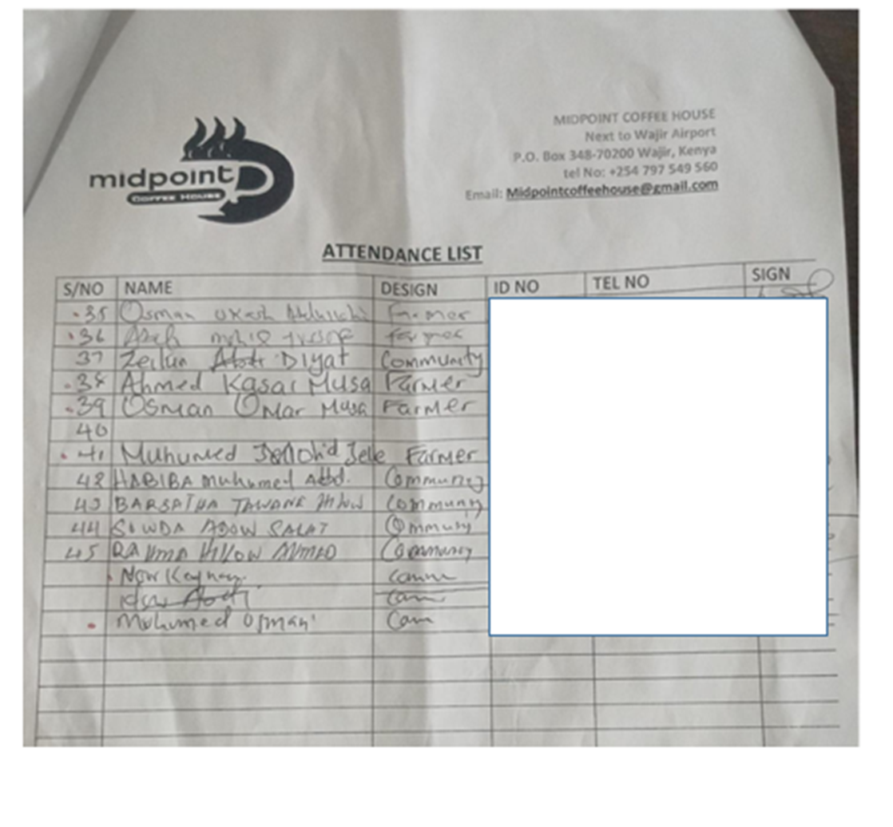

Appendix 6: Minutes of the Public Participation Meeting

STAKEHOLDER ENGAGEMENT MEETING FOR THE PROPOSED WAJIR FAECAL SLUDGE TREATMENT PLANT HELD ON 1st AUGUST, 2024 AT THE MIDPOINT COFFEE HOUSE

MEMBERS PRESENT

- Wajir Water and Sewerage Company (WAJWASCO).
- CEC Education
- Local Government and administration
- Engineers
- Alimaow chief
- Furaha Chief

AGENDA

APOLOGIES
NIL

- Introductions
- Proposed project presentations
- Public participation Guidelines
- Stakeholder feedback and discussions
- Closing remarks

MIN 01/03/2024: Introduction

The meeting was called in order by the WAJWASCO Managing Director, it started with a word of prayer at 11.40 AM. The MD called in for all consultants for introduction before welcoming the other members for self- introduction.

MIN 02/03/2024: Project awareness

The MD thanked the consultant representative for sharing the important information with the community. He told the meeting that the agenda of the day on awareness of the proposed project. The consultant took the meeting through the procedures and processes of the project and the importance the community members plays in such consultative meetings of the proposed project. The project is a consultative and community input and contributions is key that’s why they should be consulted. She told the meeting that both environmental and social issues affect members of the community during project implementation phase.

She then took the members through the anticipated project impacts and proposed mitigation measures.

MIN 03/03/2024: Public Concerns and matters arising

S  No. | Concern/Comment/Question | Response/Recommendation
1 | Already the existing dumpsite has not been well managed, how can the client assure us that it will not be the same with the proposed FSTP? | The consultant and client stated that there shall be operation and maintenance plans in place to manage the plant.

 |  | There shall also be PPPs which will help in this as well.
2 | There should be direct benefits to the locals of Alimaow and Furaha areas. | This was noted.
3 | With the existing court case on the management of the existing dumpsite, how is the client going to ensure it is handled to prevent conflicts with the locals | The client expressed his concern and said that he shall ensure every issue is addressed to enable the project progresses without fail for the better of the community and Wajir as a whole.  In order to ensure fair hearing, this question shall be anchored in the project SEP as an ongoing concern.  The Court has issued Stay Orders on the case and allowed parties to remedy the situation at the Dumpsite. The Environmental & Management Coordination Act that regulates the proceedings of Tribunal and Environmental Law Court provides an automatic stay under section 130 which states the following; No decision or order of the Tribunal shall be enforced until the time for lodging an appeal has expired or, where the appeal has been commenced, until the appeal has been determined.  The Appeal has been allowed by the Environment and Court and amention done. As of now one of the Petitioners out of the two who had filed the case has since withdrawn from the Petition and sent withdrawal to the Court email.  This Project is one of the definite actions that the County is taking in order to improve the site and ensure the site in question is managed well including access control, solid  waste management and air-fouling.
4 | A member stated that other members of the community who had not attended the meeting should also be consulted at a later stage  before the project starts. | This was noted
5 | The attendees wanted to understand the importance of the byproducts of the proposed plant. | There will be production of waste water, that after undergoing treatment can be used for irrigation in farms.  The dried sludge could be used as manure, or processed into briquettes.
6 | The attendees expressed their concern with the client, thus were reluctant if the project will be successful given the past incidences of corruption that have led to project failures in the community, and thus were requesting that the project to be taken with the serious it  deserves by audits to prevent project failures. | This was noted.

MIN 4/03/2024: Other issues raised

The members raised an issue about the communication for the different meetings attendance since they said sometimes some of them don’t get the information when a meeting is supposed to take place.
They requested that during project implementation casual laborers should be locals within the community and not sourced from somewhere else. The community also raised an issue on the awarding of contracts to contractors, they emphasized that they would like to have a member of the community getting the tender for the job.

AOB

There being no any other business, the meeting ended with a word of prayer from Abdi Mohammed.

Meeting Minutes prepared by;

Name ......Saraphina Nasimiyu...........

Signature ..............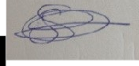............ Date ....31st July 2024............

Appendix 7: Land Ownership Documents
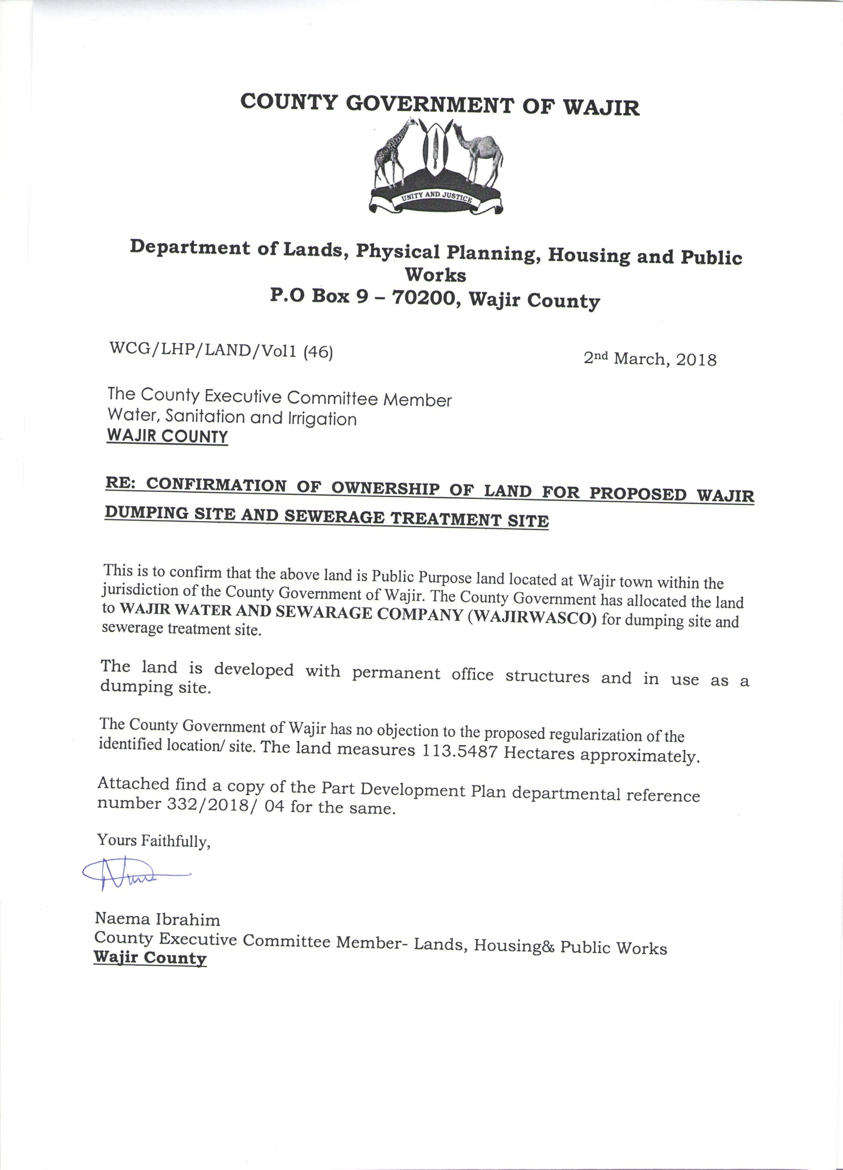

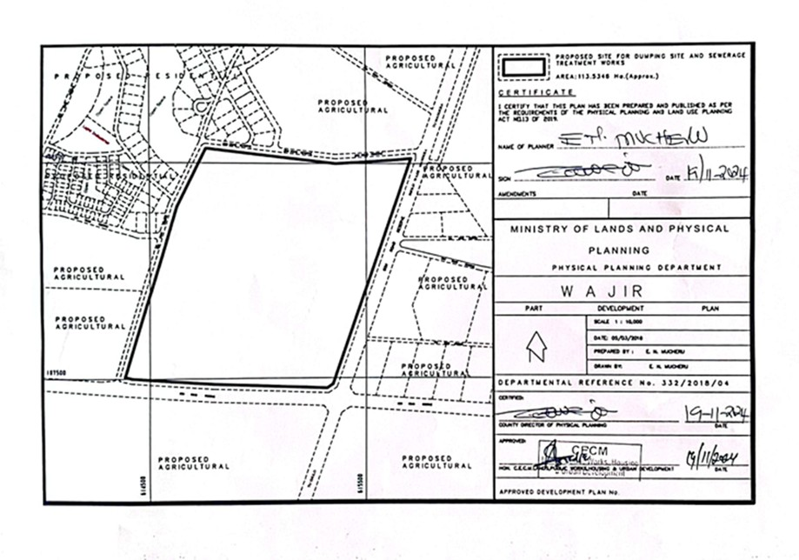

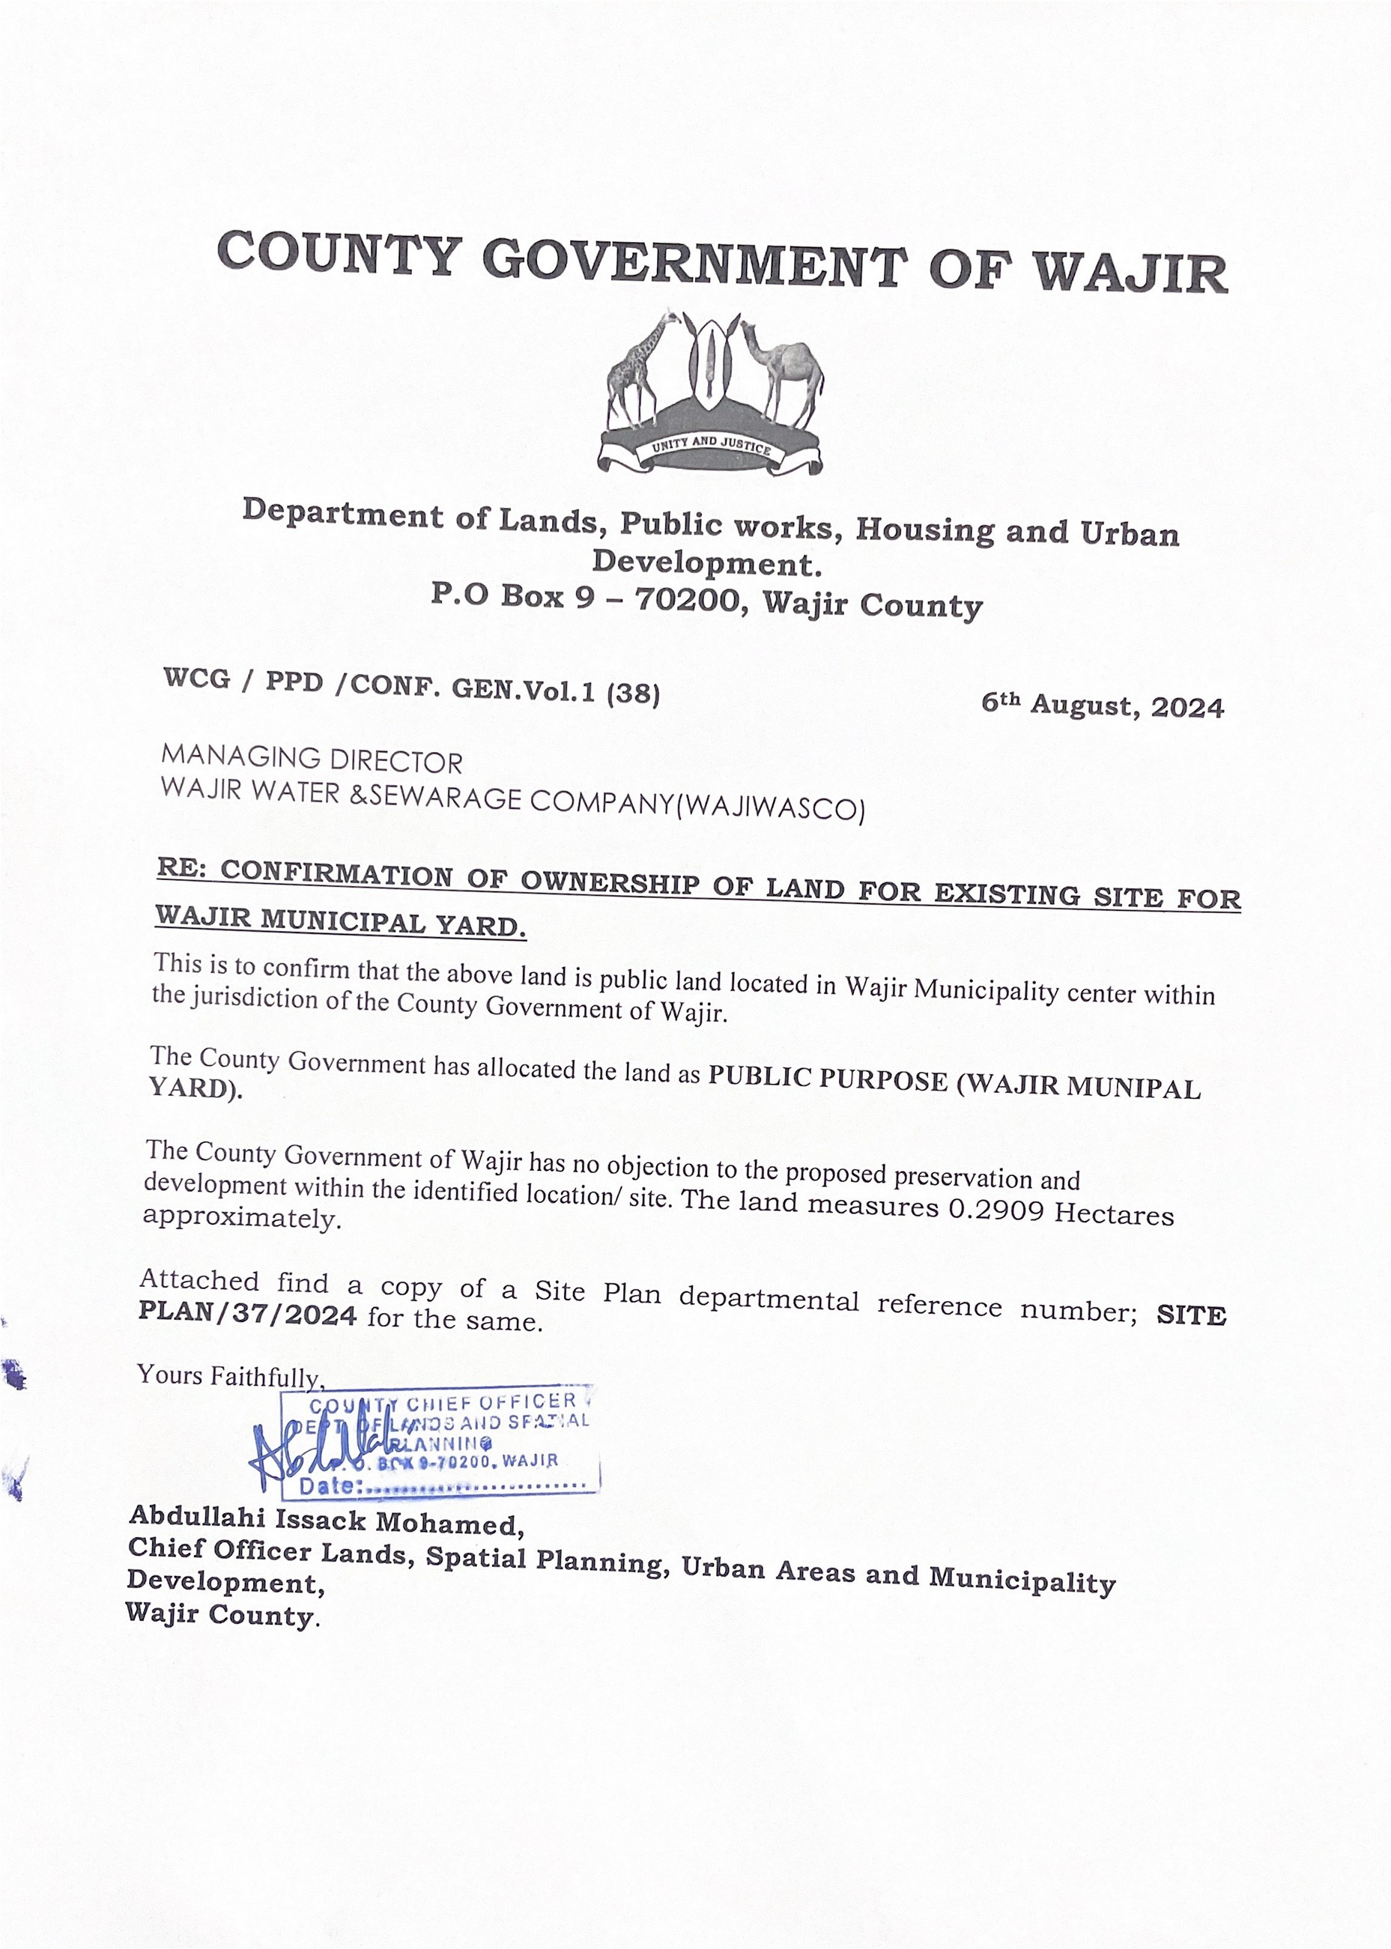

Environmental and Social Impact Assessment Report for The Proposed Wajir Faecal Sludge and Septage Treatment Plant, Wajir Municipality, Wajir County

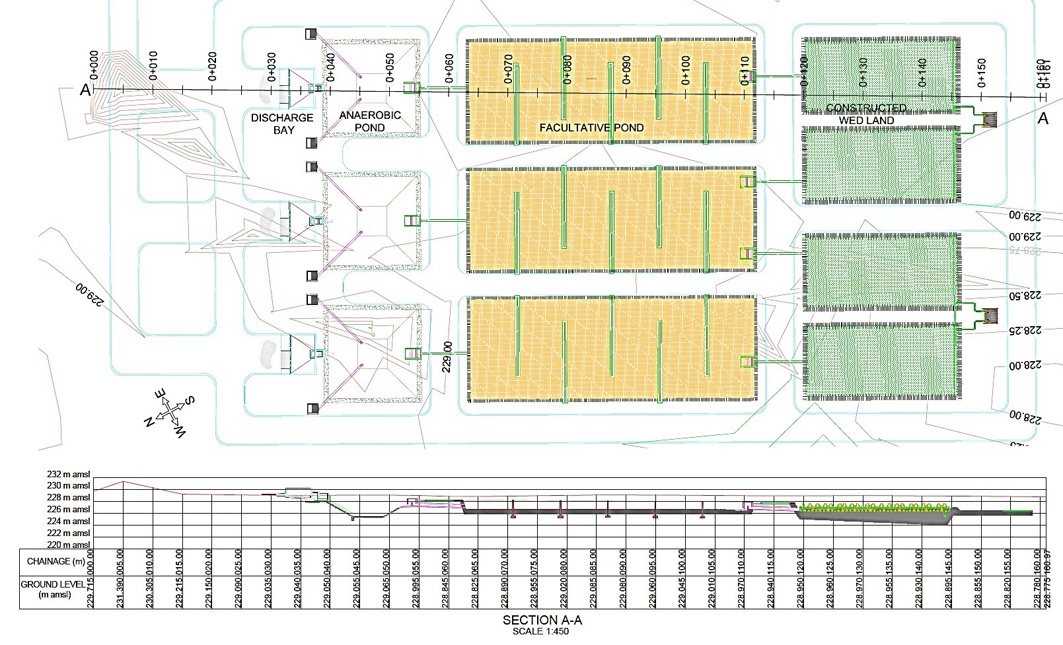
Appendix 8: Proposed FSTP Schematics

Facultative Ponds
Facultative Ponds

141

Environmental and Social Impact Assessment Report for The Proposed Wajir Faecal Sludge and Septage Treatment Plant, Wajir Municipality, Wajir County

Appendix 9: Chance Find Procedure

Environmental and Social Impact Assessment Report for The Proposed Wajir Faecal Sludge and Septage Treatment Plant, Wajir Municipality, Wajir County

Purpose of the chance find procedure
The chance find procedure outlines actions required if previously unknown heritage resources, particularly archaeological resources, are encountered during project construction or operation. It is a process that prevents chance finds from being disturbed until an assessment by a competent specialist is made and actions consistent with the requirements are implemented.

Scope of the chance find procedure
This procedure is applicable to all activities conducted by the personnel, including contractors, that have the potential to uncover a heritage item/site. The procedure details the actions to be taken when a previously unidentified and potential heritage item/site is found during construction activities. Procedure outlines the roles and responsibilities and the response times required from both project staff, and any relevant heritage authority.

Chance find procedure
If any person discovers a physical cultural resource, such as (but not limited to) archaeological sites, historical sites, remains and objects, or a cemetery and/or individual graves during excavation or construction, the following steps shall be taken:
- Stop all works in the vicinity of the find, until a solution is found for the preservation of these artefacts, or advice from the relevant authorities is obtained;
- Immediately notify a foreman. The foreman will then notify the Construction Manager and the Environment Officer (EO)/Environmental Manager (EM);
- Record details in Incident Report and take photos of the find;
- Delineate the discovered site or area; secure the site to prevent any damage or loss of removable objects. In cases of removable antiquities or sensitive remains, a night guard shall be arranged until the responsible local authorities take over;
- Notify the National Museums of Kenya as the Lead Agency of the Chance Find;
- Preliminary evaluation of the findings by archaeologists. The archaeologist must make a rapid assessment of the site or find to determine its importance. Based on this assessment the appropriate strategy can be implemented. The significance and importance of the findings should be assessed according to the various criteria relevant to cultural heritage such as aesthetic, historic, scientific or research, social and economic values of the find;
- Sites of minor significance (such as isolated or unclear features, and isolated finds) should be recorded immediately by Consultant archaeologist. The results of all archaeological work must be reported to the NMK.
- In case of significant find the National Museums of Kenya should be informed immediately and in writing within 7 days from the find.
- Decisions on how to handle the finding shall be taken by the NMK. This could include changes in the layout (such as when finding an irremovable remain of cultural or archaeological importance) conservation, preservation, restoration and salvage;
- Construction works could resume only after permission is granted from the responsible authorities.
- In case no response received within the 2 weeks’ period mentioned above, this is considered as authorization to proceed with suspended construction works.

One of the main requirements of the procedure is record keeping. All finds must be registered. Photo log, copies of communication with decision making authorities, conclusions and recommendations/guidance, implementation reports ± kept.

